**CS 2302 Data Structures**

**Fall 2019**

**Lab Report #5**

Due: November 5th, 2019

Professor: Olac Fuentes

TA: Anindita Nath

**Introduction**

For this lab, we were asked to implement a hash table that solves collisions by either chaining or linear probing to store words and their embeddings according to the hash value of the word, which is determined by one of six different hash functions. The purpose of implementing this hash table is to use the embeddings to compare two given words. For this lab, it is key to remember the properties of hash tables since they are required for all exercises. The main objective of this lab is to compare the overall performance (running times, load factor, and percent usage of the hash table) of the hash functions in order to determine the most efficient hash function to store words and their embeddings in a hash table, retrieve word embeddings, and compare various pairs of words.

**Proposed Solution Design and Implementation**

**Operation #1 (length of the word % length of the hash table):**

For this operation, I implemented a function in both *HashTableChain* and *HashTableLP* classes that calculates the hash value of a word by dividing the length of the word by the length of the hash table and returning the value of the remainder.

**Operation #2 (ASCII value of the first character in the word % length of the hash table):**

For this operation, I implemented a function in both *HashTableChain* and *HashTableLP* classes that calculates the hash value of a word by dividing the ASCII value of the first character in the word by the length of the hash table and returning the value of the remainder.

**Operation #3 (Product of ASCII values of the first and last characters in the word % length of the hash table):**

For this operation, I implemented a function in both *HashTableChain* and *HashTableLP* classes that calculates the hash value of a word by dividing the product of the ASCII values of the first and last characters in the word by the length of the hash table and returning the value of the remainder.

**Operation #4 (Sum of ASCII values of the characters in the word % length of the hash table):**

For this operation, I implemented a function in both *HashTableChain* and *HashTableLP* classes that calculates the hash value of a word by dividing the sum of the ASCII values of every character in the word by the length of the hash table and returning the value of the remainder.

**Operation #5 (Recursive formulation):**

For this operation, I implemented a function in both *HashTableChain* and *HashTableLP* classes that calculates the hash value of a word by recursively traversing through the entire word character by character. If the word is empty, the function returns 1. Otherwise, it adds the ASCII value of the first character in the word to the next recursive call, which is 255 greater than the current function call. Once the function traverses through the entire word, it divides the total result by the length of the hash table and returns the value of the remainder.

**Operation #6 (Polynomial formulation):**

For this operation, I implemented a function in both *HashTableChain* and *HashTableLP* classes that calculates the hash value of a word by iteratively traversing through the entire word as if it was a polynomial expression. To do this, I initialized the sum of the polynomial expression to 0 and declared two additional variables: the coefficient and the exponent. For the coefficient variable, I declared it with a value of 41 after I tried different arbitrary values that would produce the best results possible. For the exponent variable, I initialized its value to the length of the word minus 1. For each character in the word, the function updates the sum of the polynomial expression by adding the product of the ASCII value of the current character in the word and the coefficient raised to the power of the current exponent (the value of the exponent is decremented with every iteration). Once the function traverses through the entire word, it divides the sum of the polynomial expression by the length of the hash table and returns the value of the remainder.

In the *HashTableChain* class, I modified the *insert(k)* and *find(k)* functions to accommodate not only the hash function chosen by the user but also the objects containing a word and its embedding and the words to be compared, respectively. The first modified function (i.e. *insert(k)*) appends an object containing a word and its embedding to the list of the appropriate bucket in the hash table, which is determined by the hash value of the word that was calculated according to the hash function chosen by the user. The second modified function (i.e. *find(k)*) traverses through the contents of the appropriate bucket in the hash table and returns the object containing a word and its embedding if the word in the object matches the searched word. Otherwise, the function returns -1 if the searched word is not in the table.

Additionally, I implemented additional functions that calculate the load factor and the percent usage of the hash table. The load factor function counts the number of elements in each bucket and divides the total sum of the elements in the hash table by the length of the table. The percent usage function counts the number of non-empty buckets in the table, divides the total sum of non-empty buckets by the length of the table, and returns that value multiplied by 100.

Lastly, I implemented a function that builds the hash table of word embeddings that solves collisions by chaining. This function reads a file that contains many words and their embeddings and retrieves each word along with its embedding. If the word starts with an alphabetic character, then it creates object for that word and its embedding and inserts it into its proper place in the hash table.

In the *HashTableLP* class, I also modified the *insert(k)* and *find(k)* functions. The first modified function calculates the hash value of the word in the object containing a word and its embedding according to the hash function chosen by the user and places the object at the position in the table dictated by the hash value. If that position is already occupied by another object, then the function traverses through the table until it finds the next empty bucket into which the object can be placed. The second modified function calculates the hash value of the searched word according to the hash function chosen by the user and returns the object containing a word and its embedding at that position in the table if the word in the object matches the searched word. Otherwise, the function traverses through the table until it finds either the matching object of the searched word or an empty-since-start bucket. If it finds the latter or the searched word is not in the table, it returns -1.

Additionally, I implemented load factor and percent usage functions like those in the *HashTableChain* class but with the properties of a hash table that solves collisions by linear probing. Lastly, I implemented a function like the one in the *HashTableChain* class that builds the hash table of word embeddings that solves collisions by linear probing.

For both hash table implementations, I implemented a *WordEmbeddingHashTable* class that has four functions to find the similarity between two words by using the cosine distance formula: sim(w0, w1) = e0 · e1 / |e0||e1|, where e0 · e1 is the dot product of the embeddings of the two words and |e0| and |e1| are the magnitudes of the embeddings. Two of these functions apply to the hash table that solves collisions by chaining, and the other two apply to the hash table that solves collisions by linear probing. Furthermore, each pair of functions has two separate implementations, one that reads a text file of paired words and the other that takes words from the user.

In the main file, I implemented a program that gives the user the option to choose their hash table implementation, as well as their hash function. Additionally, the user is prompted to read a text file of paired words or enter two words in order to compare words. Once all selections have been made, the program builds the corresponding hash table and displays its stats, which include its load factor, size, and percent usage. Additionally, it displays the paired words along with their numerical similarity value. Lastly, it displays the running times for constructing the hash table and processing the query.

**Experimental Results**

**Hash Table that Solves Collisions by Chaining**

**Operation #1:**

For this operation, I will test text files of size 50, 100, and 150. The size of the hash table is determined by the total number of lines in the original “glove.6B.50d” text file.

Case 1: Size of text file = 50

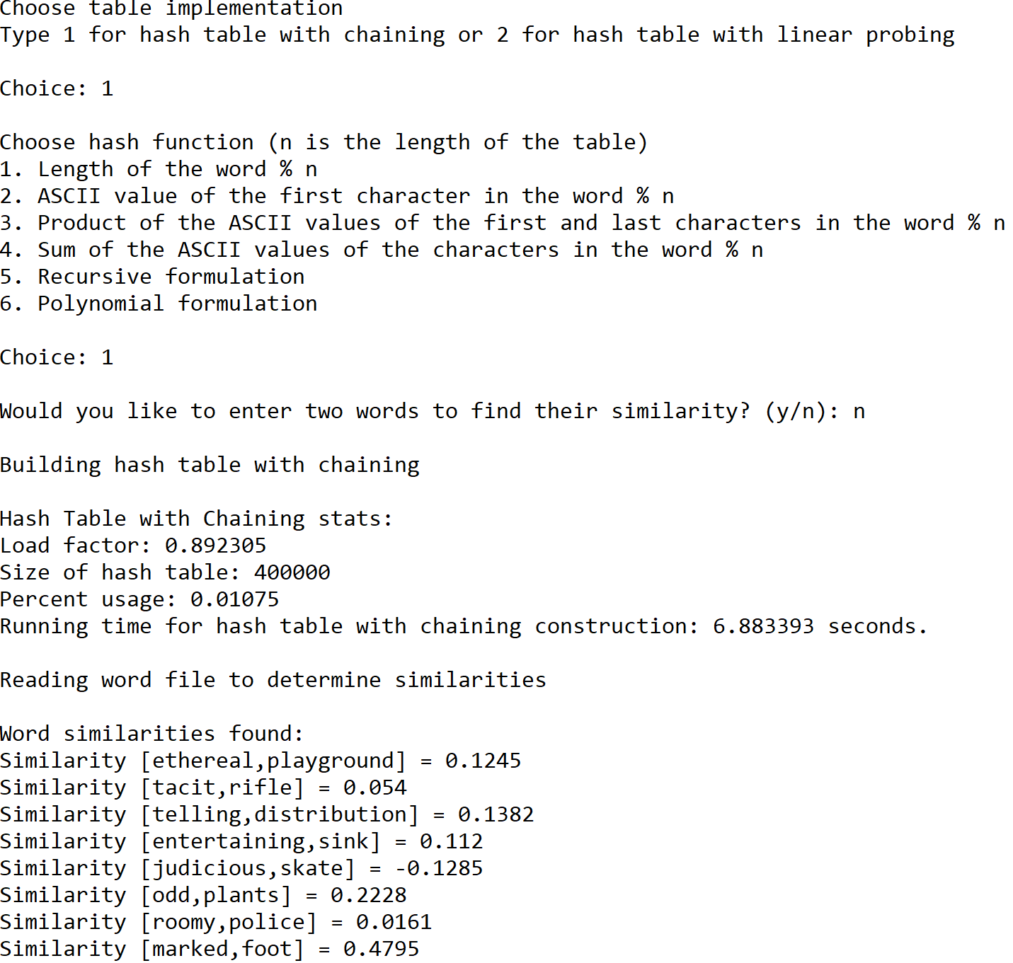

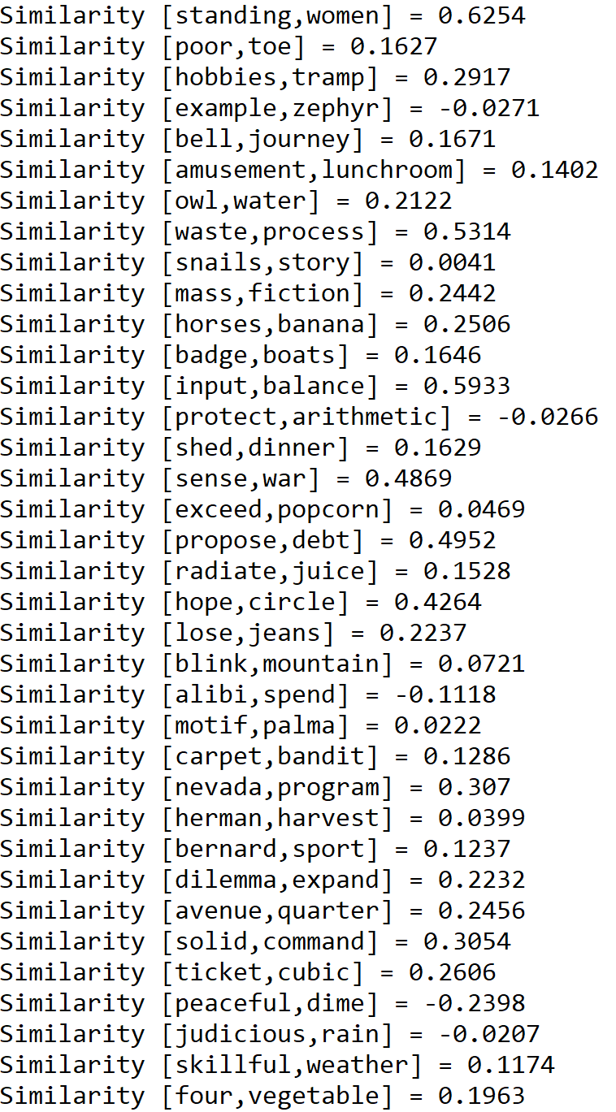

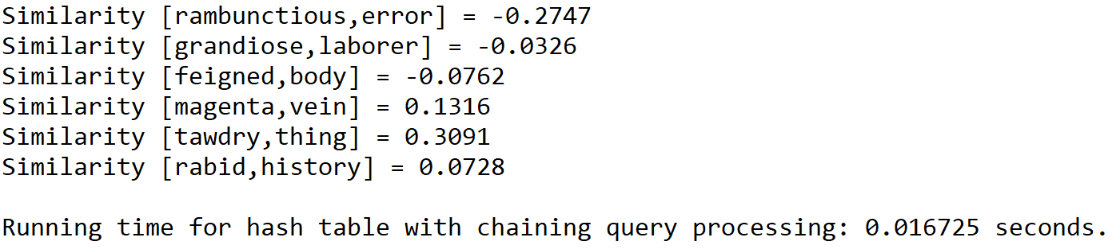

Case 2: Size of text file = 100

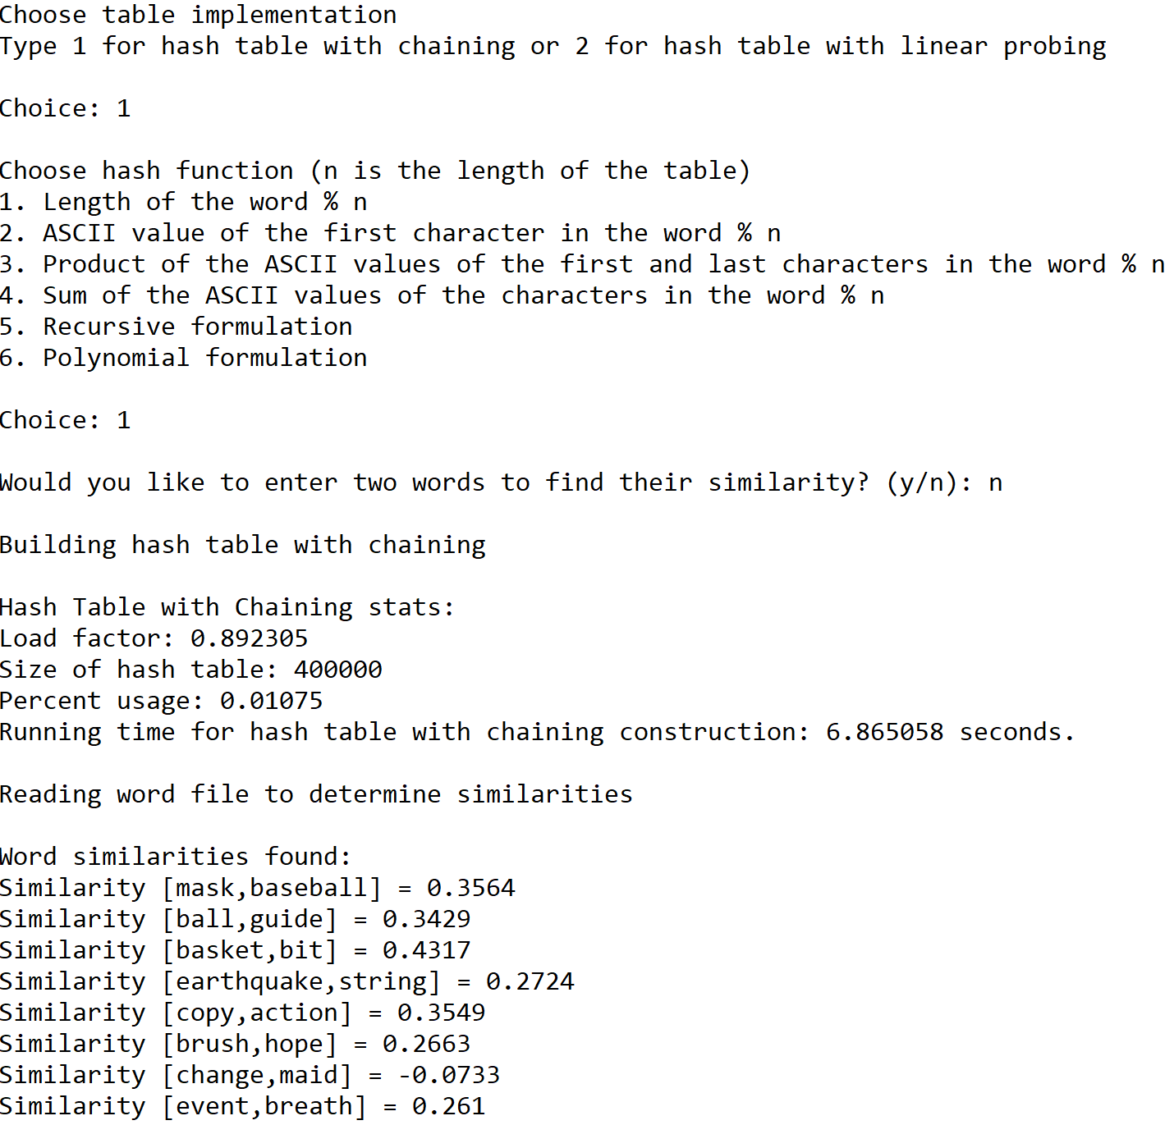

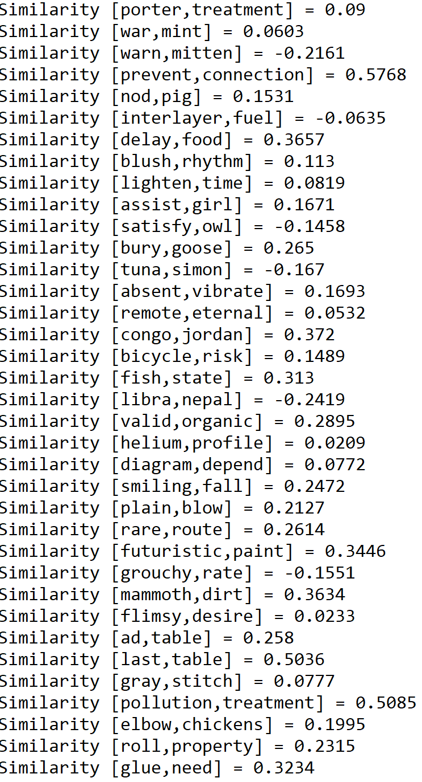

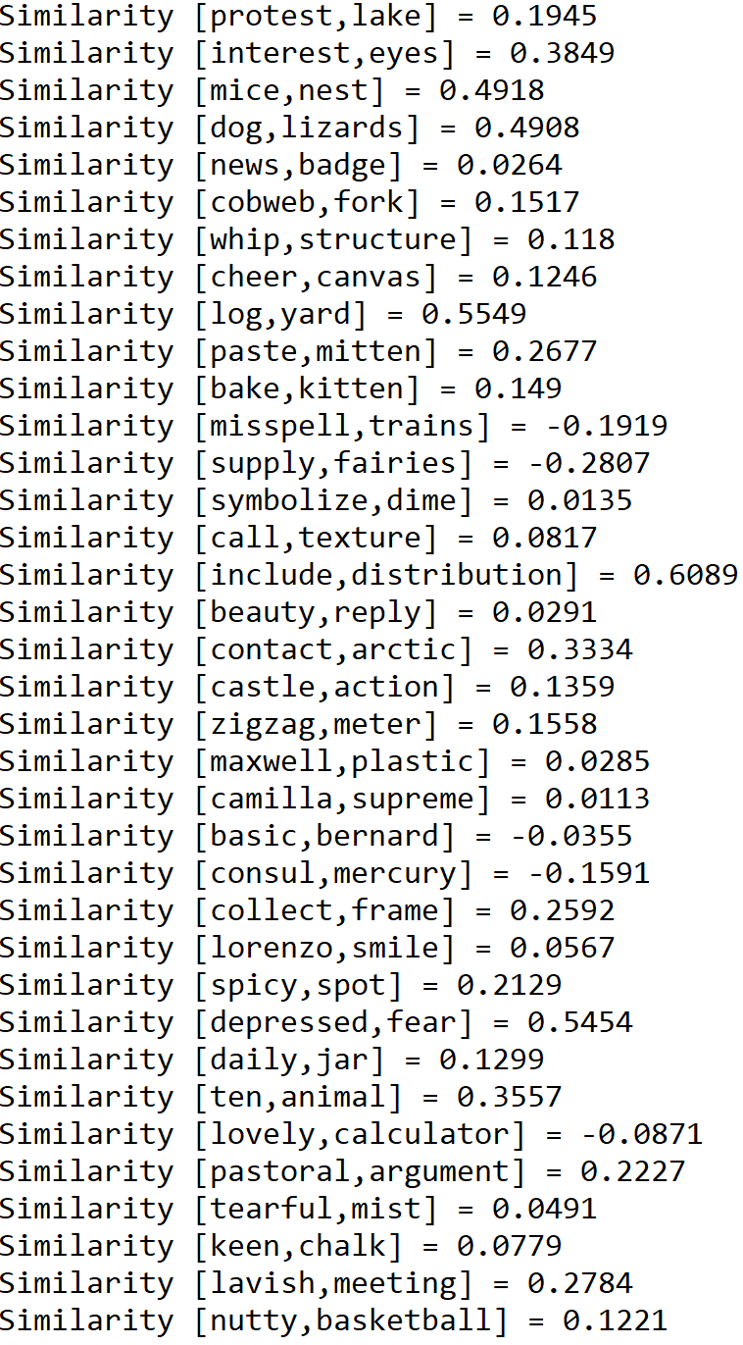

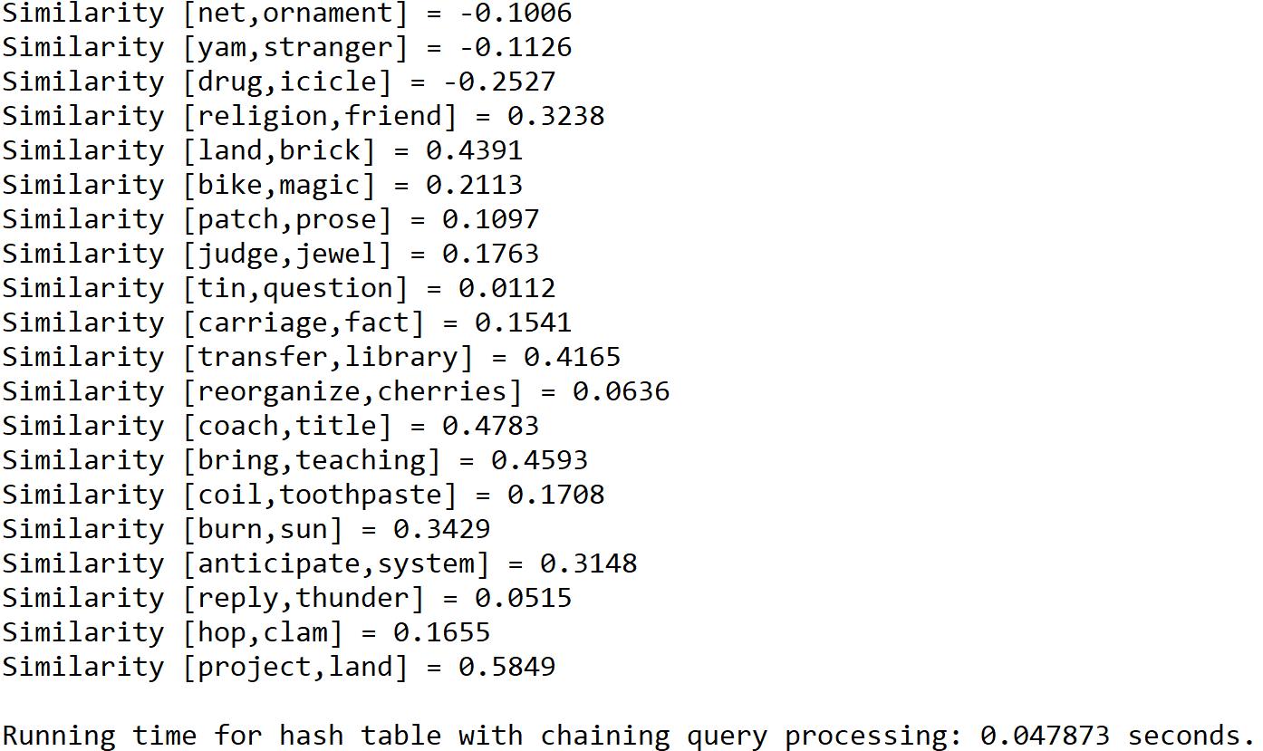

Case 3: Size of text file = 150

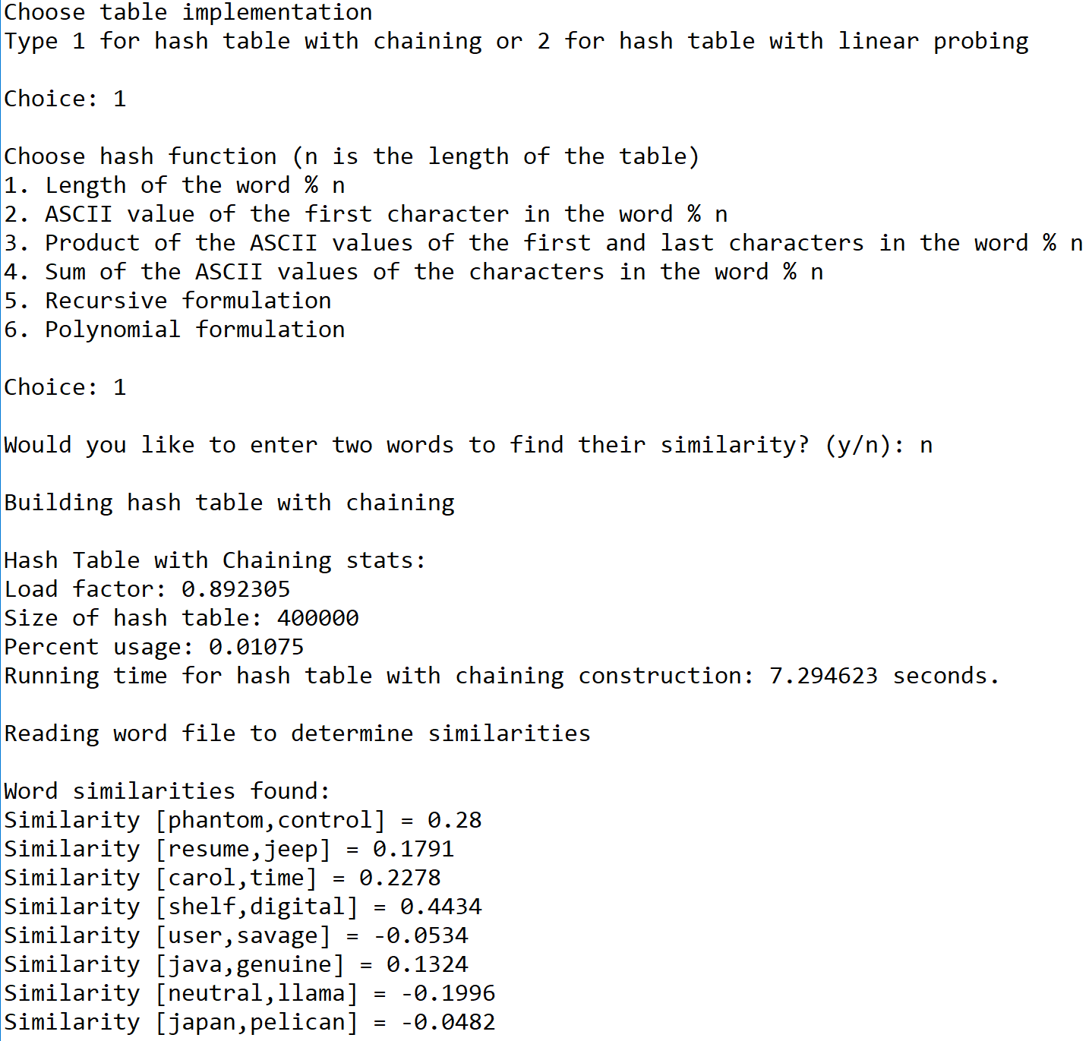

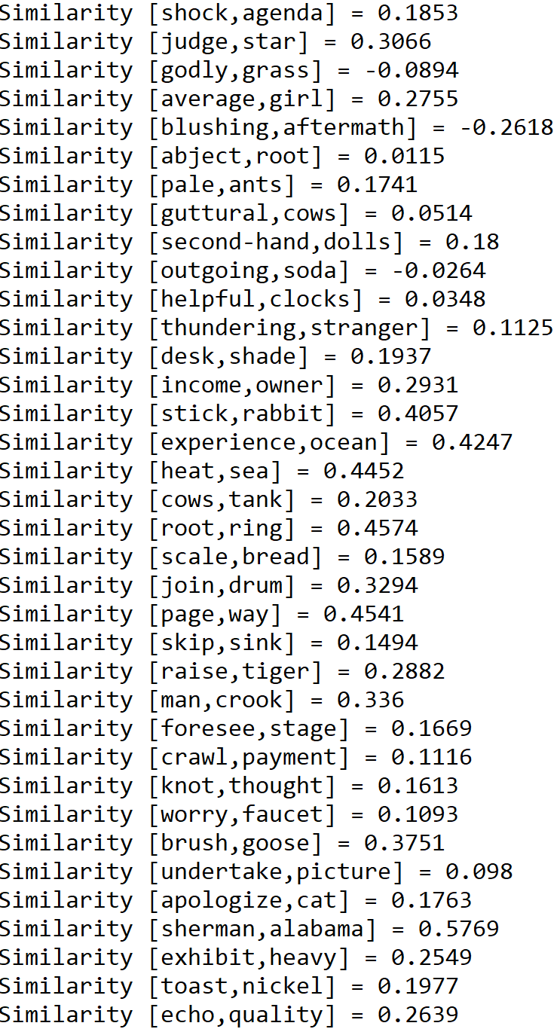

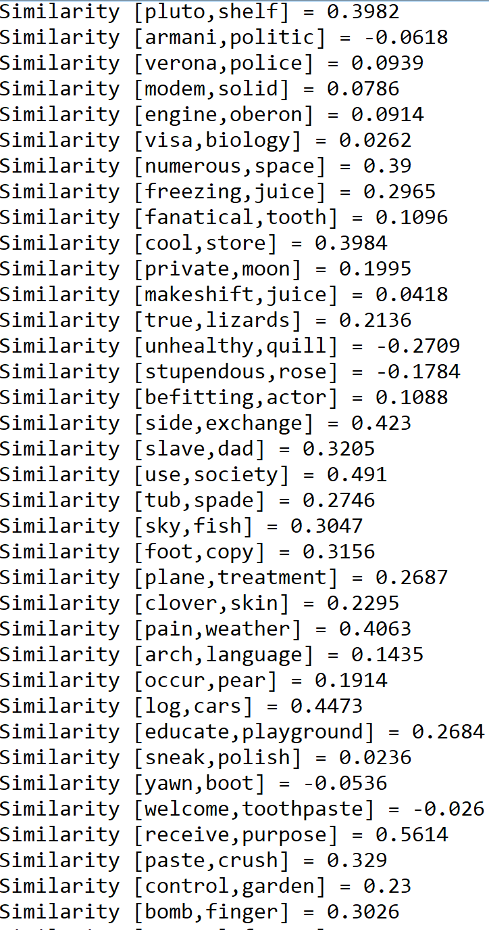

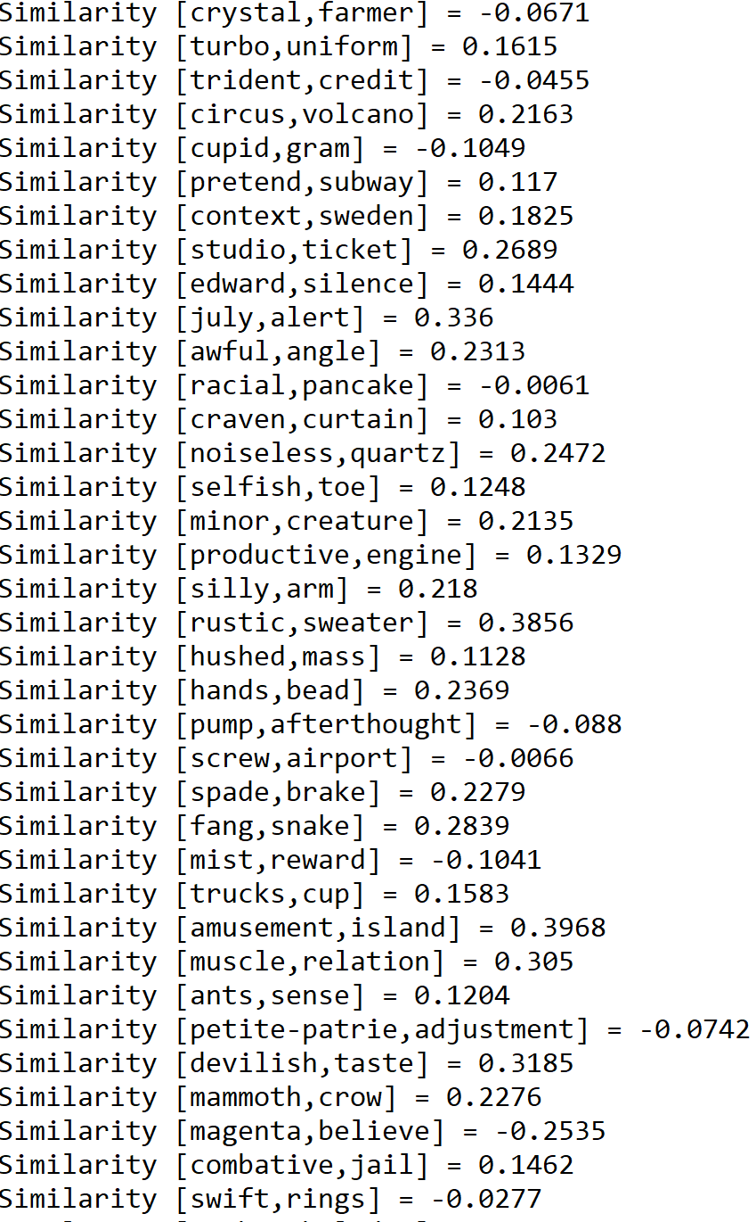

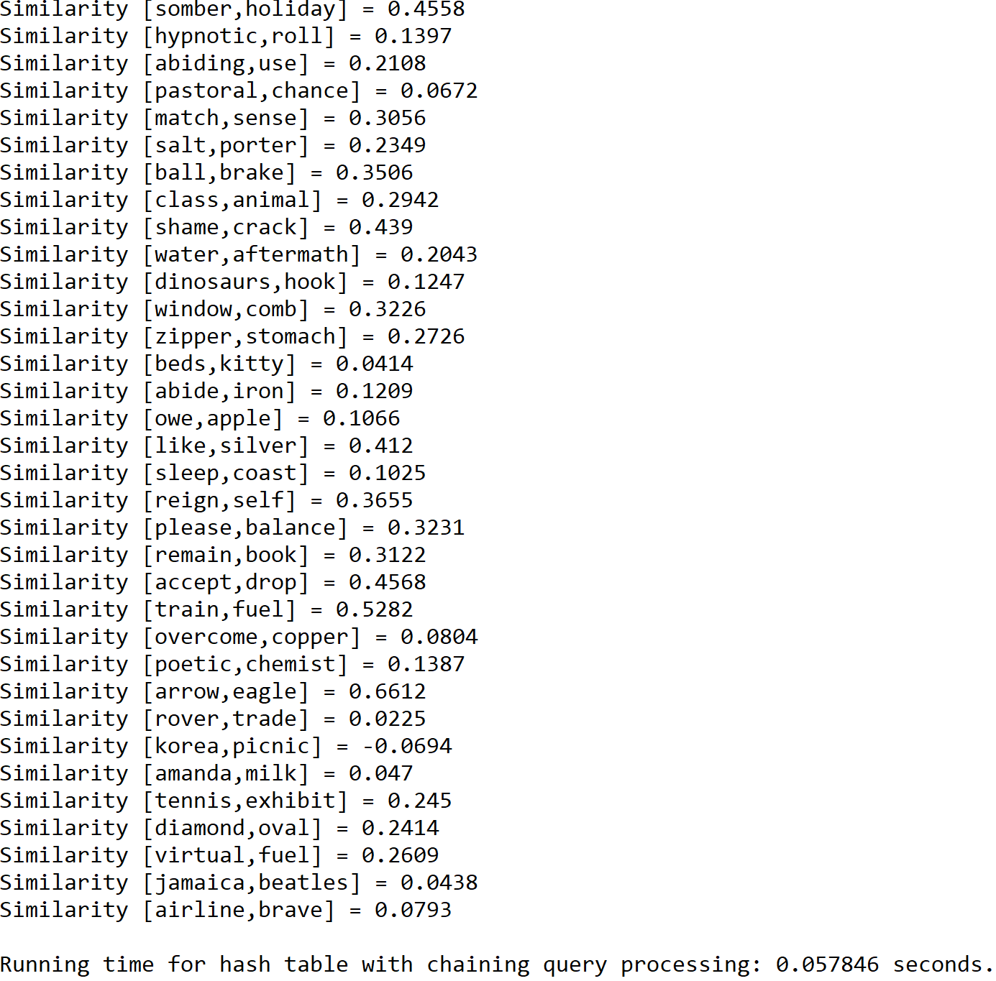

**Operation #2:**

For this operation, I will test text files of size 50, 100, and 150. The size of the hash table is determined by the total number of lines in the original “glove.6B.50d” text file.

Case 1: Size of text file = 50

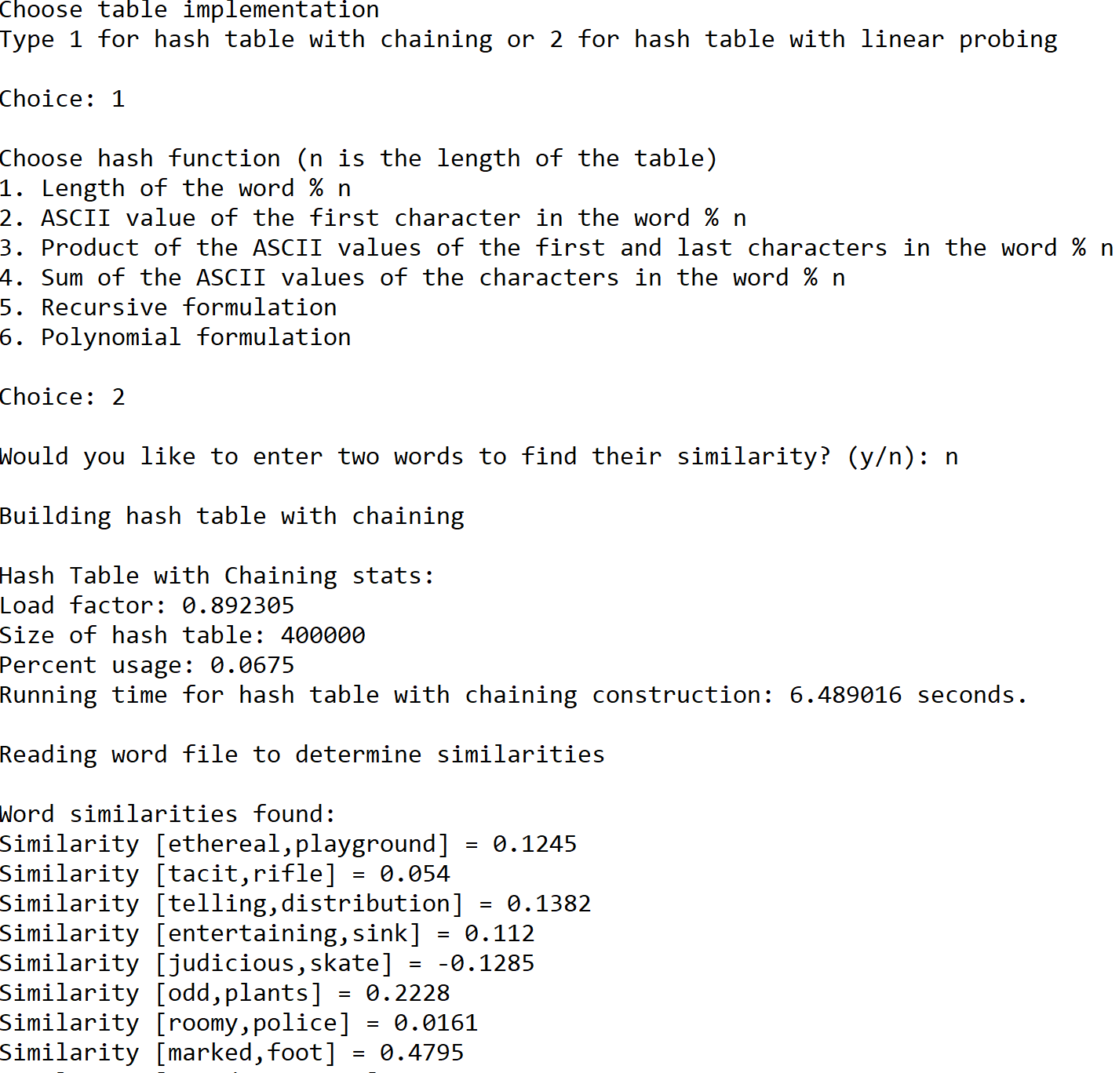



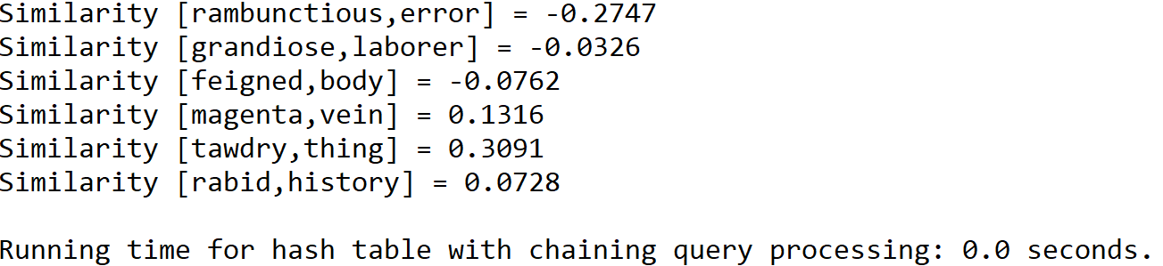

Case 2: Size of text file = 100

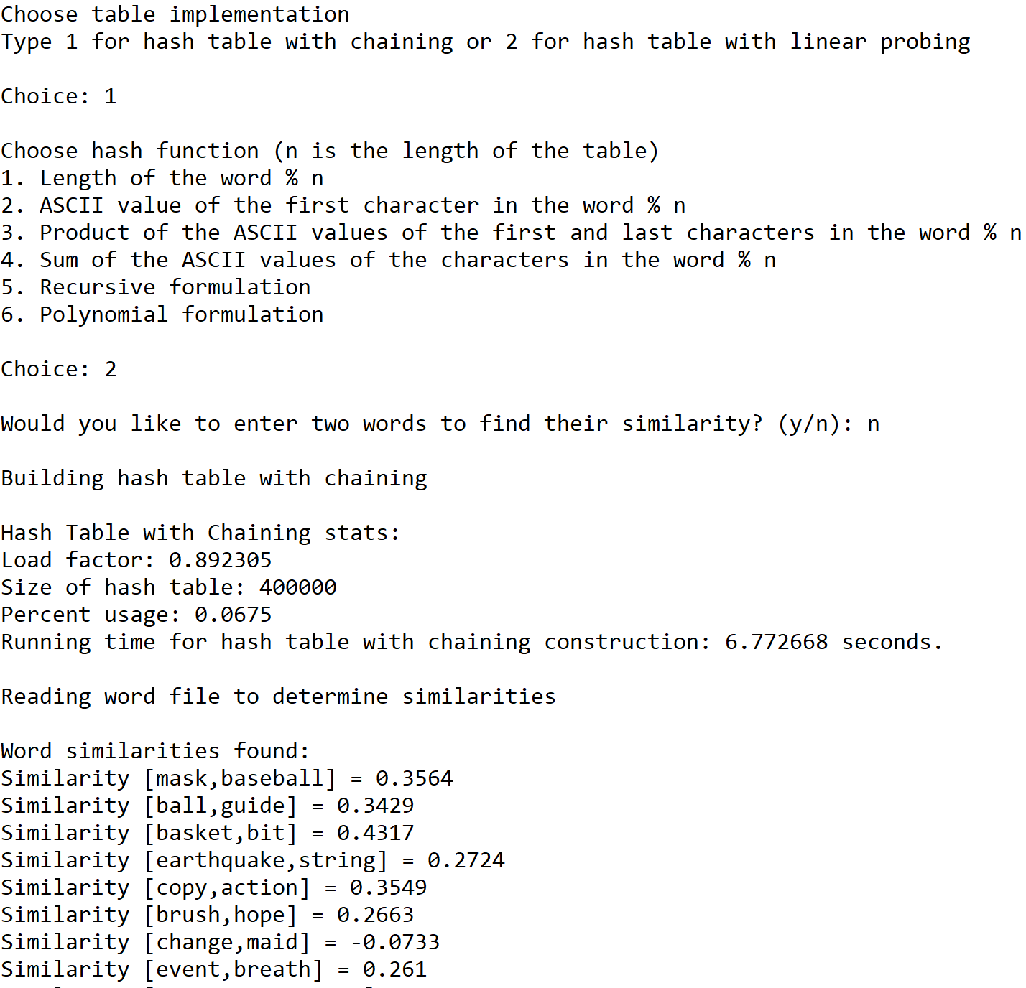





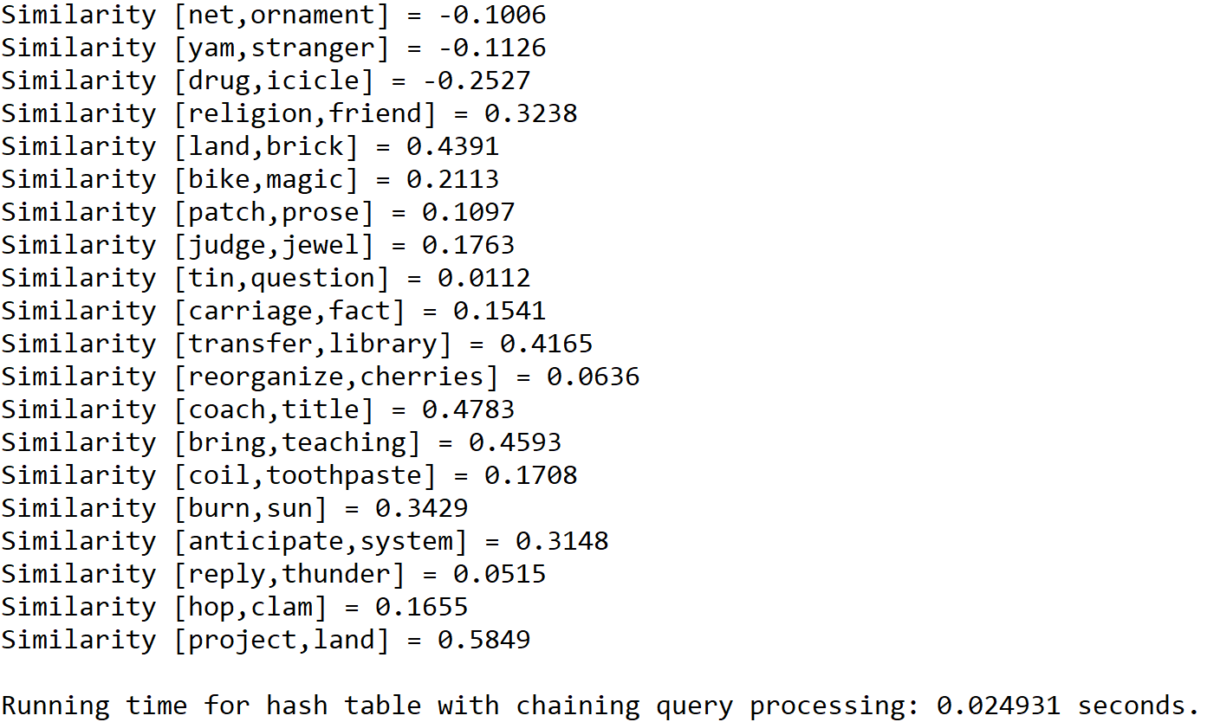

Case 3: Size of text file = 150

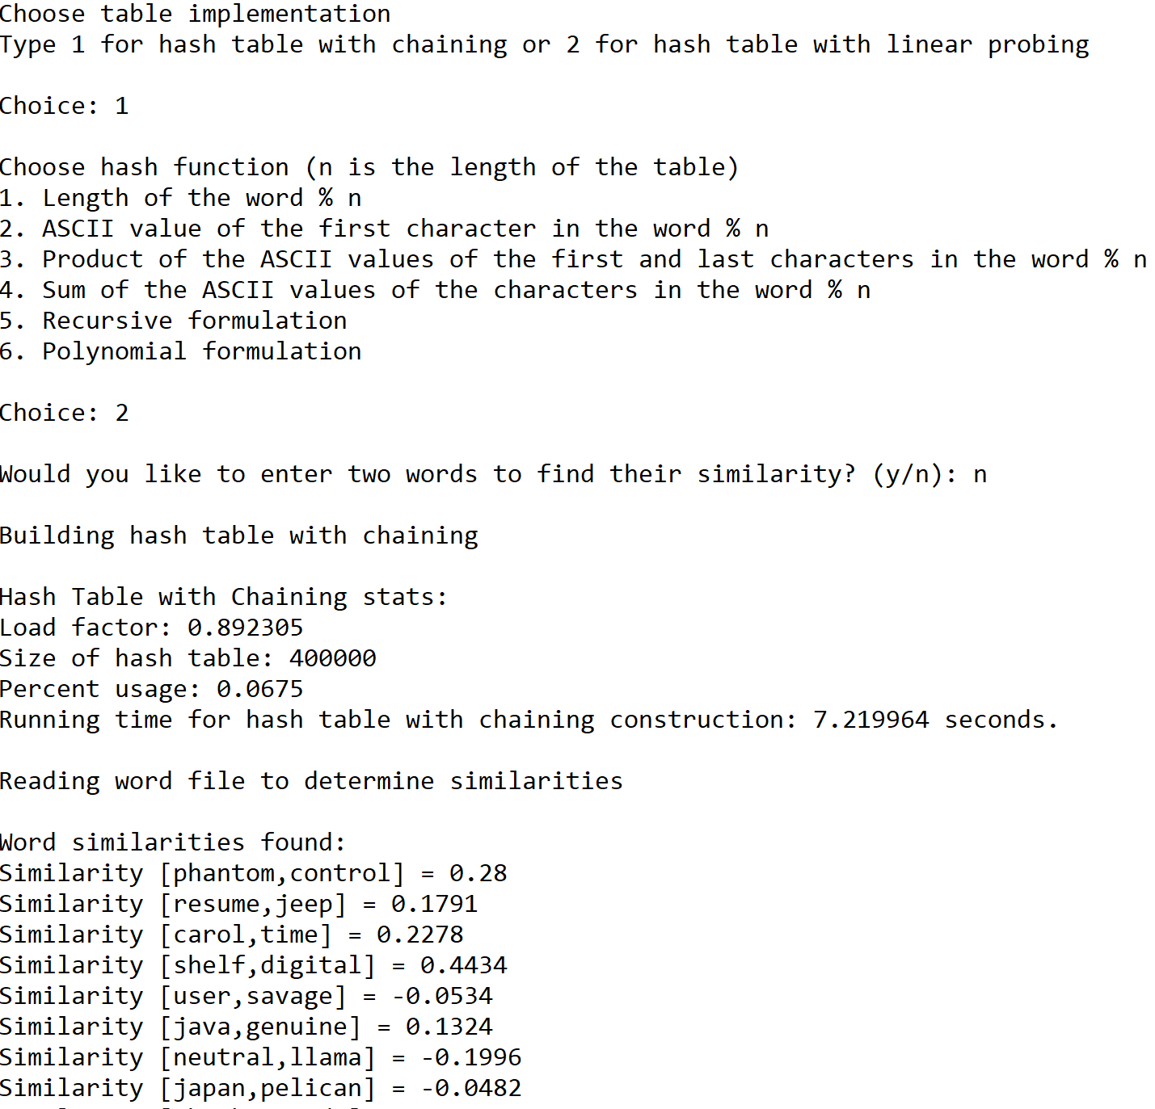





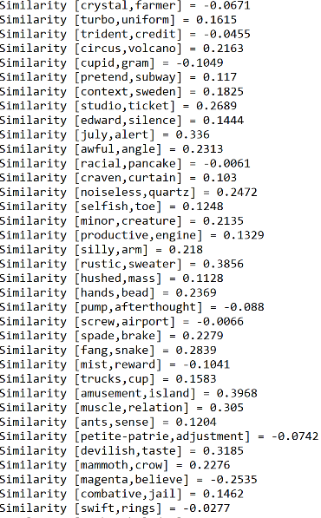  
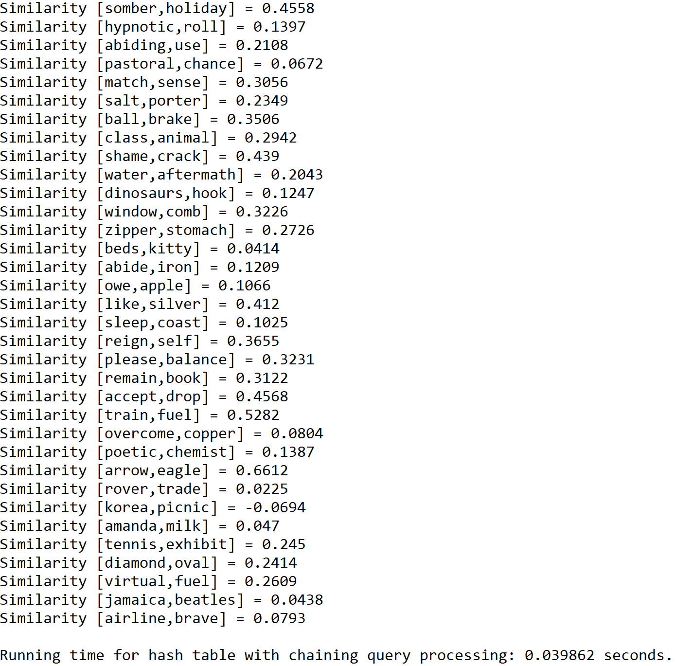

**Operation #3:**

For this operation, I will test text files of size 50, 100, and 150. The size of the hash table is determined by the total number of lines in the original “glove.6B.50d” text file.

Case 1: Size of text file = 50

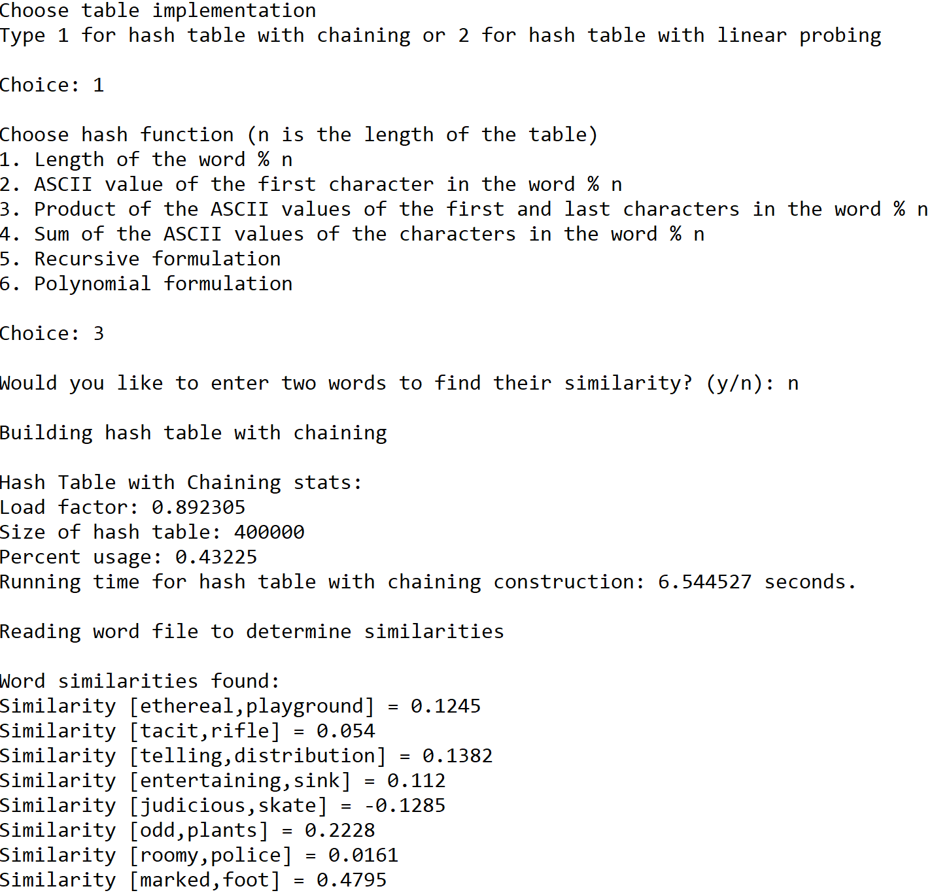





Case 2: Size of text file = 100

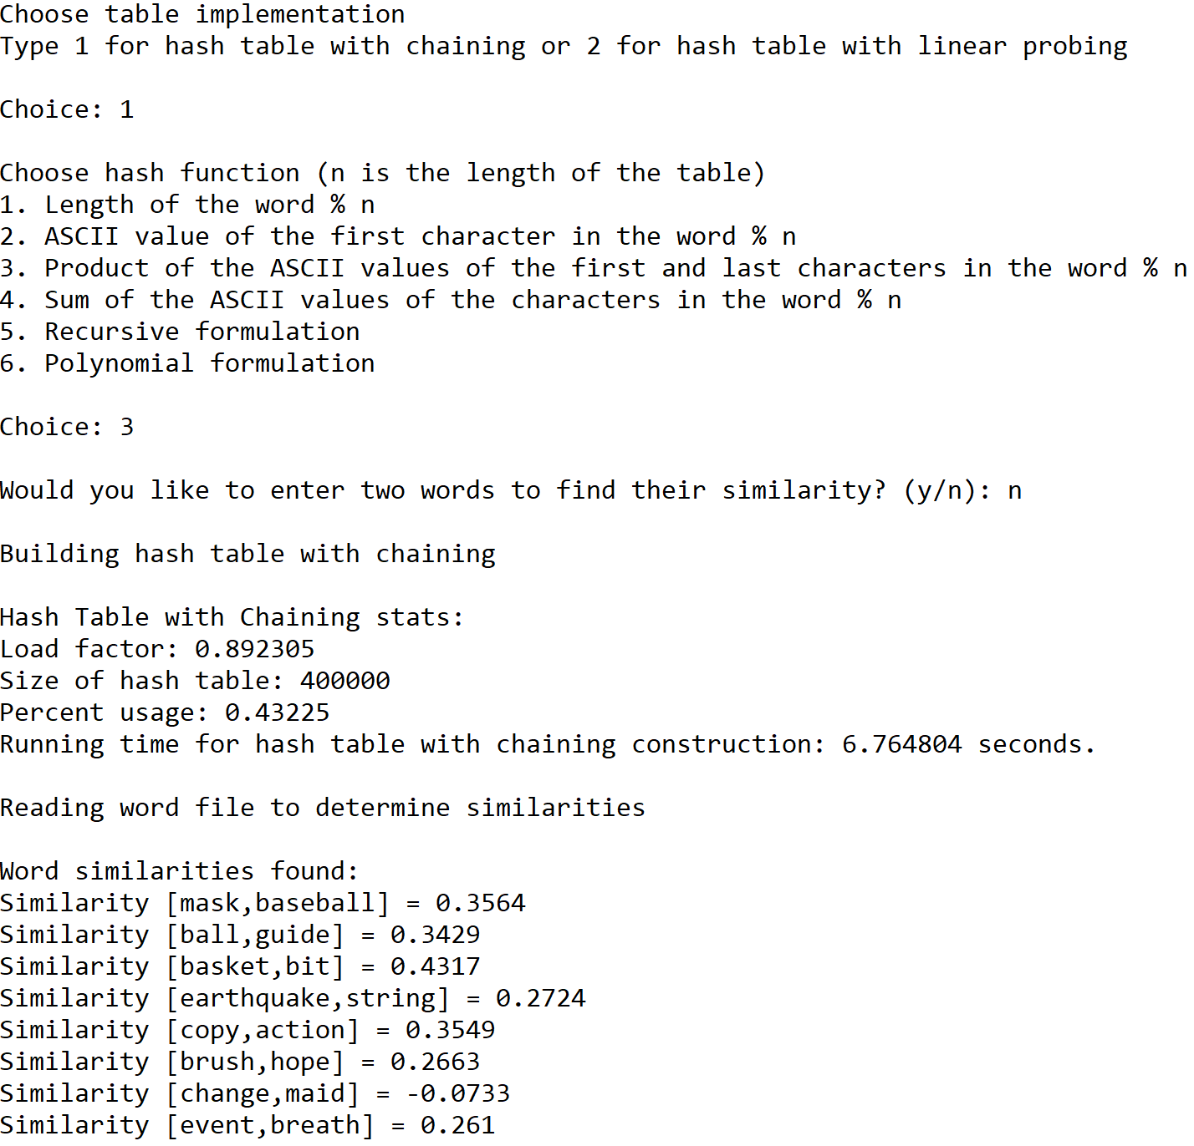





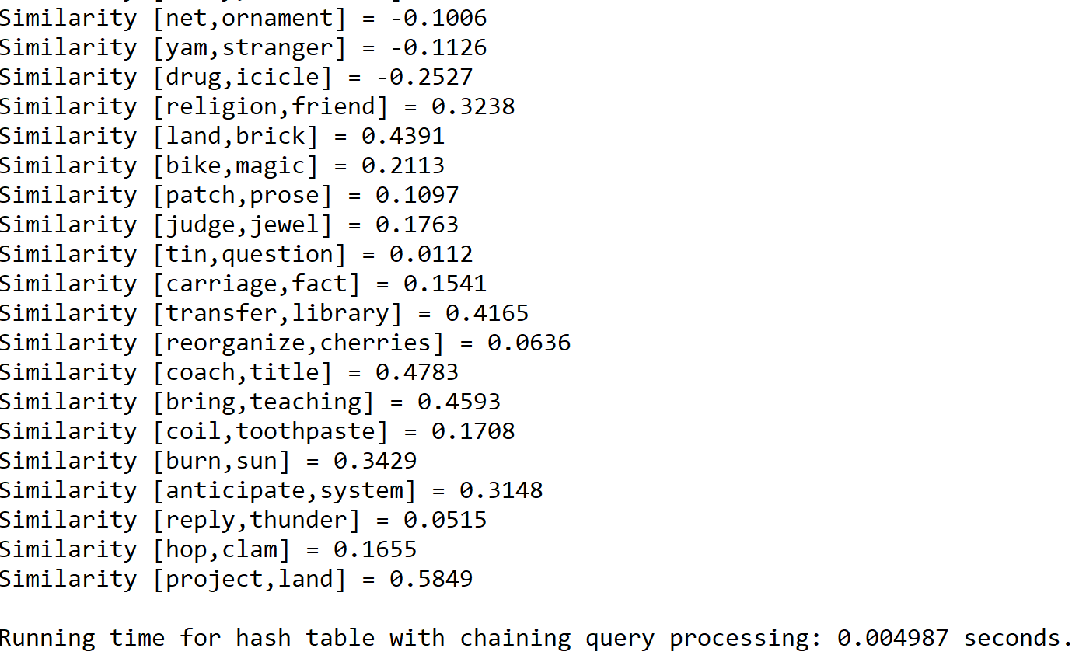

Case 3: Size of text file = 150

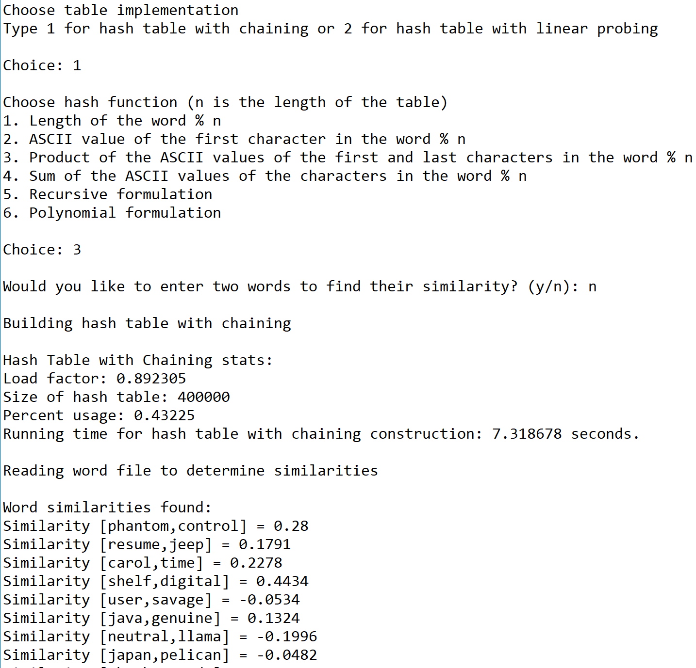







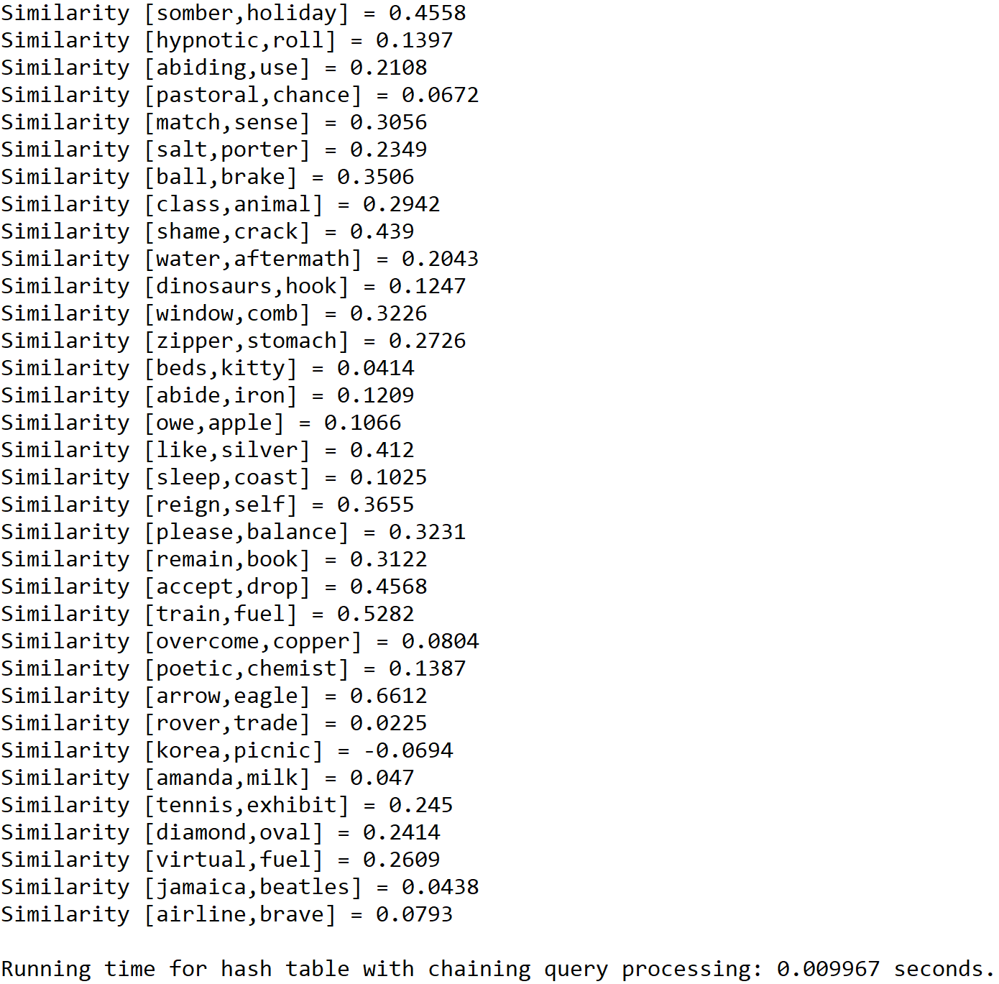

**Operation #4:**

For this operation, I will test text files of size 50, 100, and 150. The size of the hash table is determined by the total number of lines in the original “glove.6B.50d” text file.

Case 1: Size of text file = 50

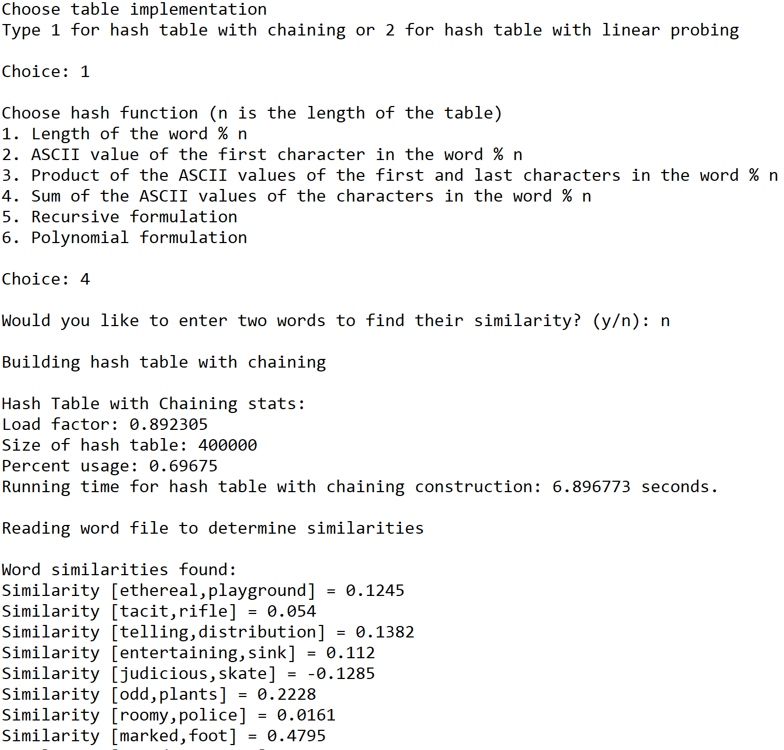



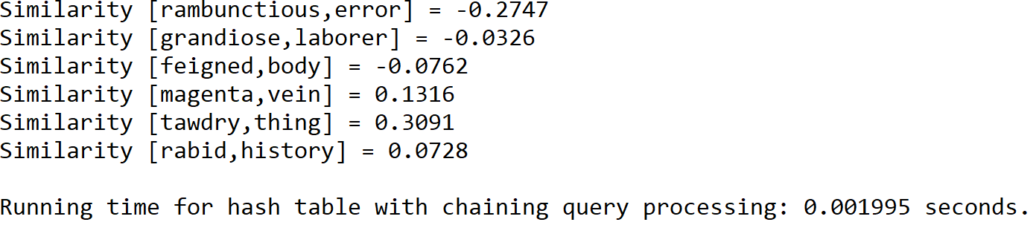

Case 2: Size of text file = 100

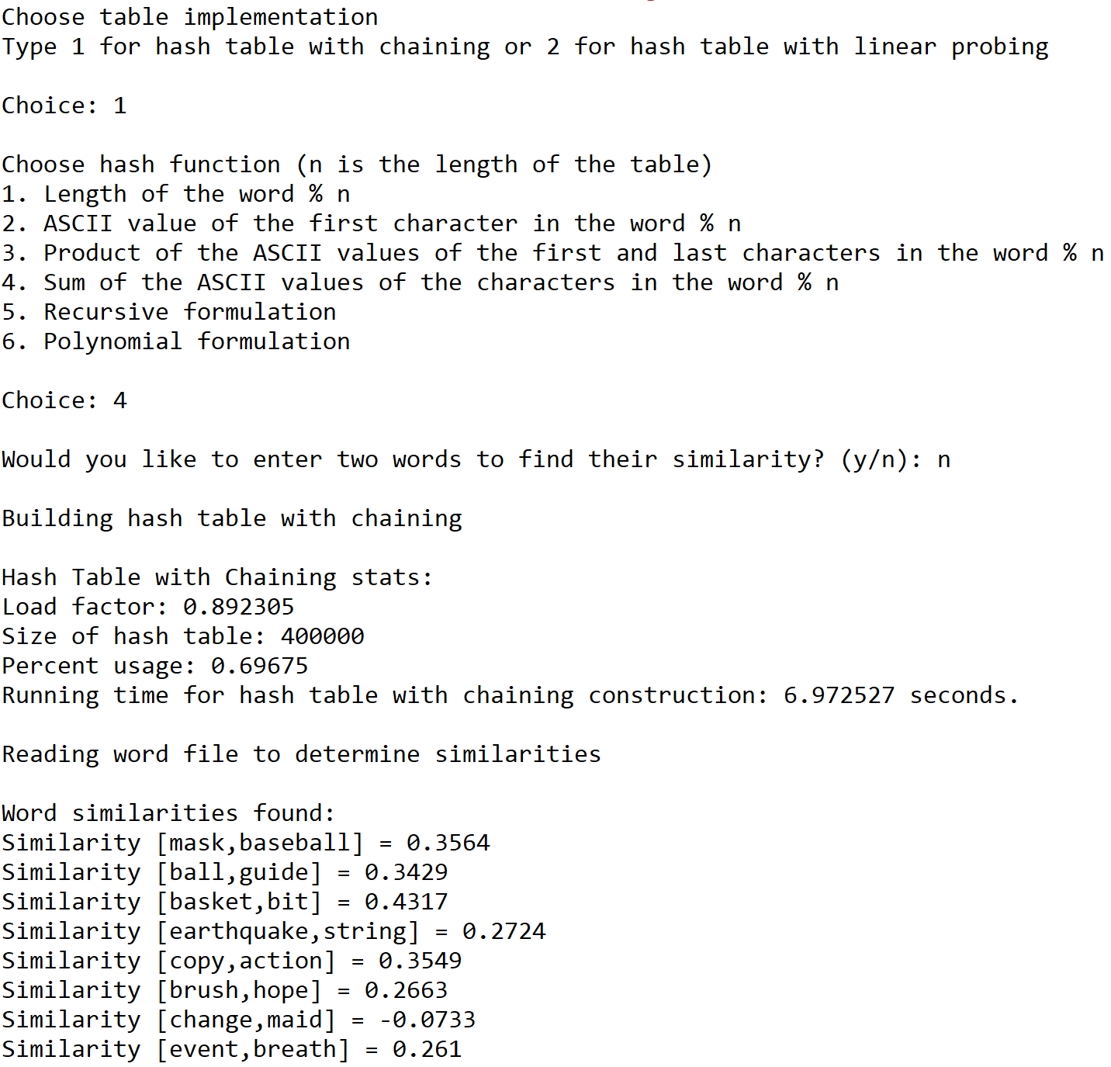





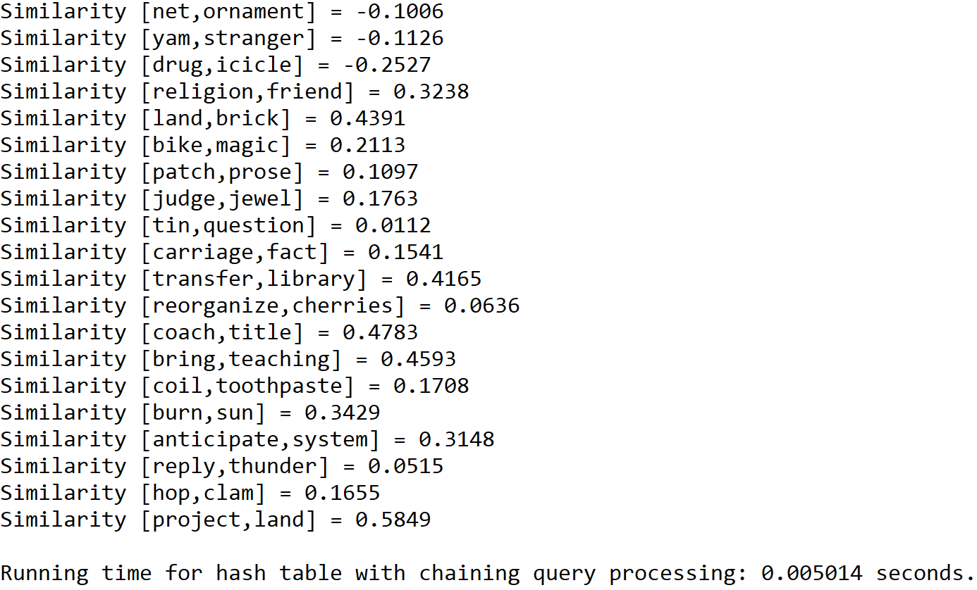

Case 3: Size of text file = 150

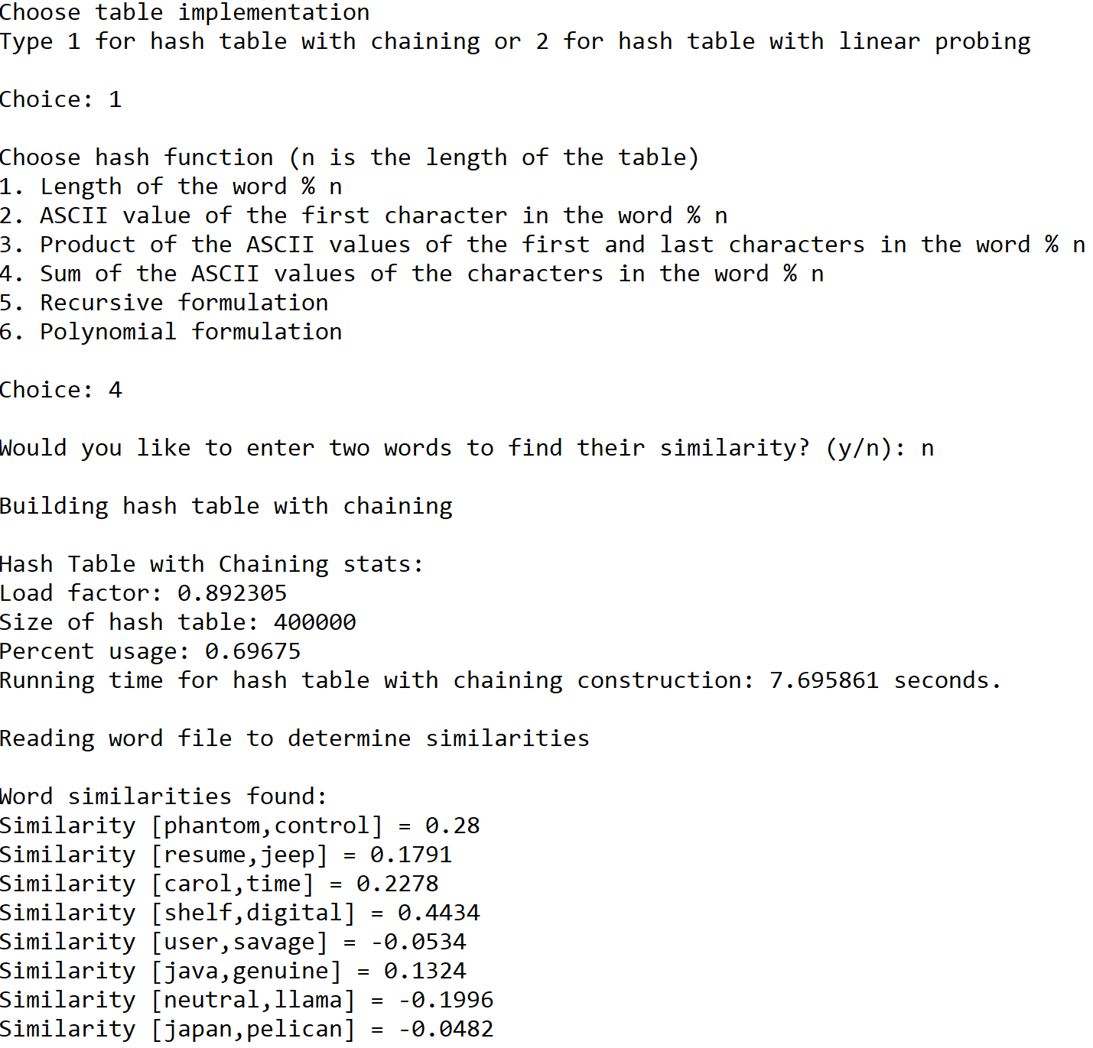







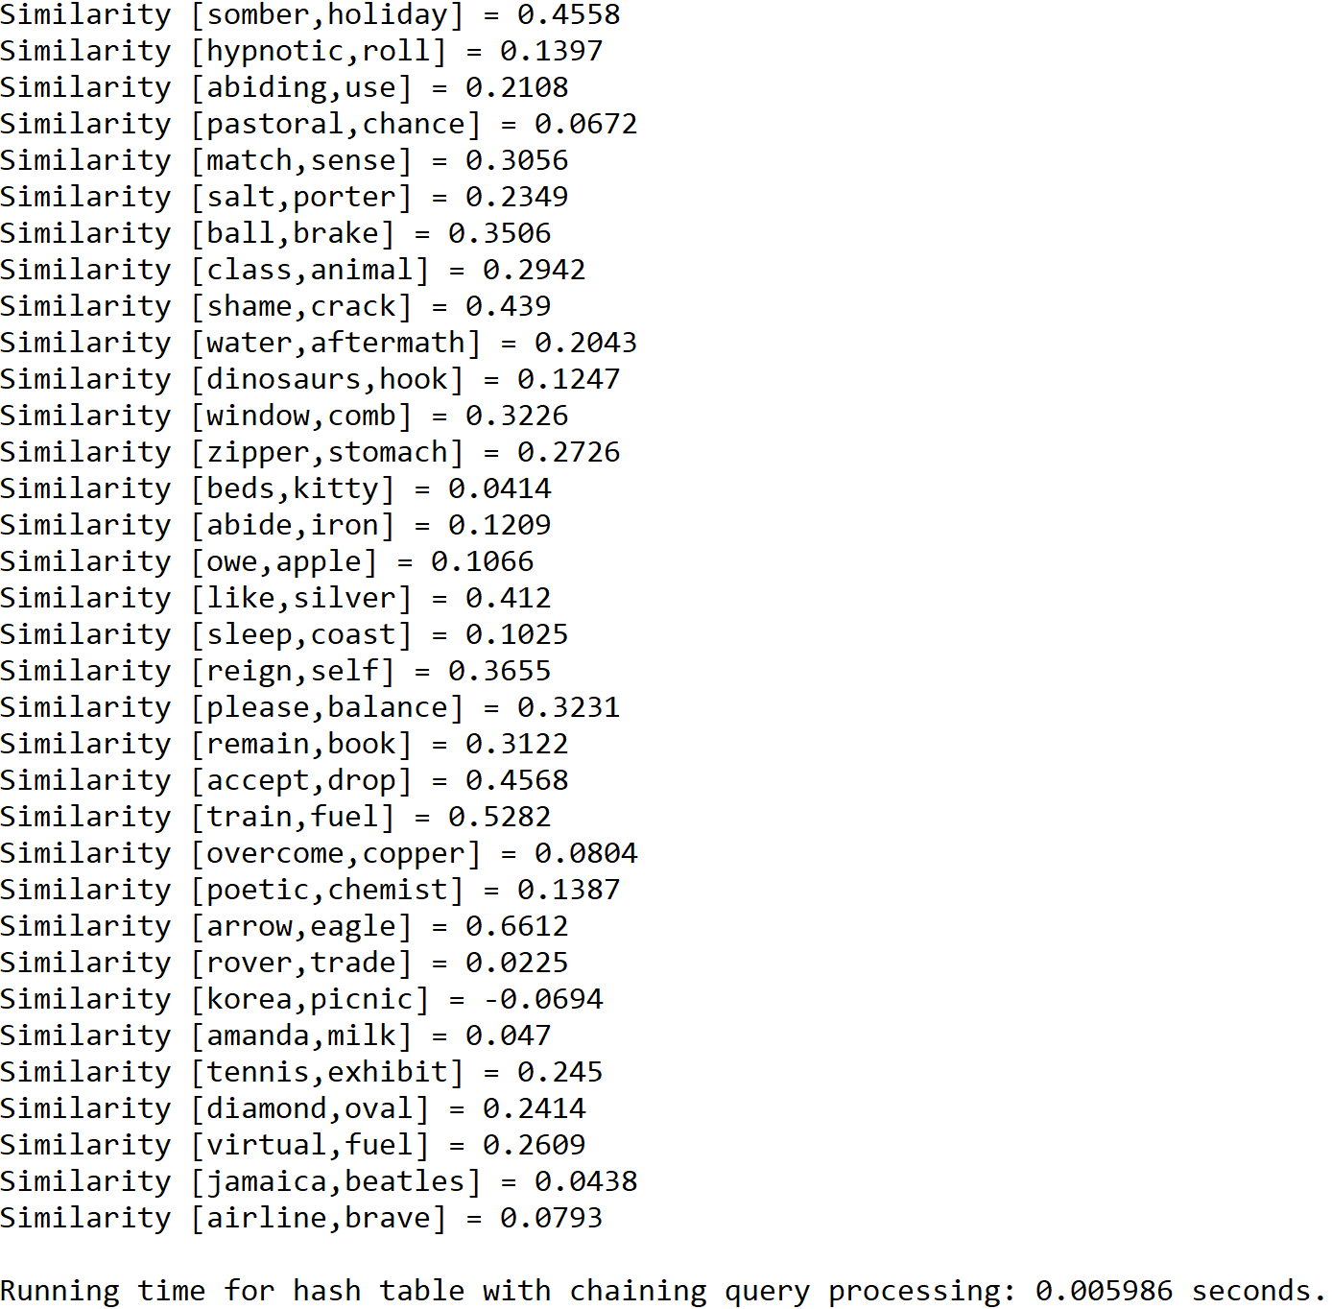

**Operation #5:**

For this operation, I will test text files of size 50, 100, and 150. The size of the hash table is determined by the total number of lines in the original “glove.6B.50d” text file.

Case 1: Size of text file = 50

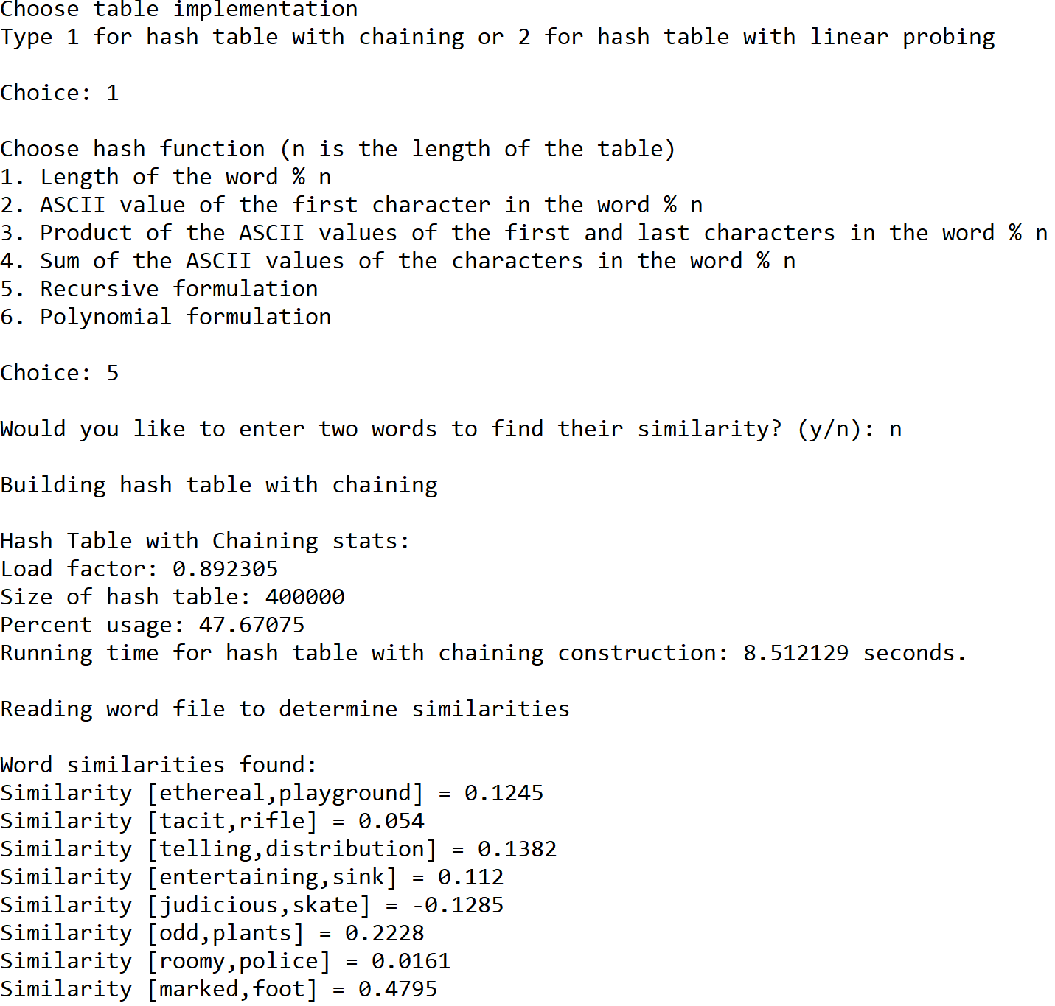



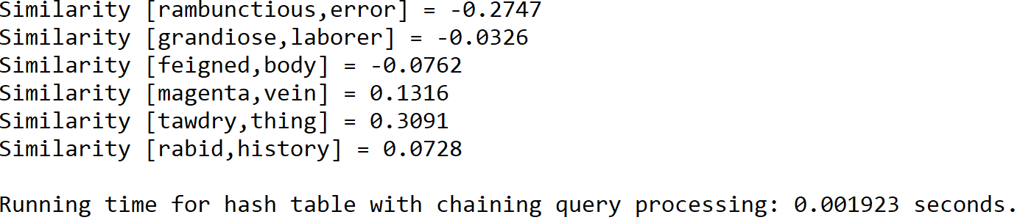

Case 2: Size of text file = 100

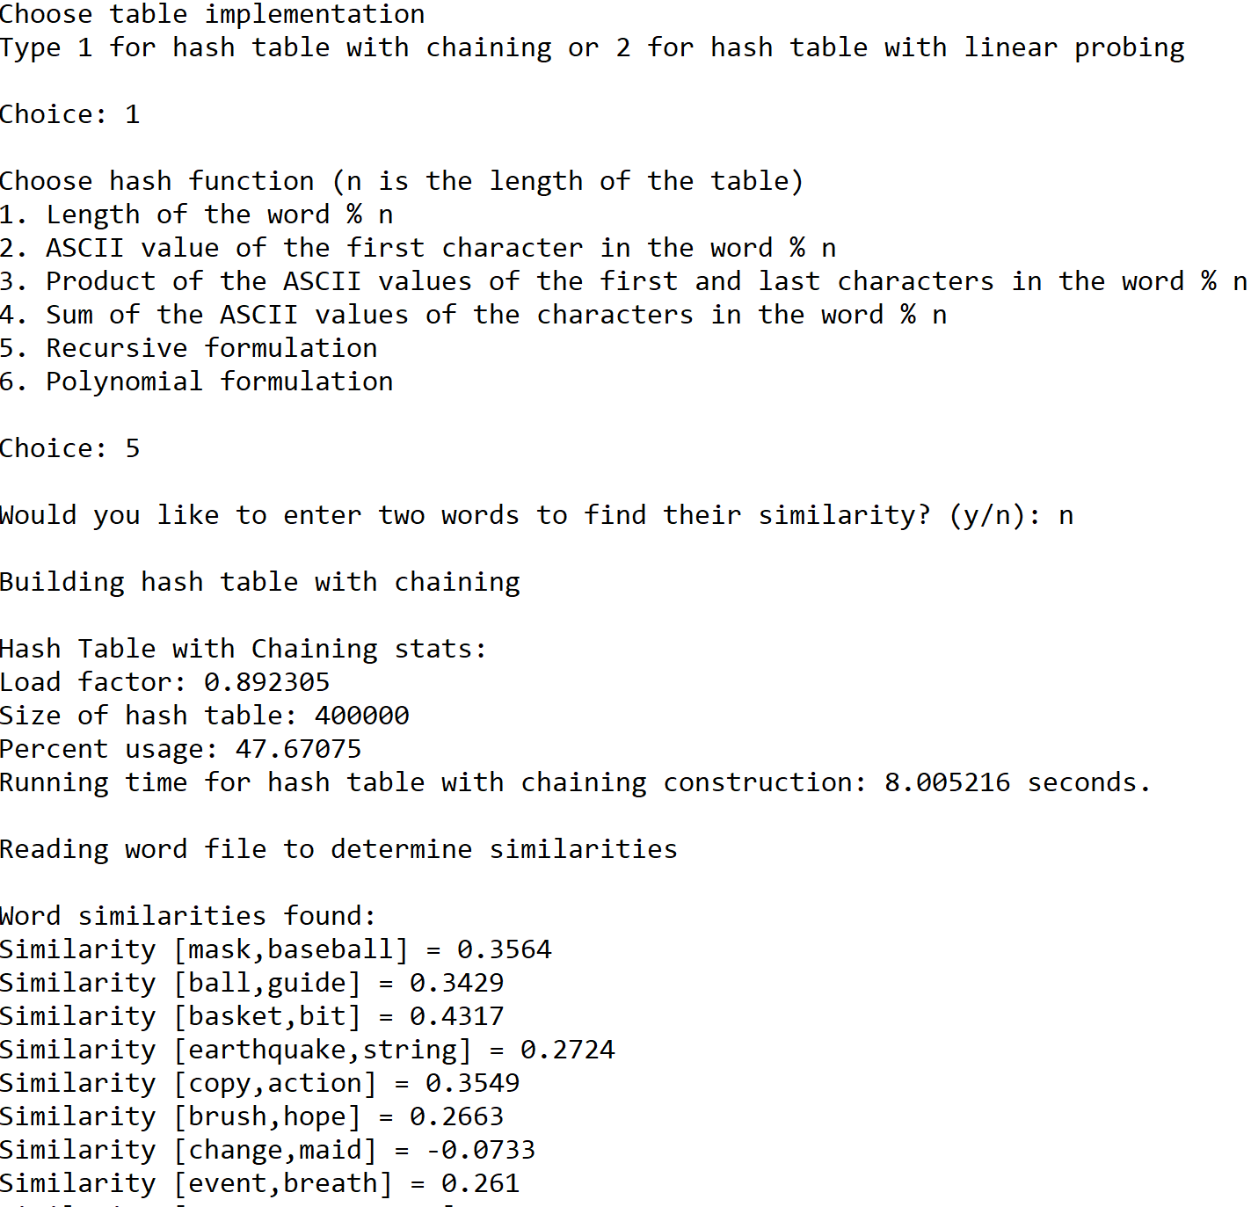





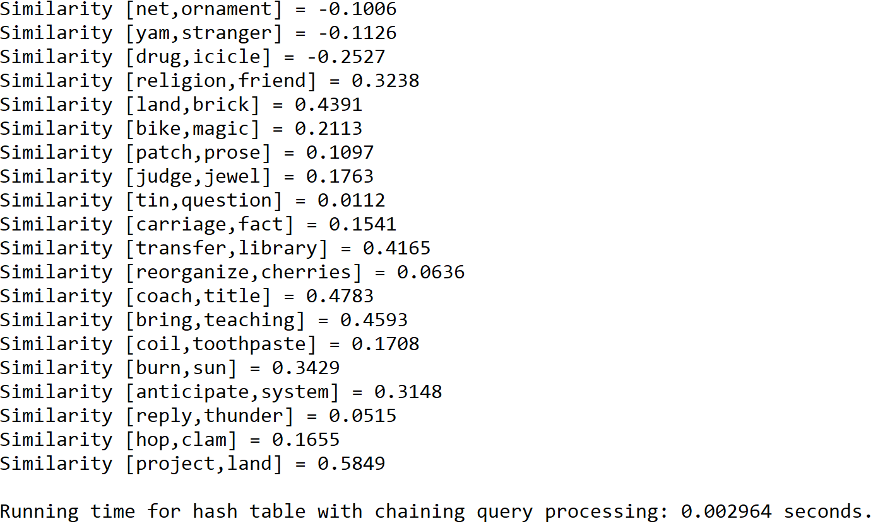

Case 3: Size of text file = 150

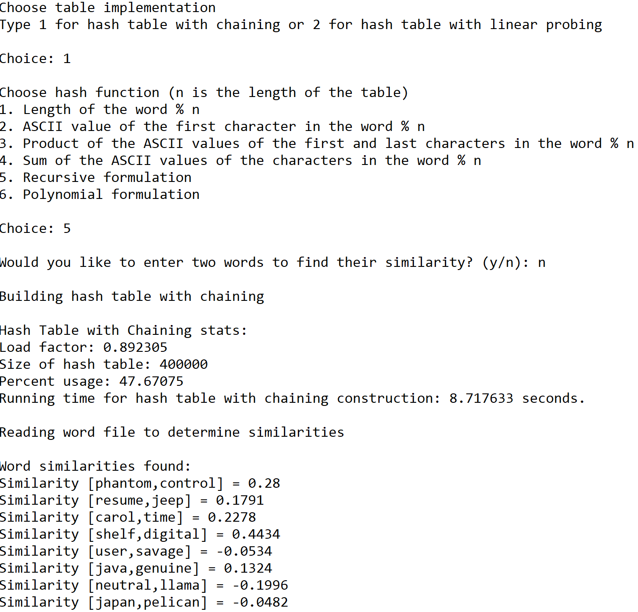







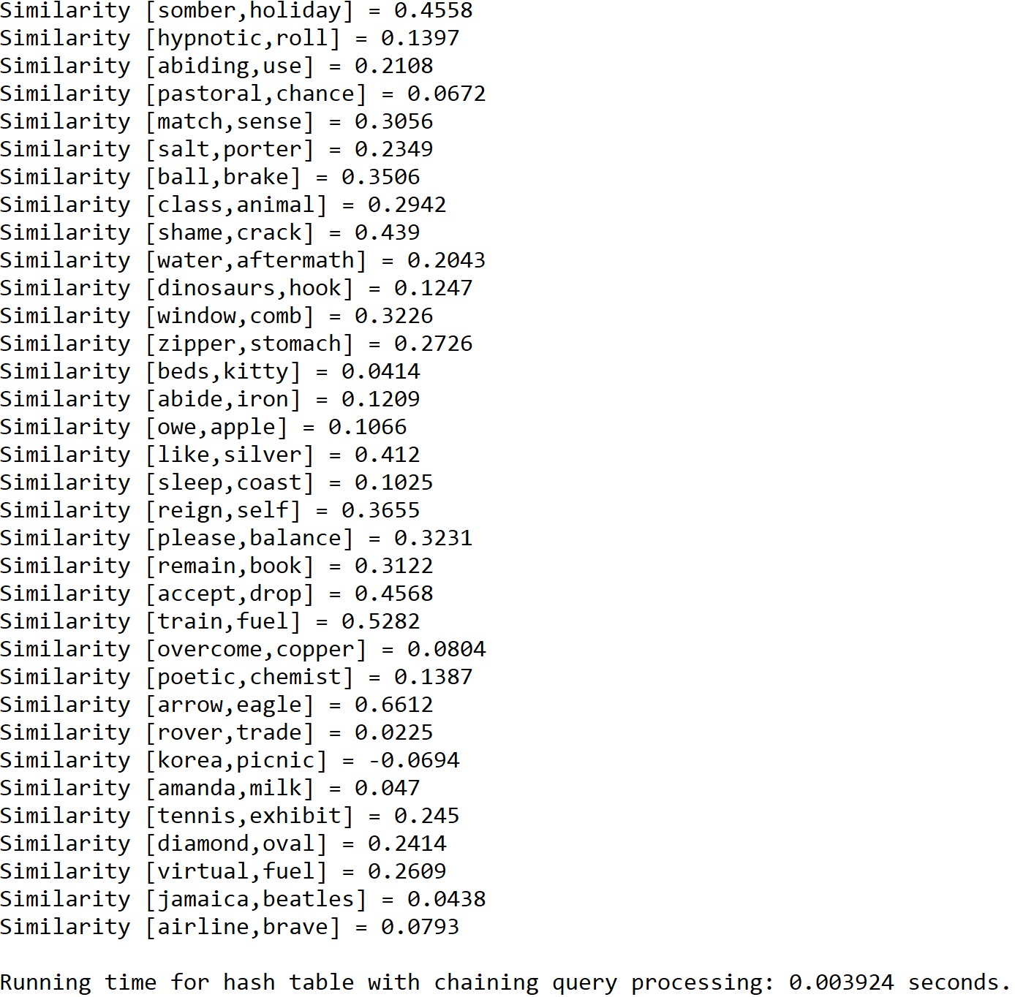

**Operation #6:**

For this operation, I will test text files of size 50, 100, and 150. The size of the hash table is determined by the total number of lines in the original “glove.6B.50d” text file.

Case 1: Size of text file = 50

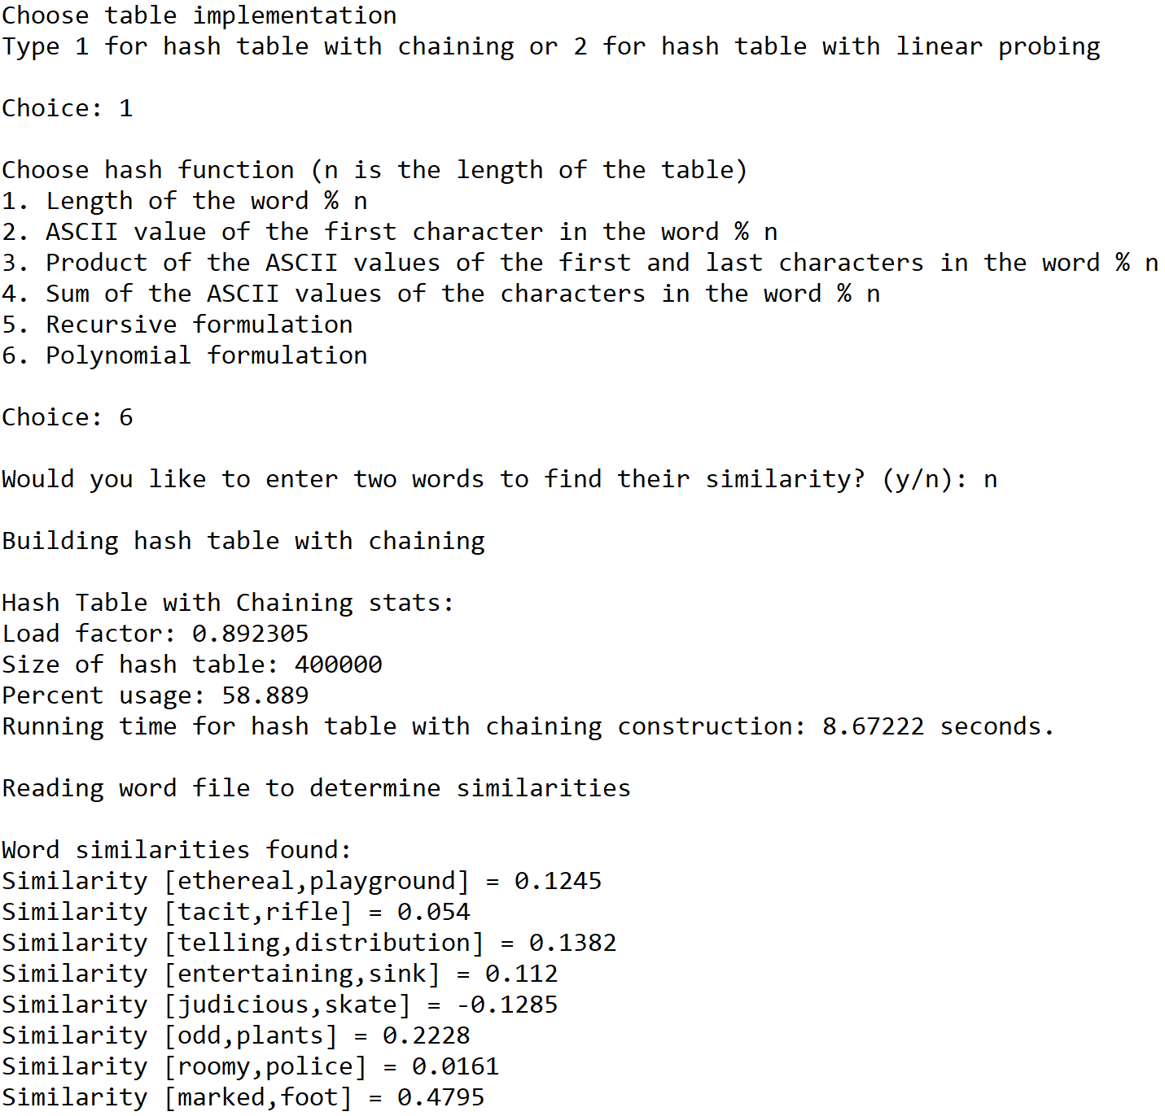



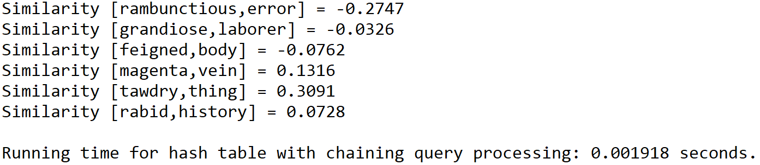

Case 2: Size of text file = 100

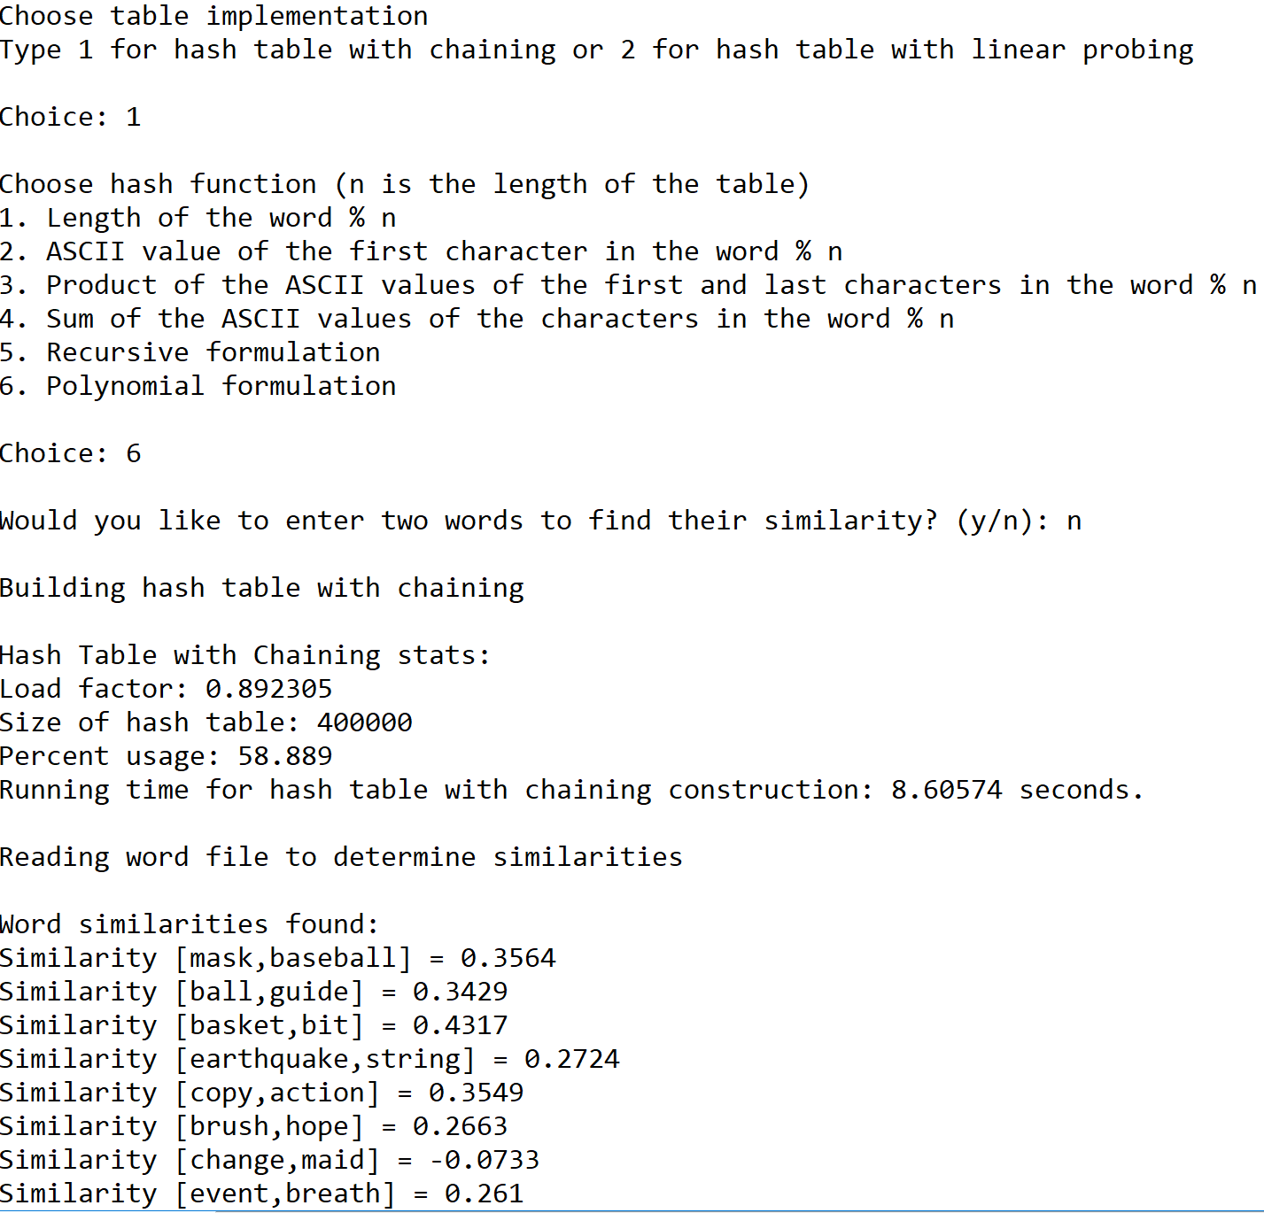





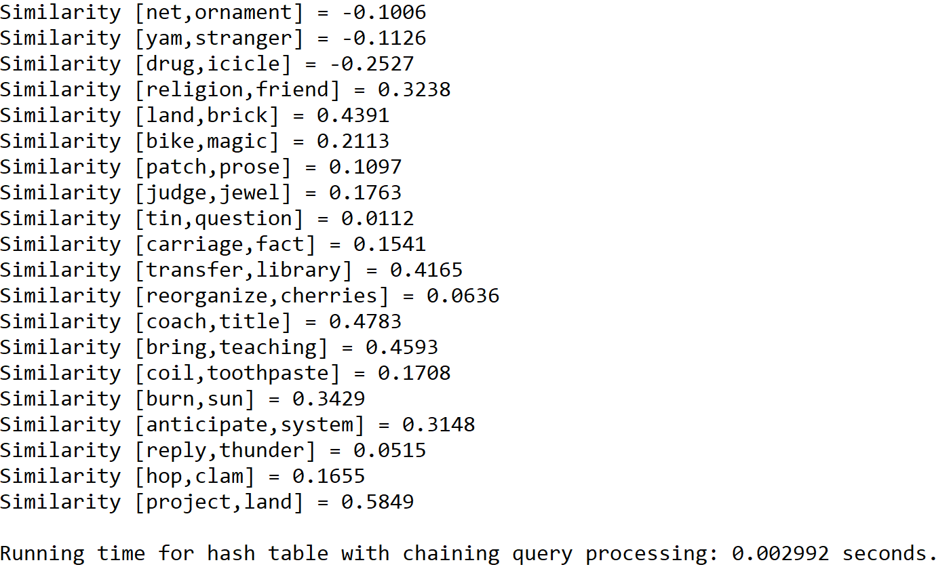

Case 3: Size of text file = 150

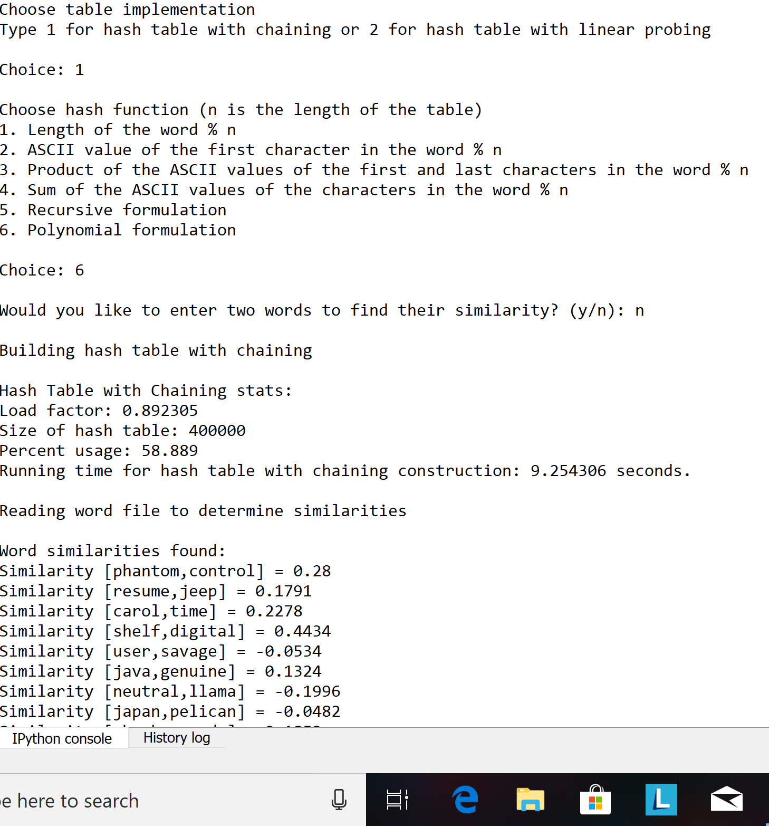







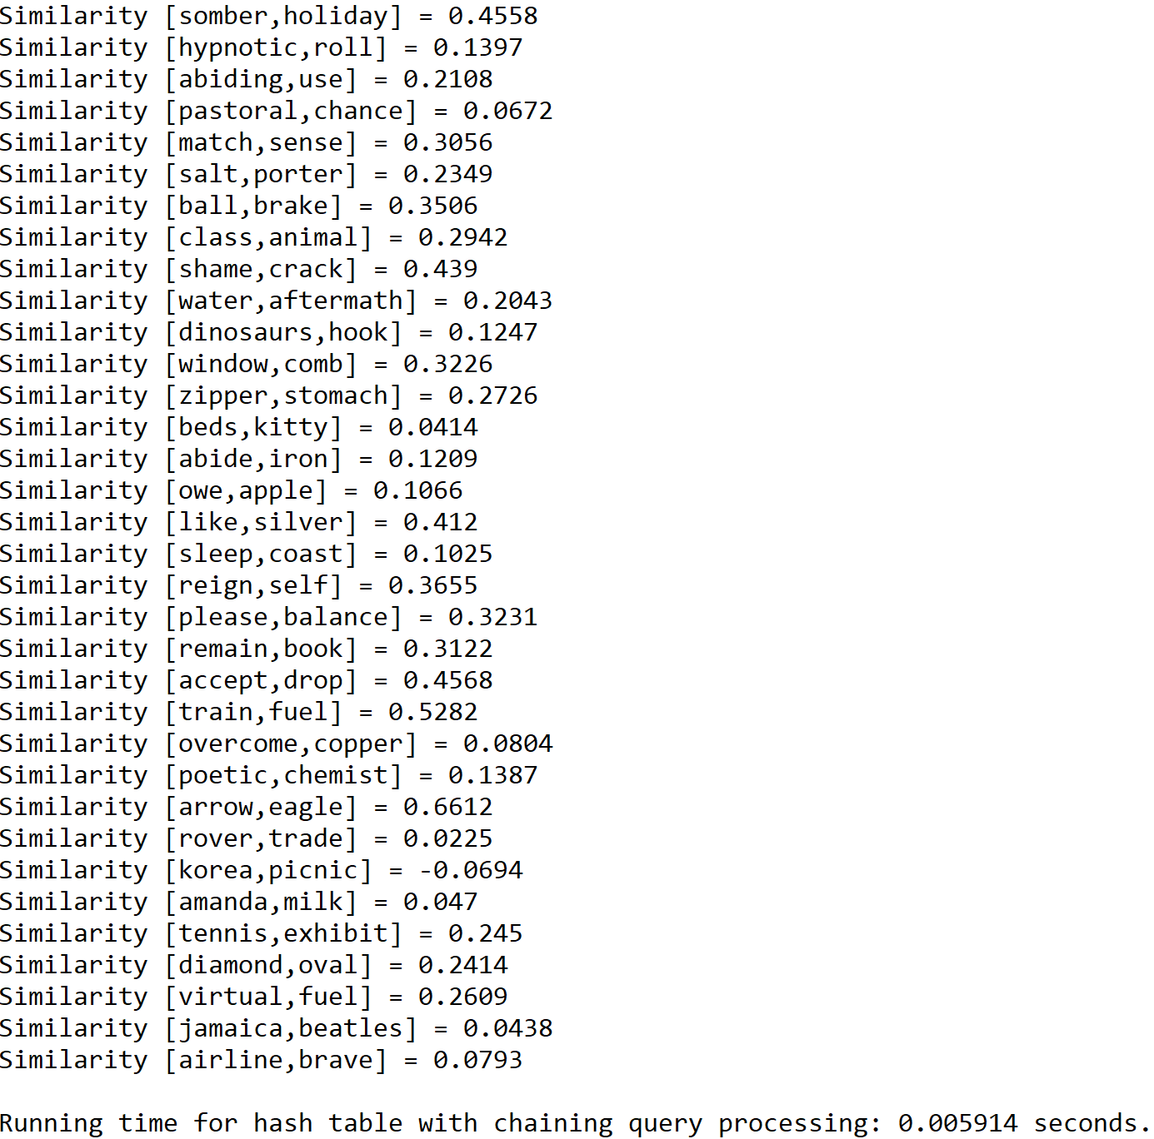

**Hash Table that Solves Collisions by Linear Probing**

**Operation #1:**

For this operation, I will test text files of size 50, 100, and 150. The size of the hash table is determined by the total number of lines in a subset of the “glove.6B.50d” text file times 5. Additionally, the words in the second text file are modified so that they appear in the subset of the first file.

Case 1: Size of text file = 50

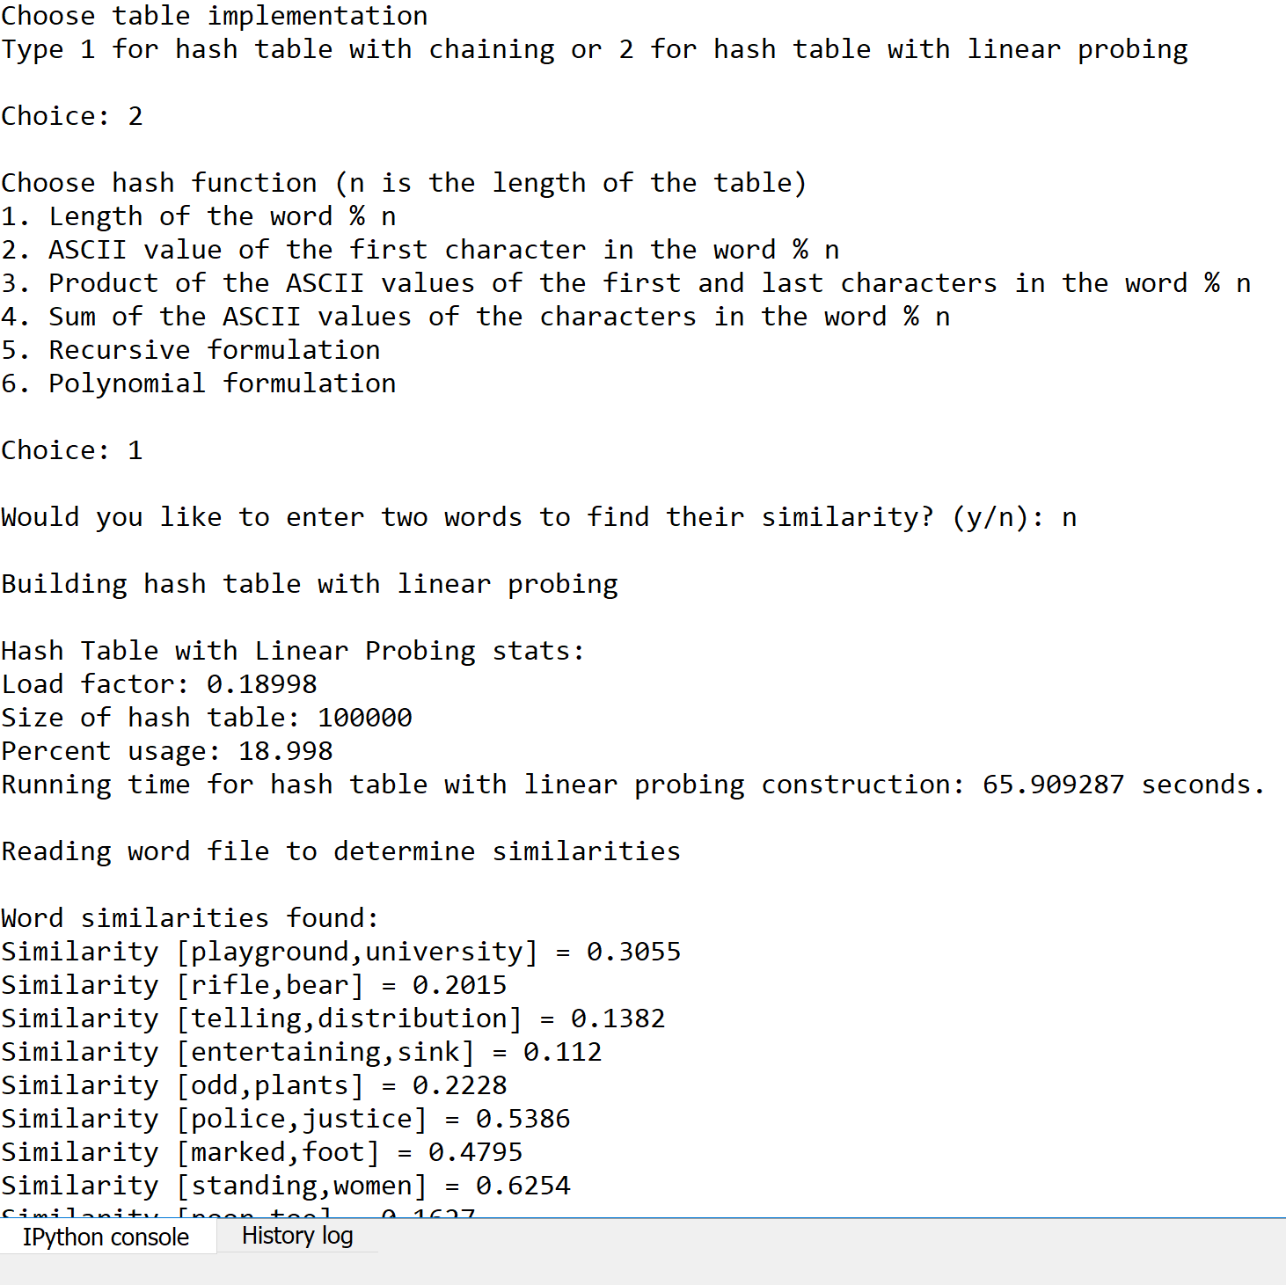

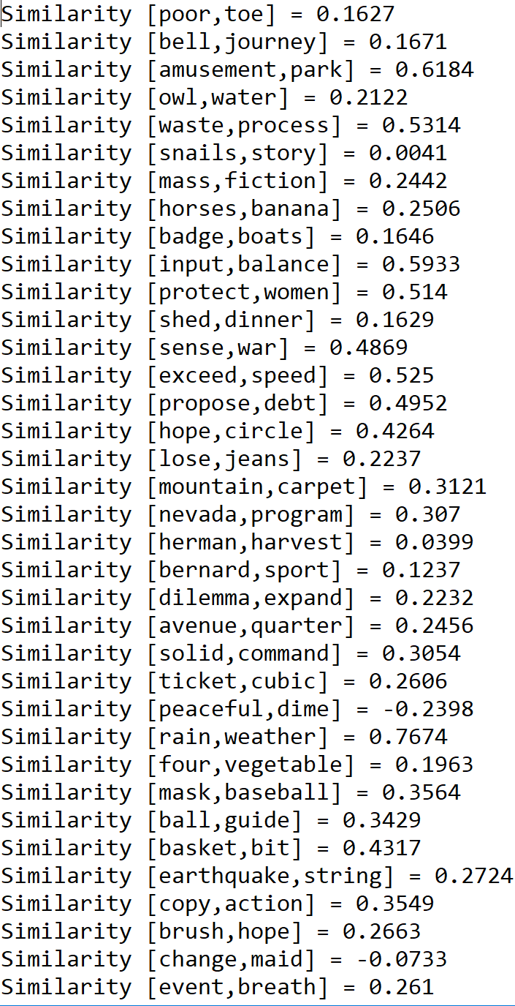

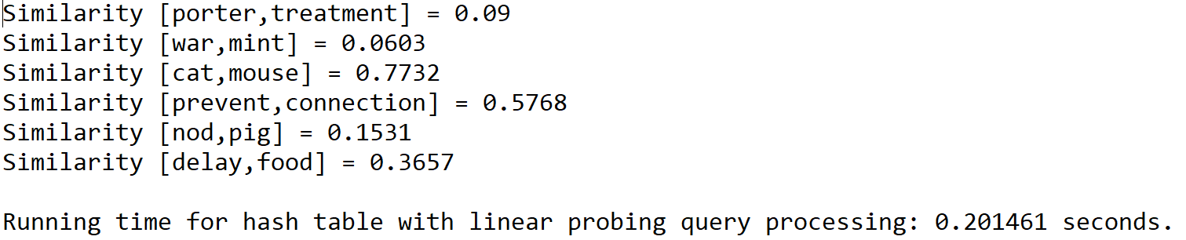

Case 2: Size of text file = 100

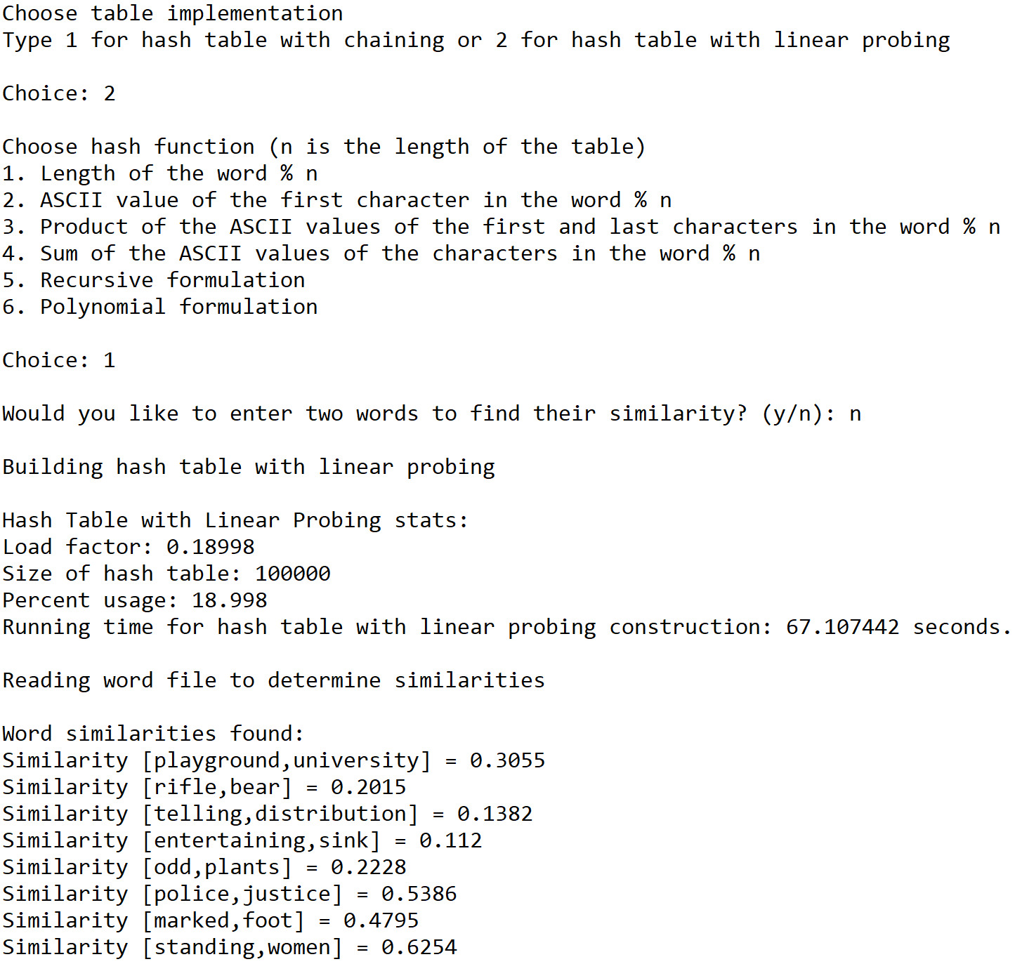



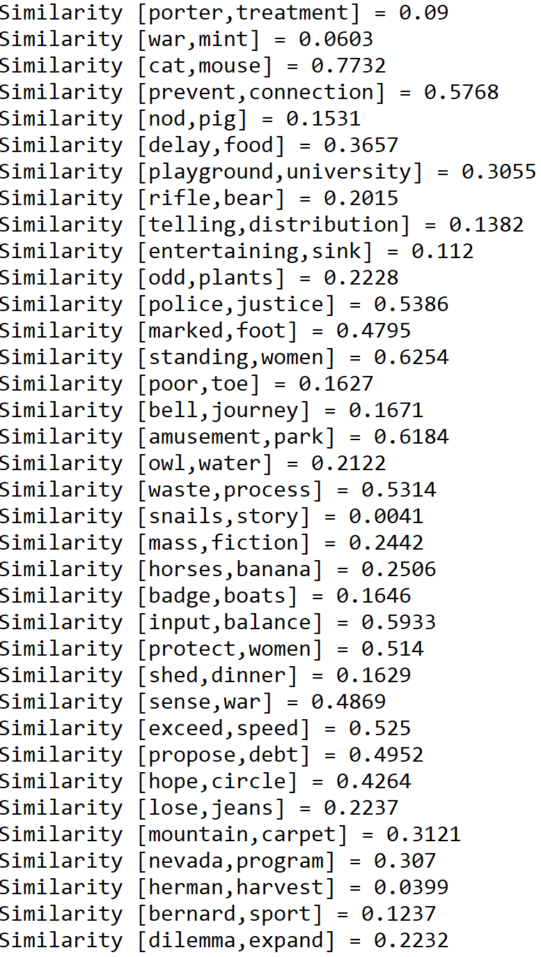

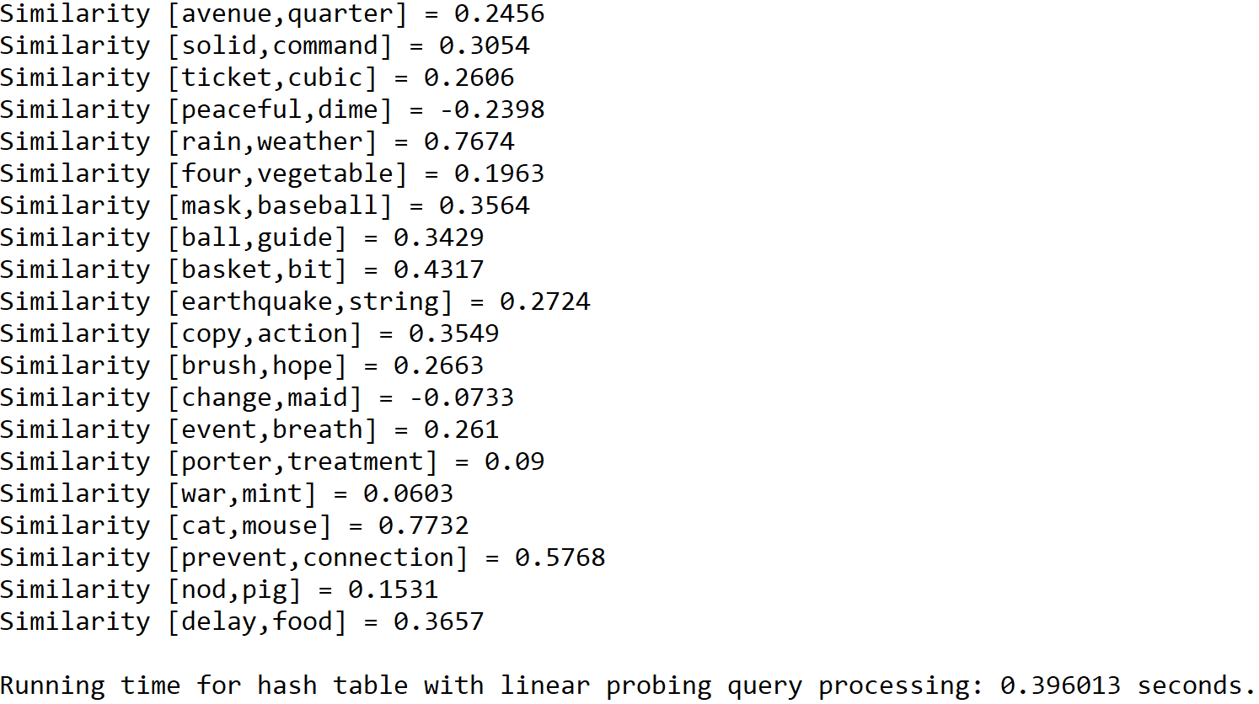

Case 3: Size of text file = 150

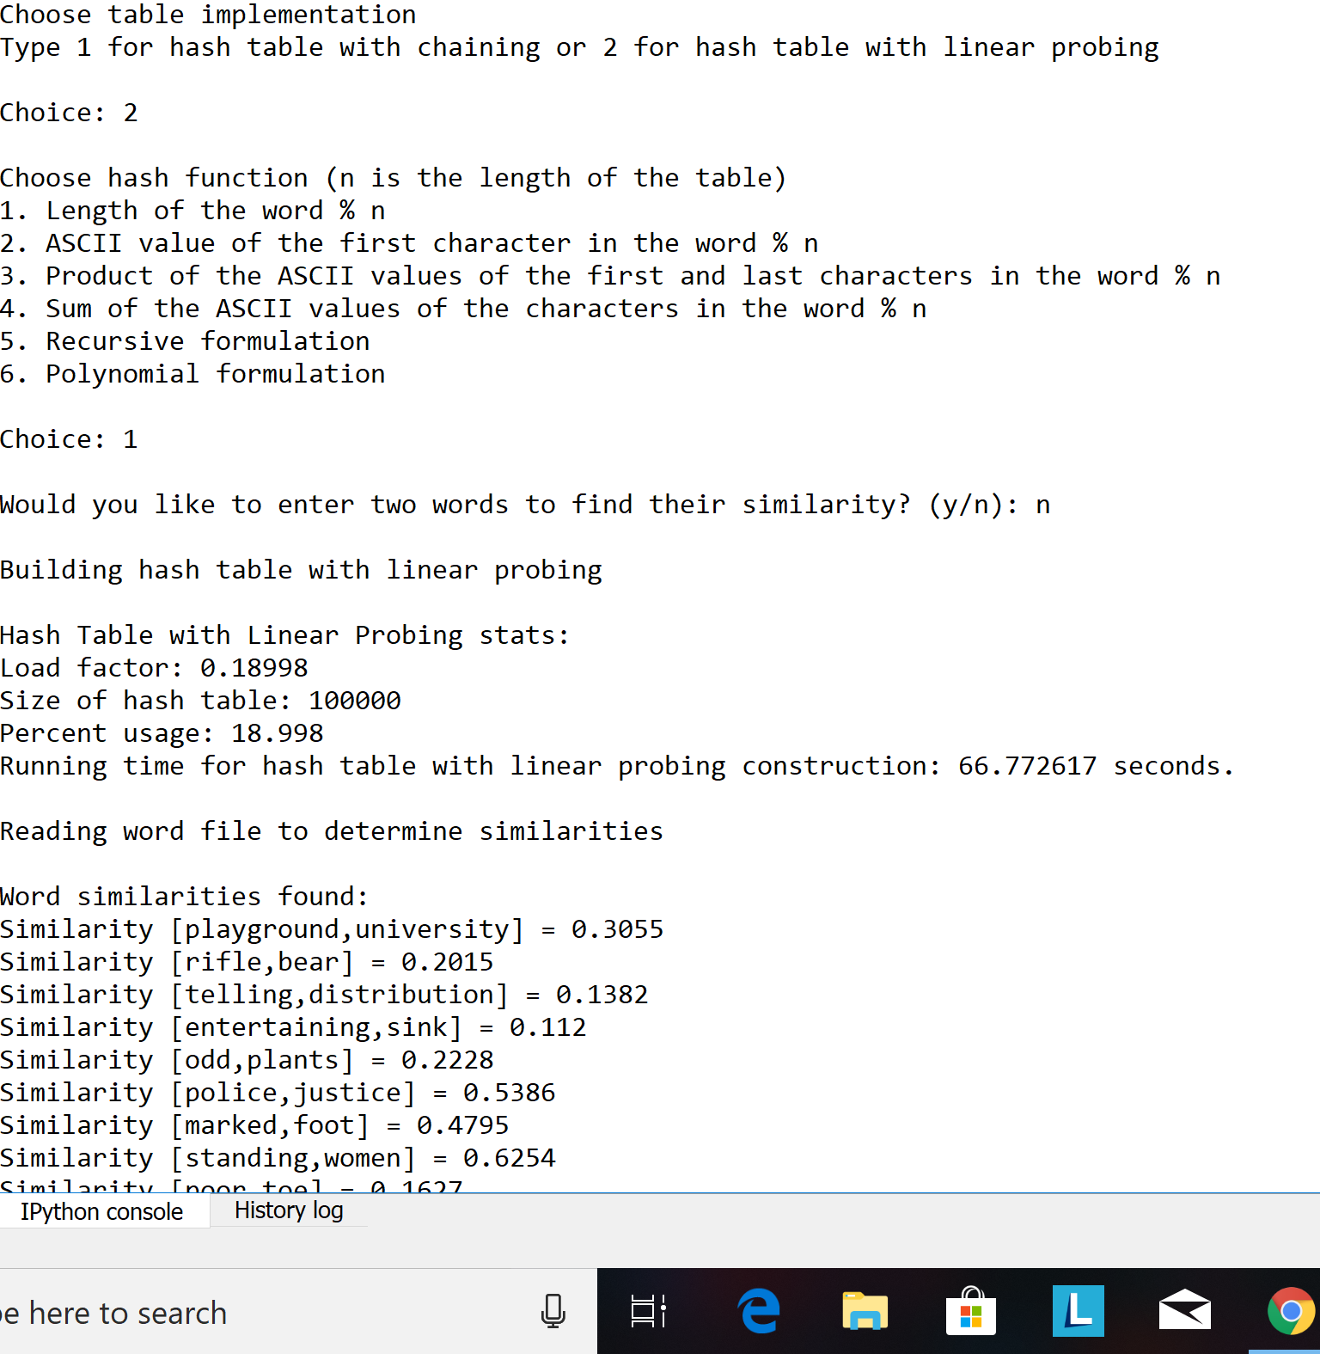





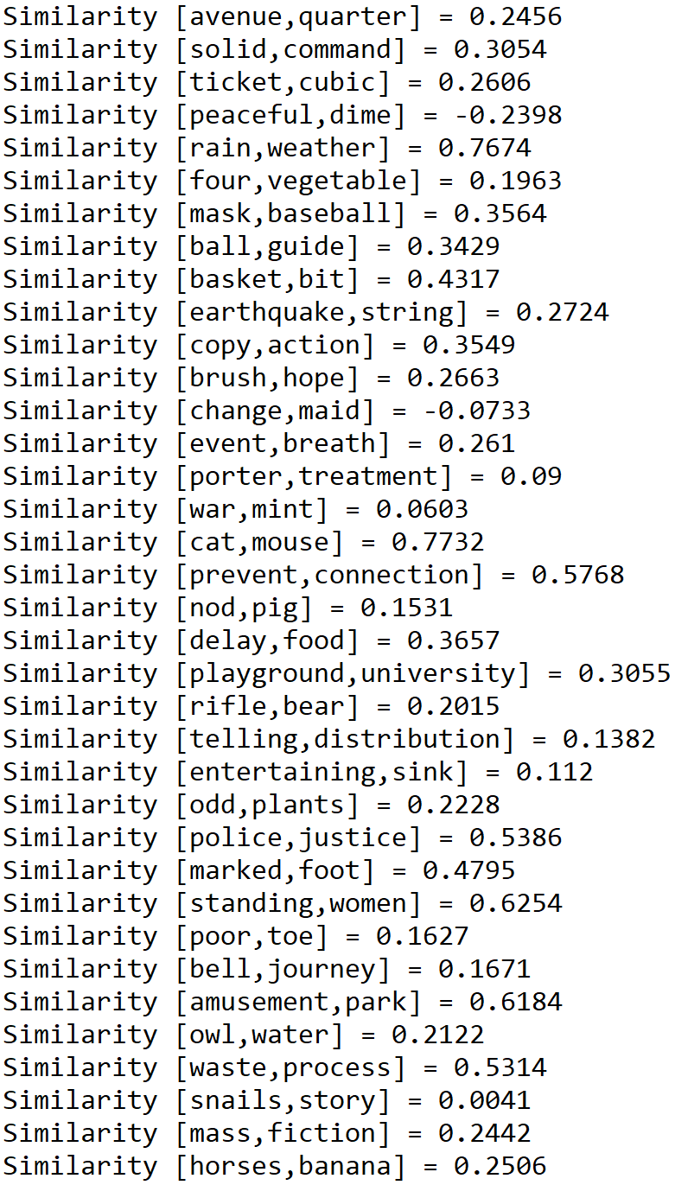

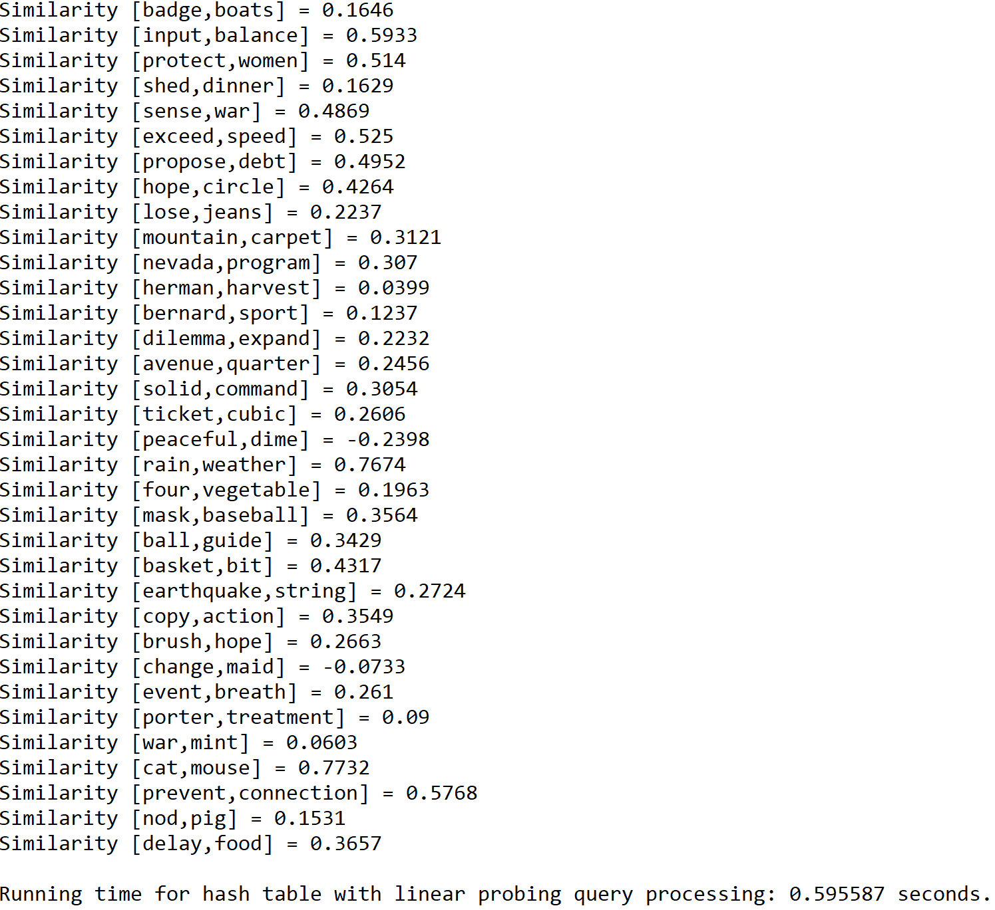

**Operation #2:**

For this operation, I will test text files of size 50, 100, and 150. The size of the hash table is determined by the total number of lines in a subset of the “glove.6B.50d” text file times 5. Additionally, the words in the second text file are modified so that they appear in the subset of the first file.

Case 1: Size of text file = 50

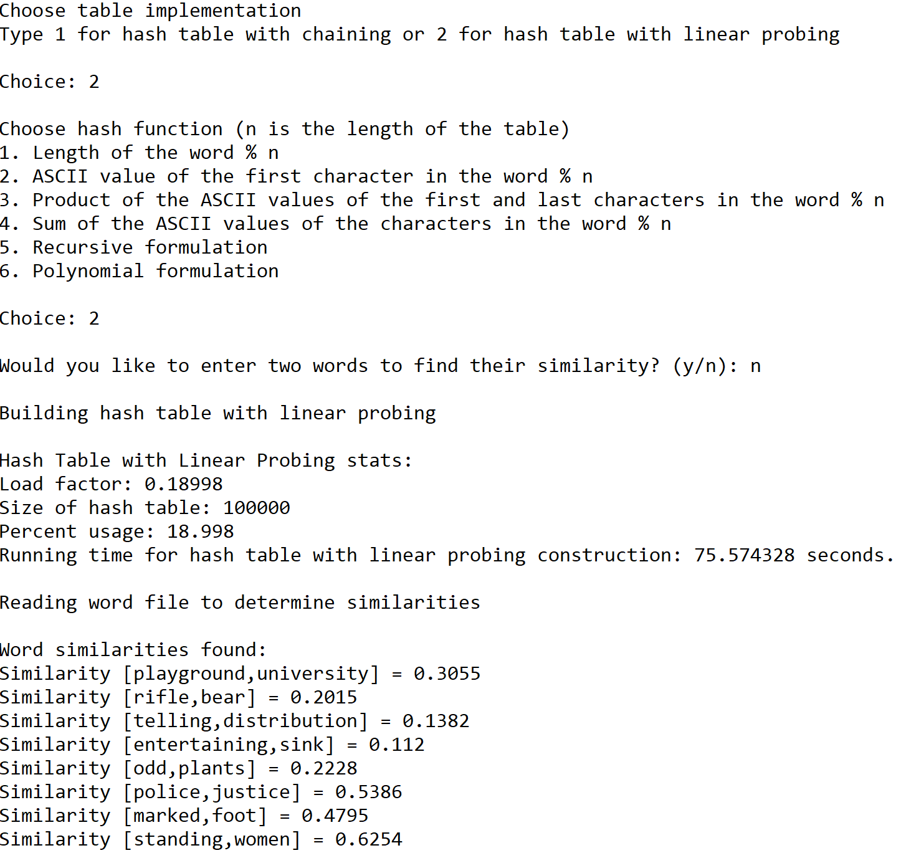



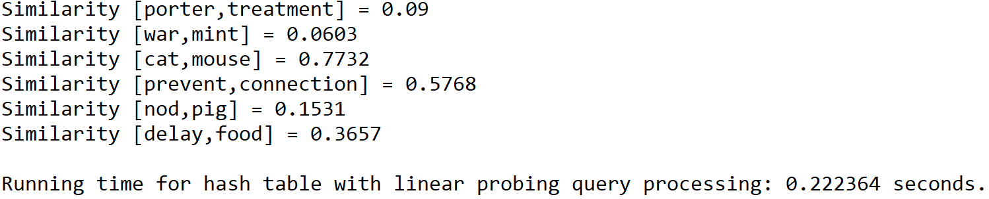

Case 2: Size of text file = 100

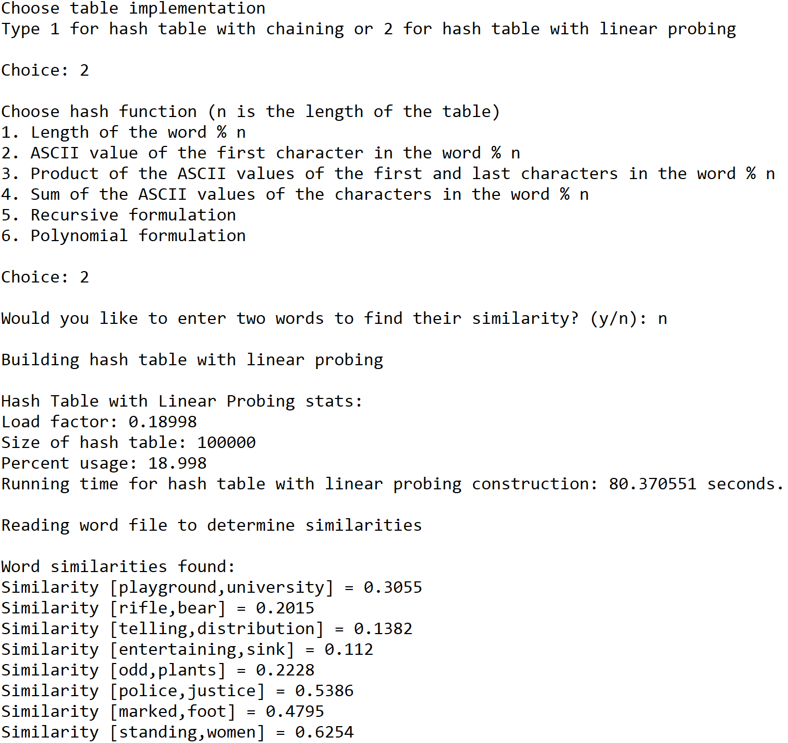





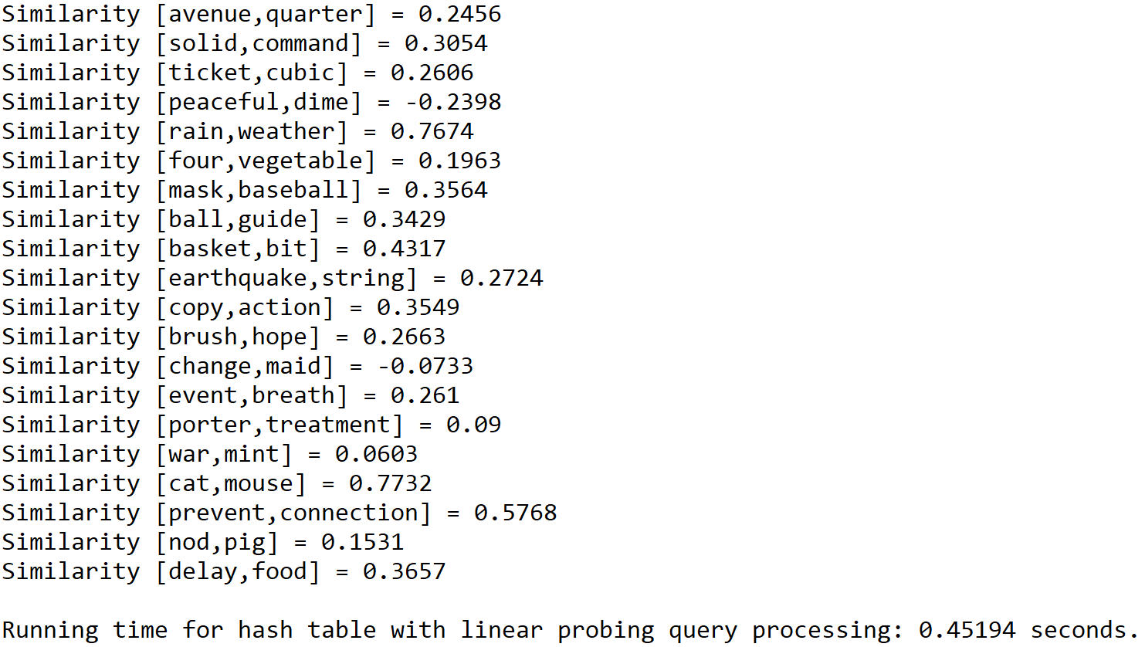

Case 3: Size of text file = 150

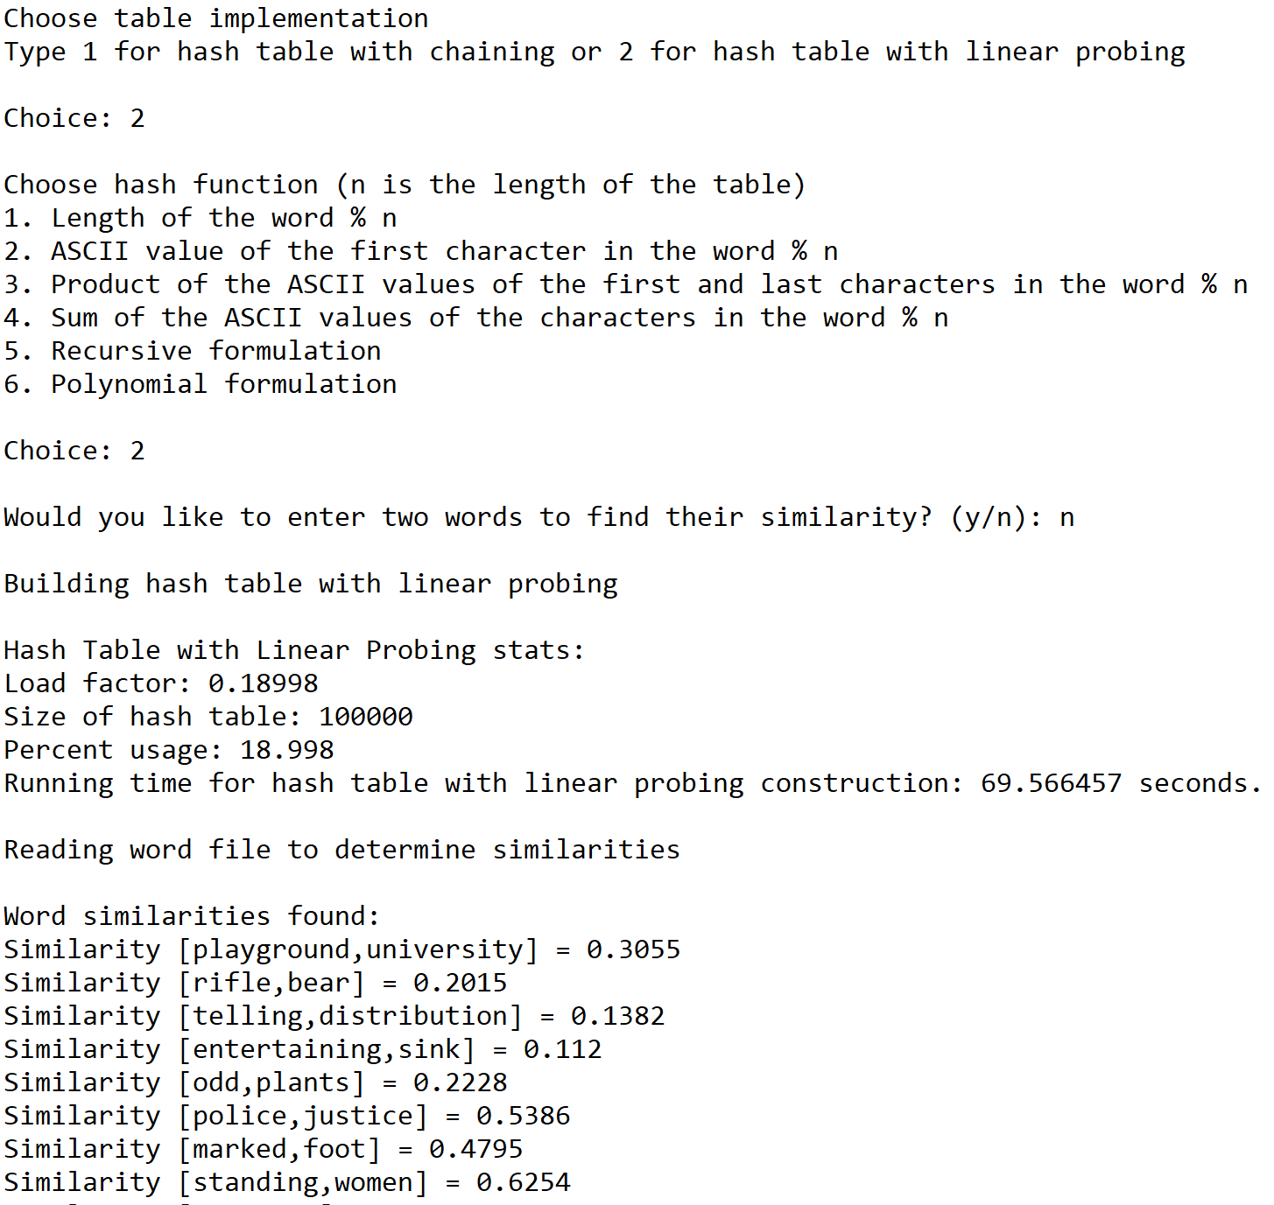







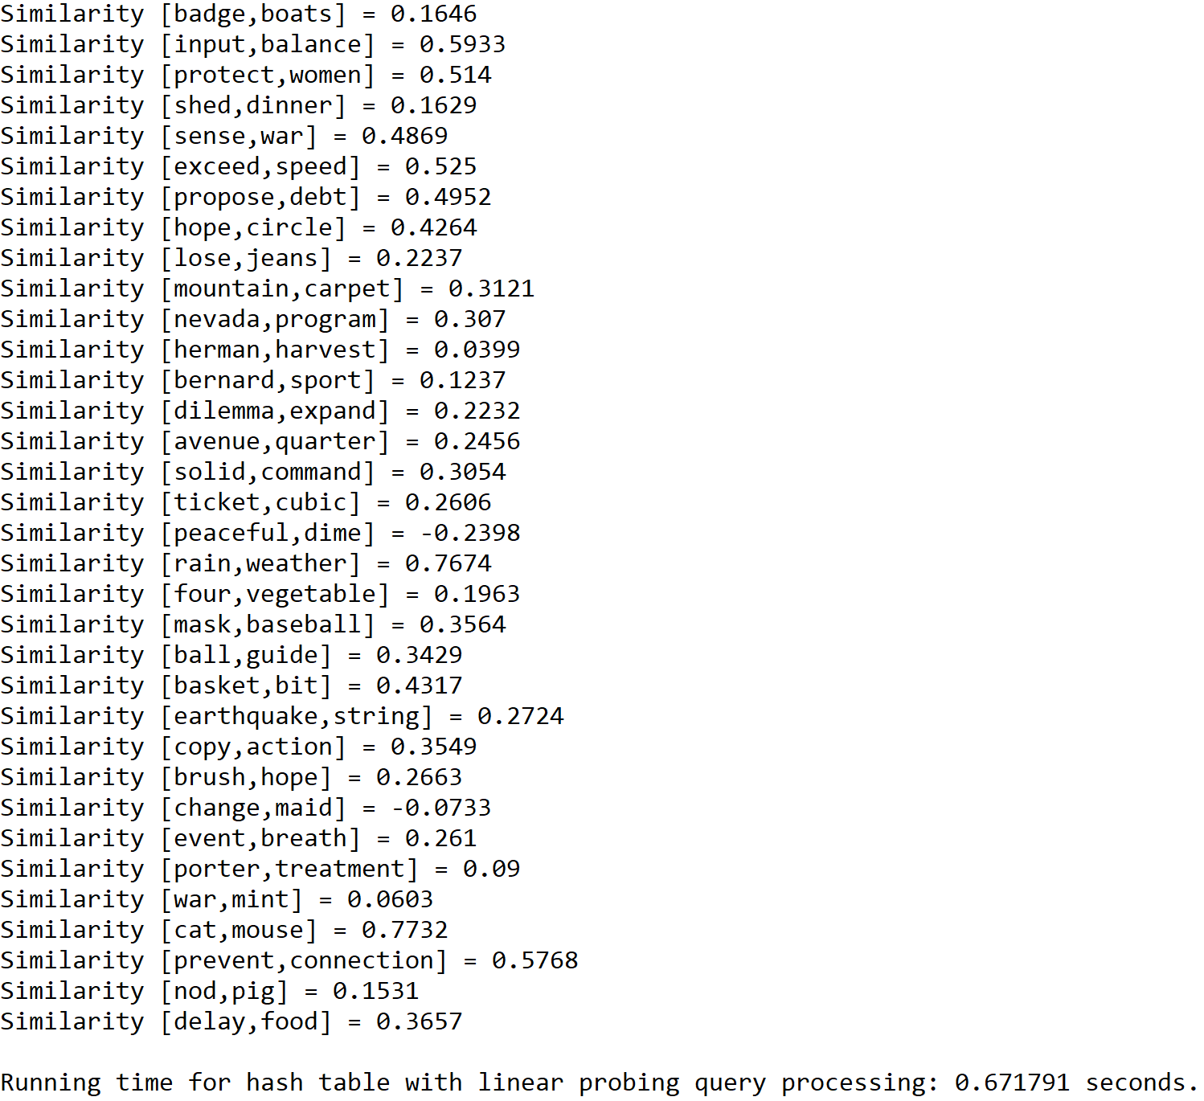

**Operation #3:**

For this operation, I will test text files of size 50, 100, and 150. The size of the hash table is determined by the total number of lines in a subset of the “glove.6B.50d” text file times 5. Additionally, the words in the second text file are modified so that they appear in the subset of the first file.

Case 1: Size of text file = 50

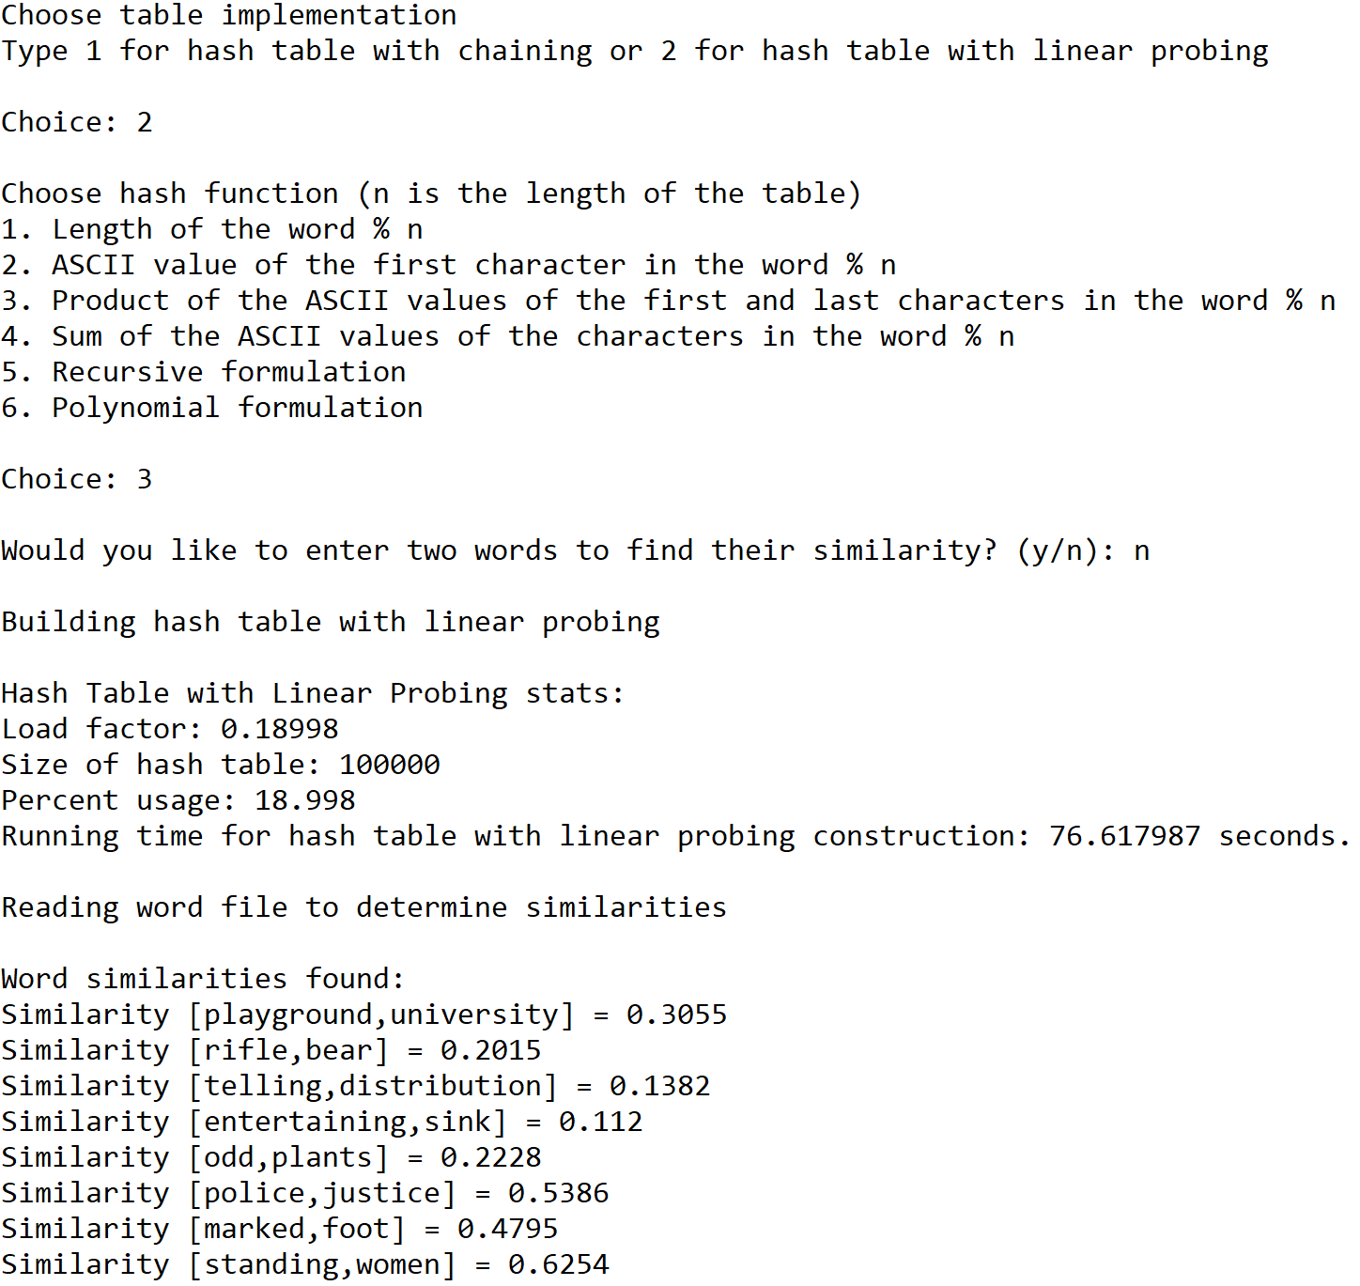



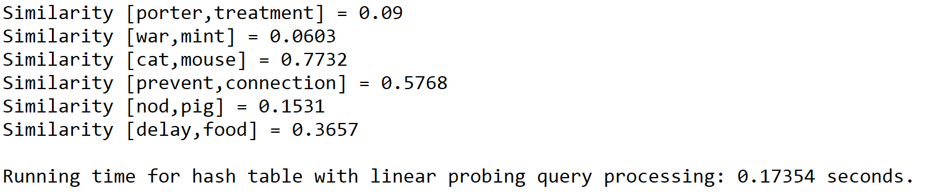

Case 2: Size of text file = 100

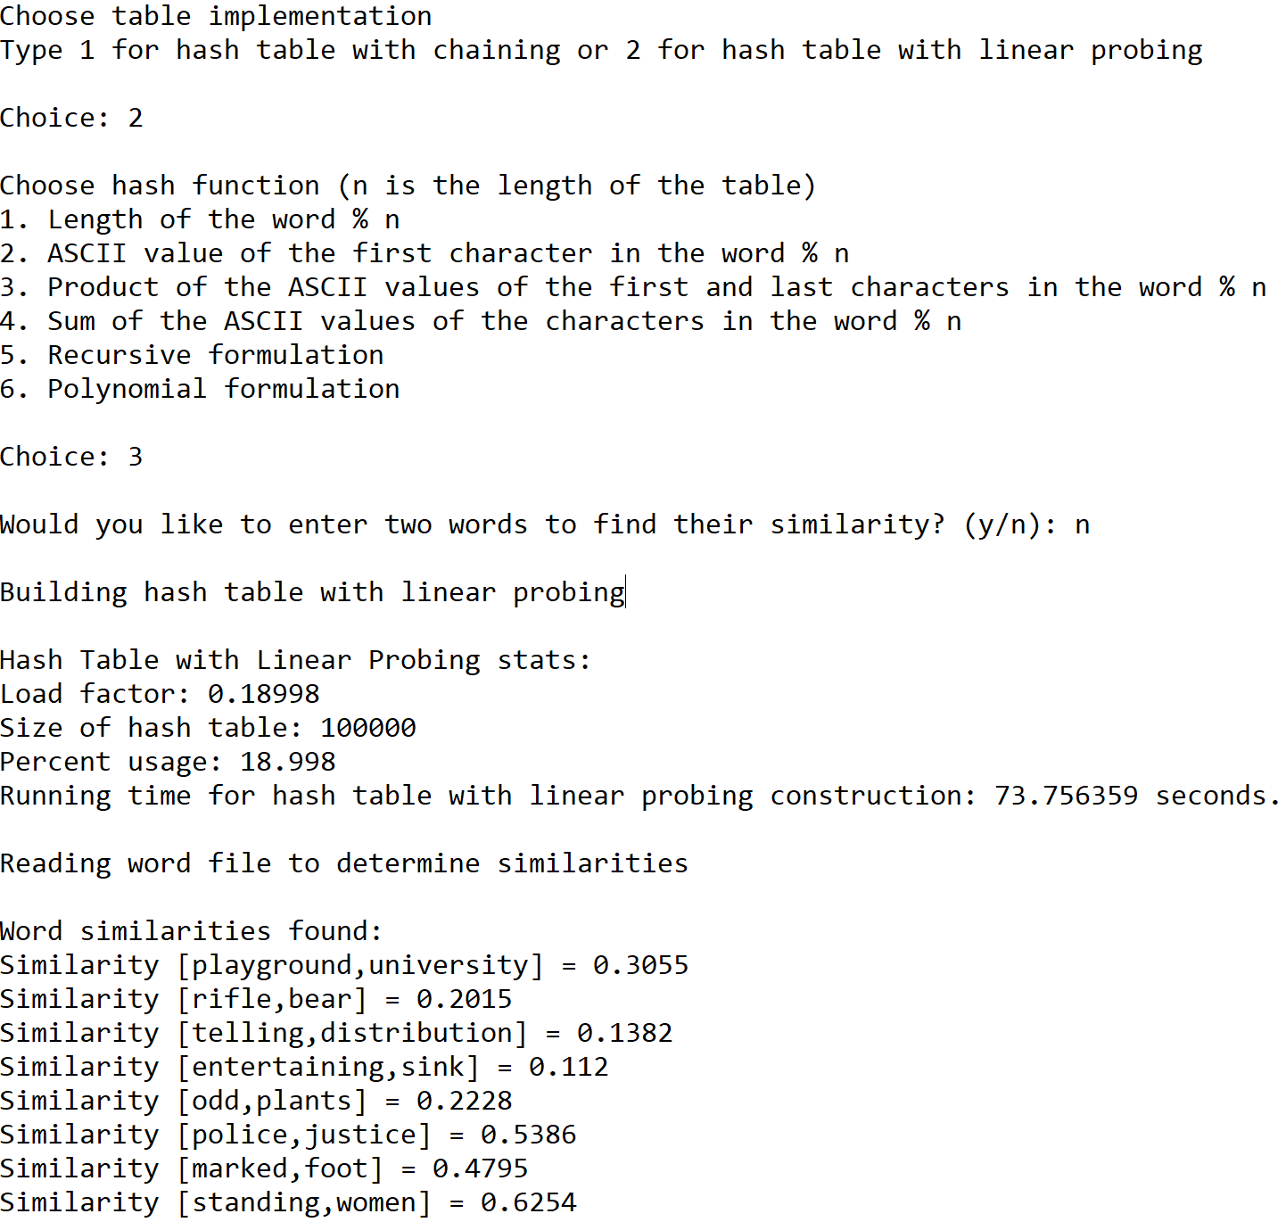





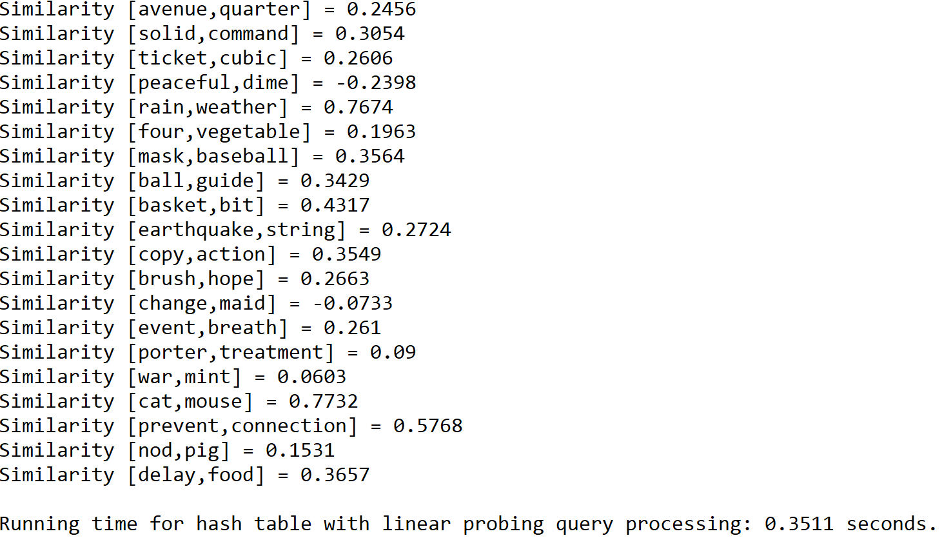

Case 3: Size of text file = 150

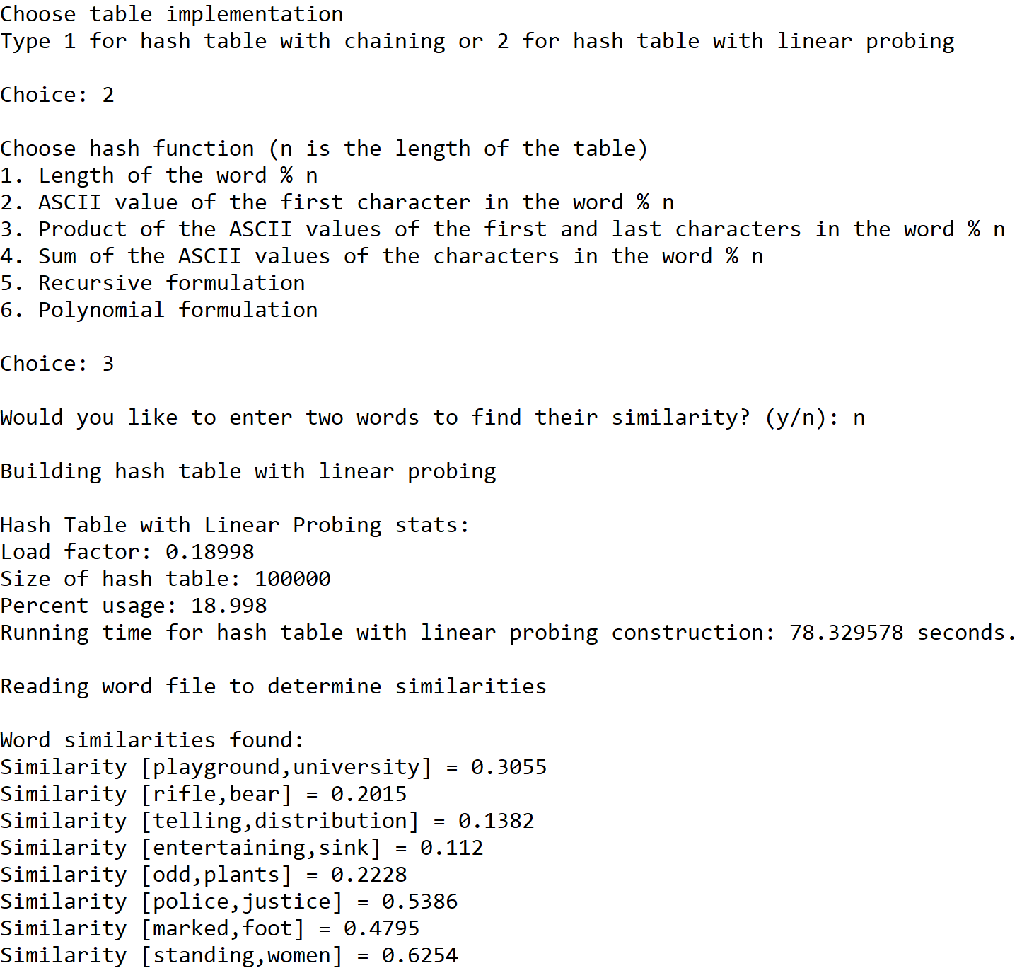







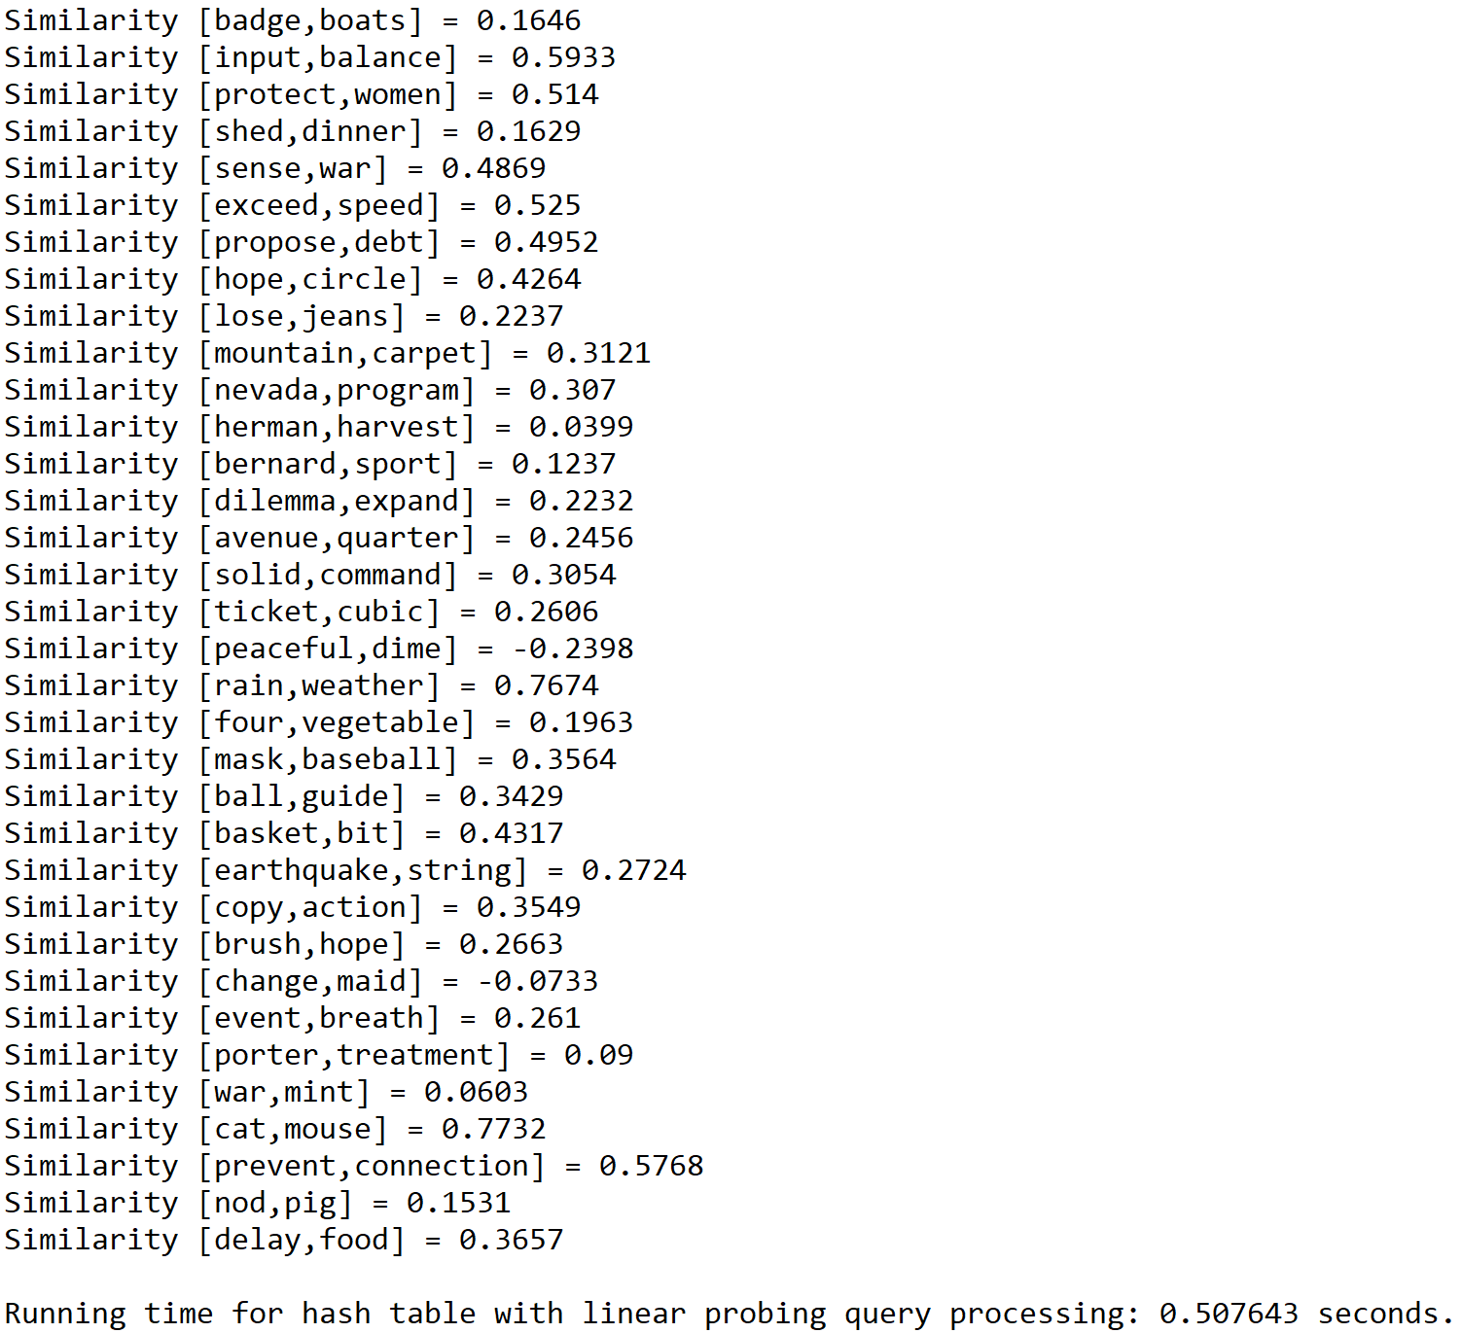

**Operation #4:**

For this operation, I will test text files of size 50, 100, and 150. The size of the hash table is determined by the total number of lines in a subset of the “glove.6B.50d” text file times 5. Additionally, the words in the second text file are modified so that they appear in the subset of the first file.

Case 1: Size of text file = 50

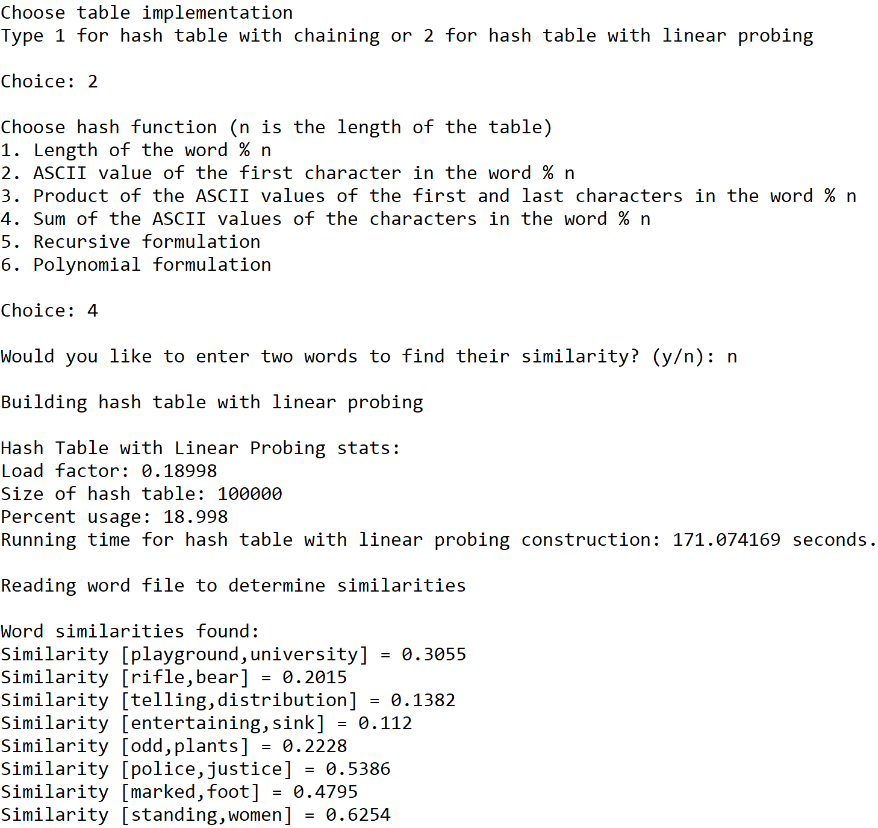



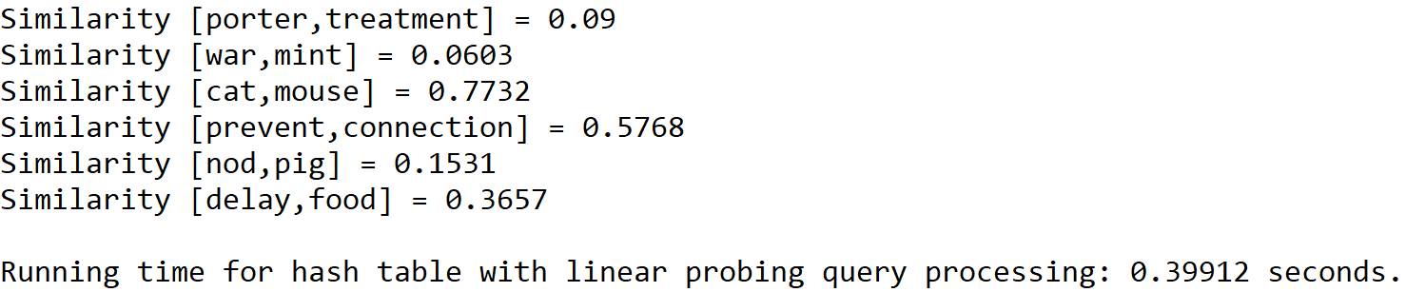

Case 2: Size of text file = 100

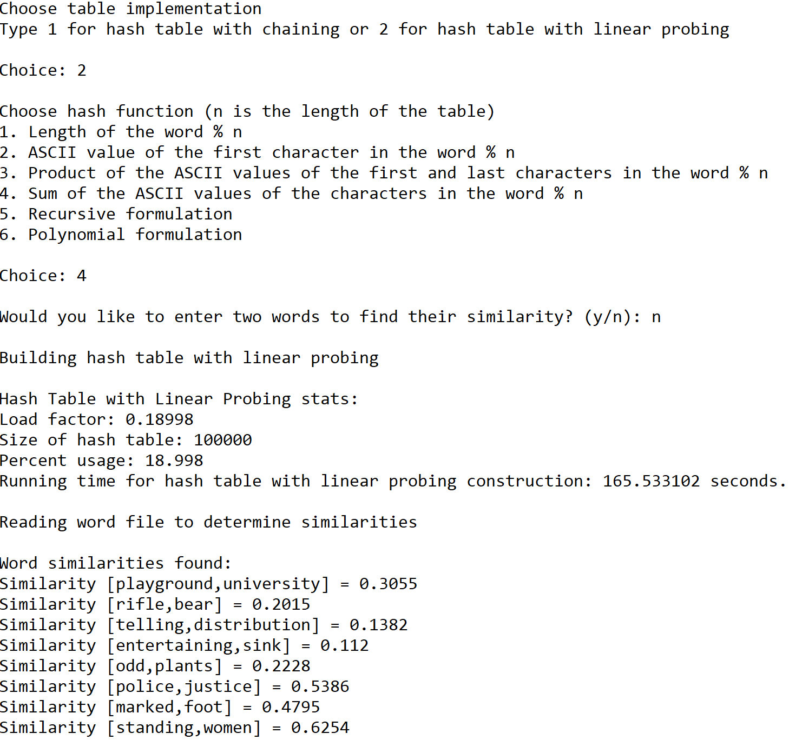





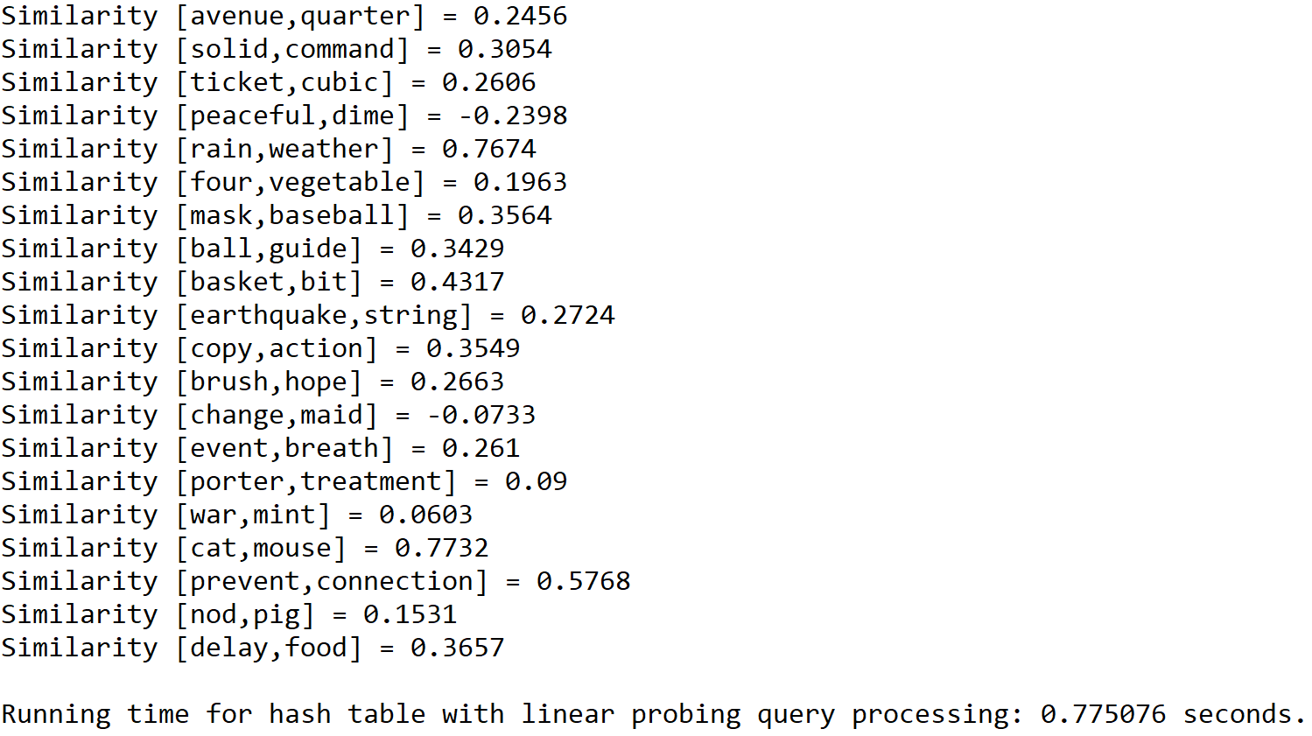

Case 3: Size of text file = 150

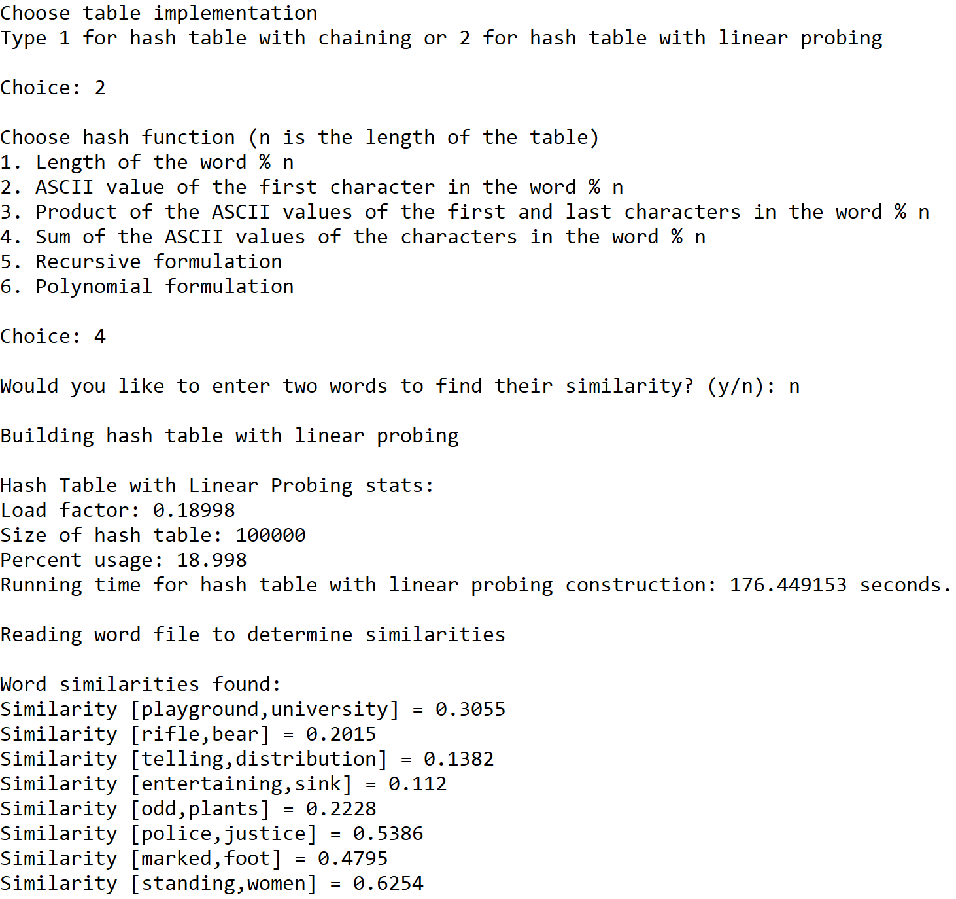







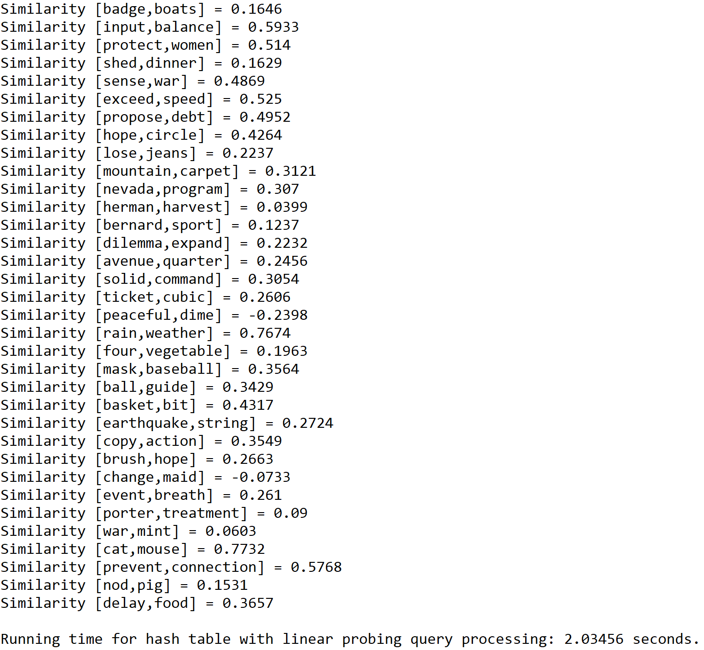

**Operation #5:**

For this operation, I will test text files of size 50, 100, and 150. The size of the hash table is determined by the total number of lines in the “glove.6B.50d” text file times 5.

Case 1: Size of text file = 50

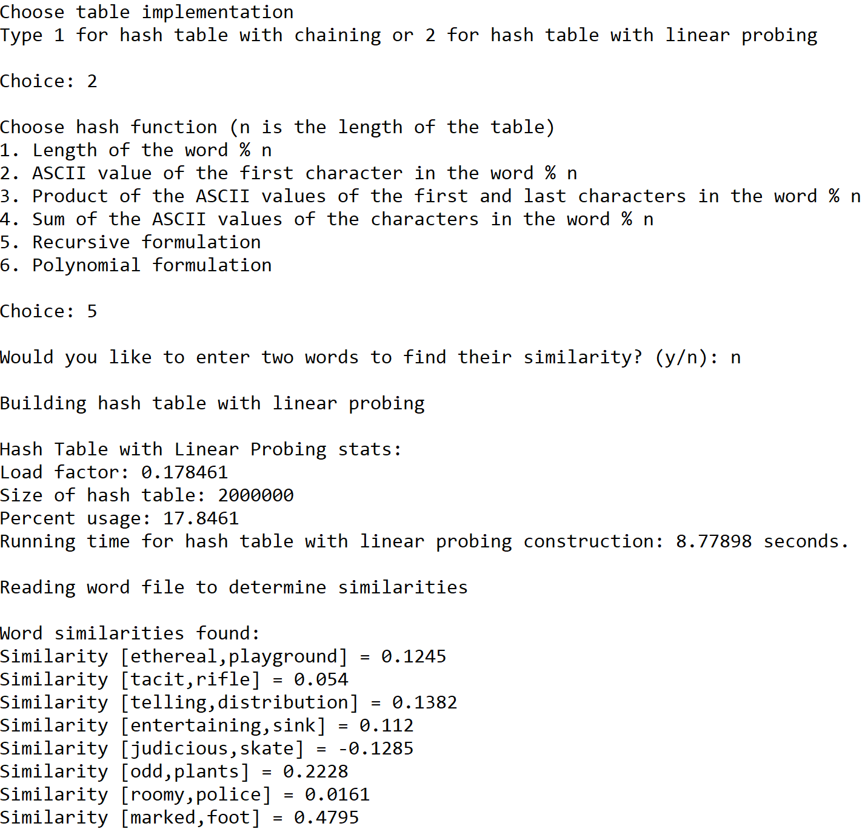

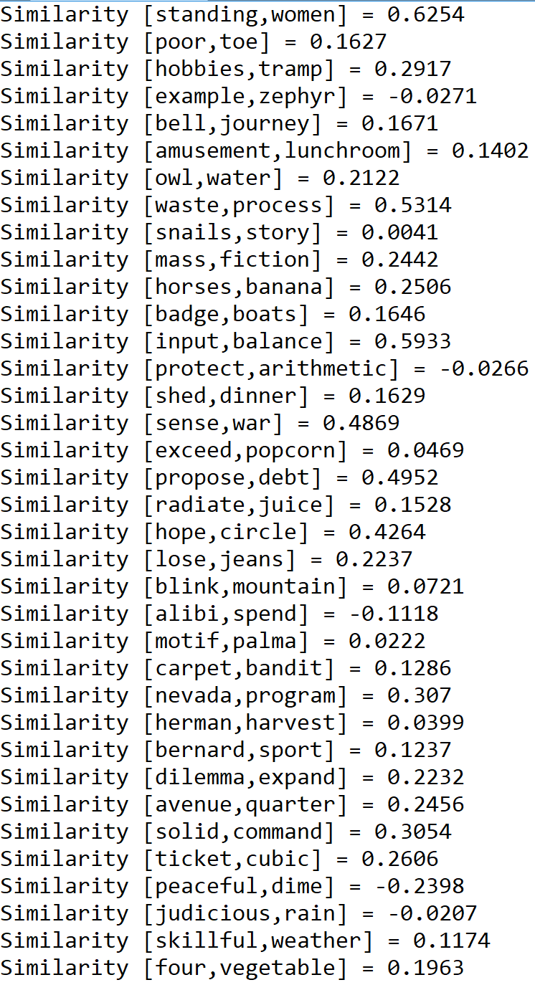

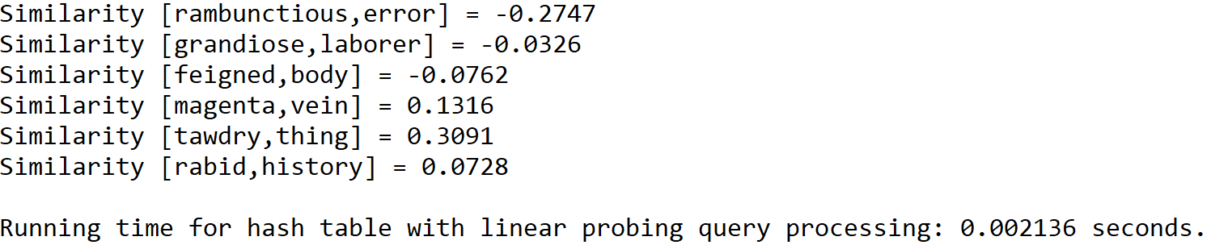

Case 2: Size of text file = 100

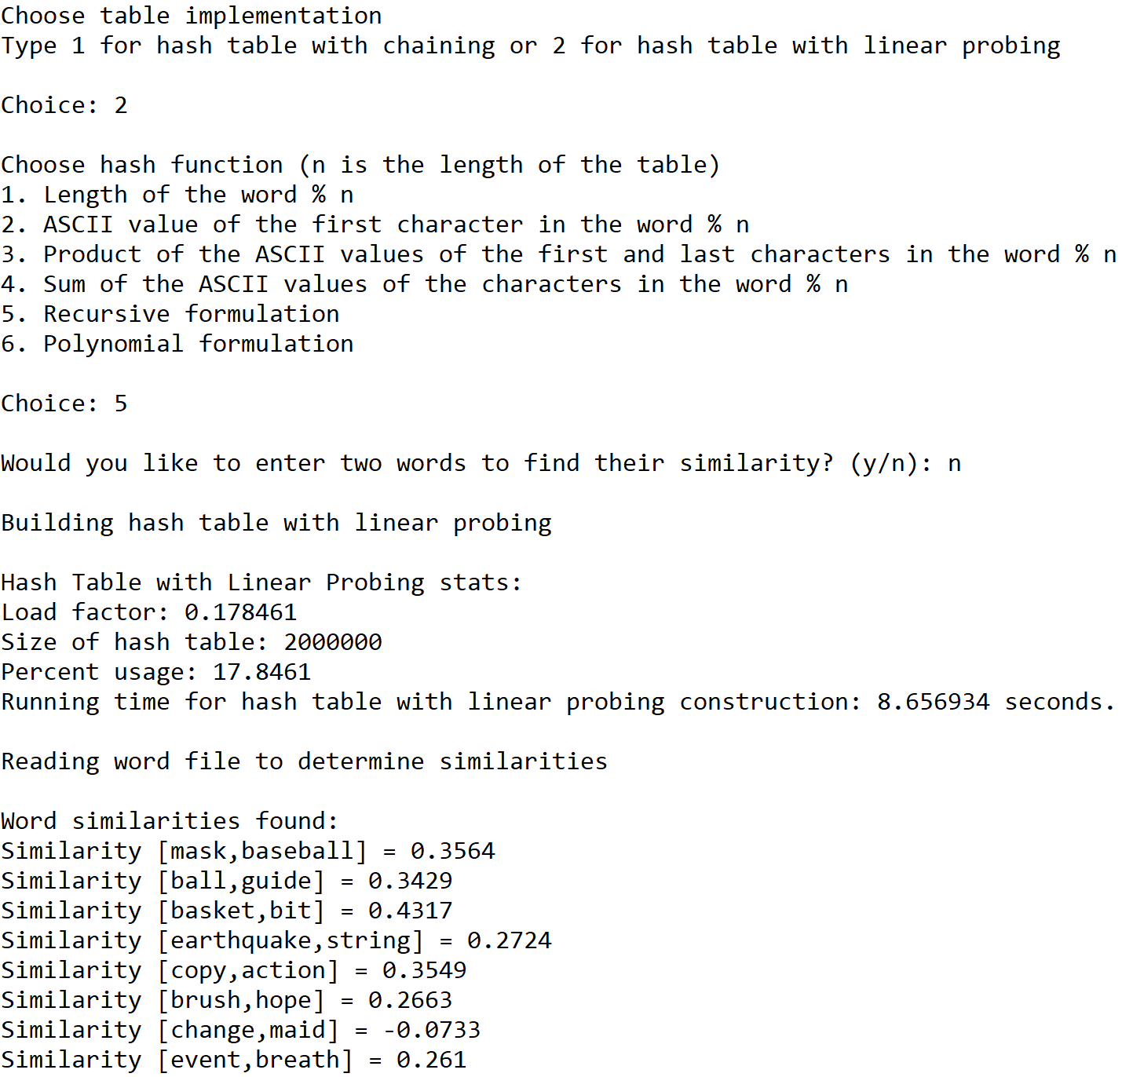

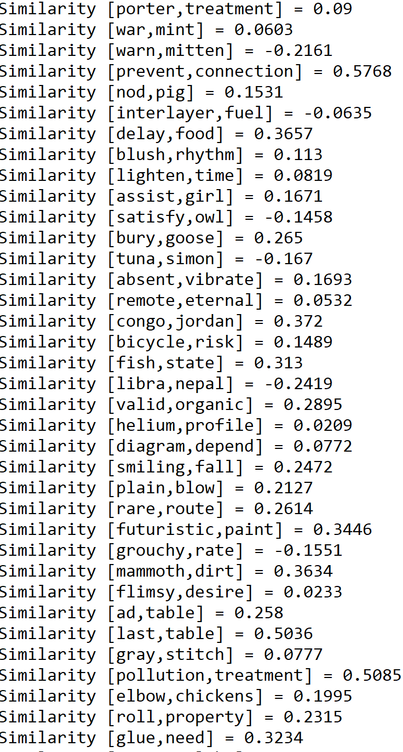

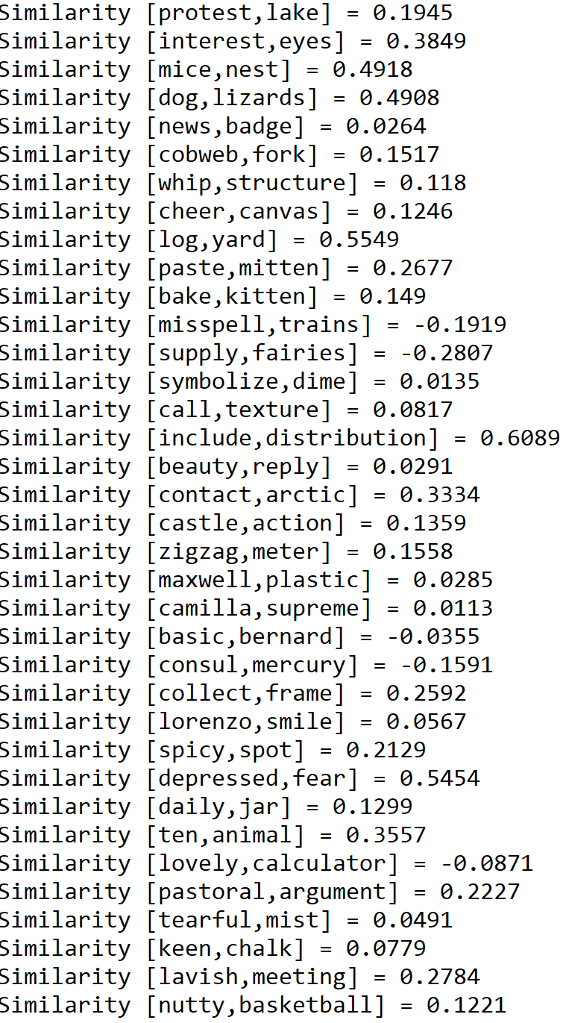

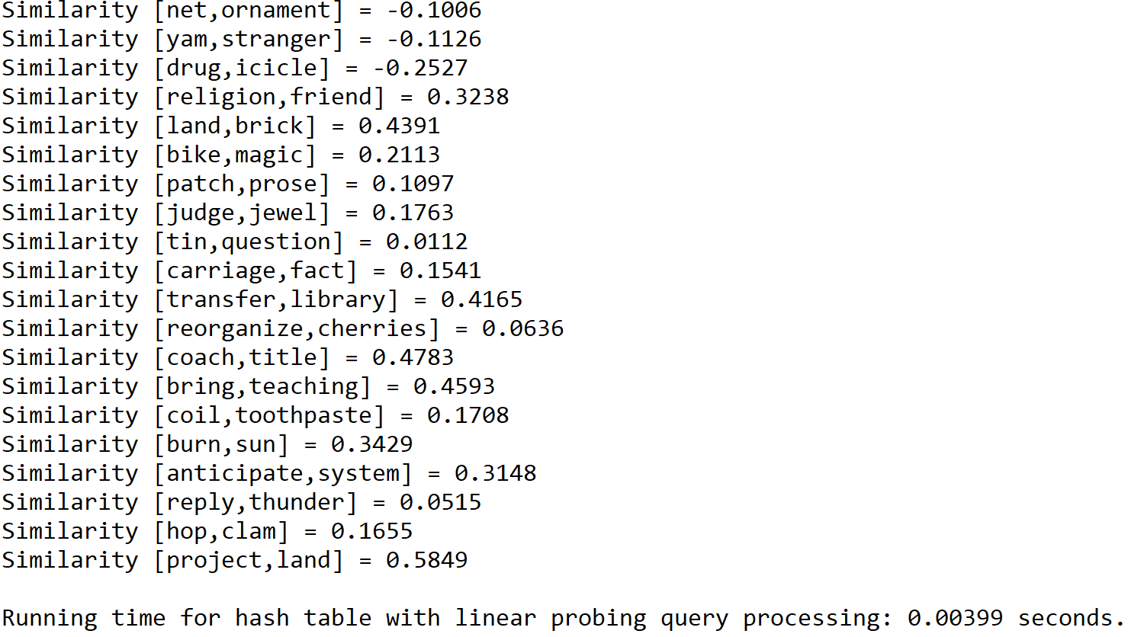

Case 3: Size of text file = 150

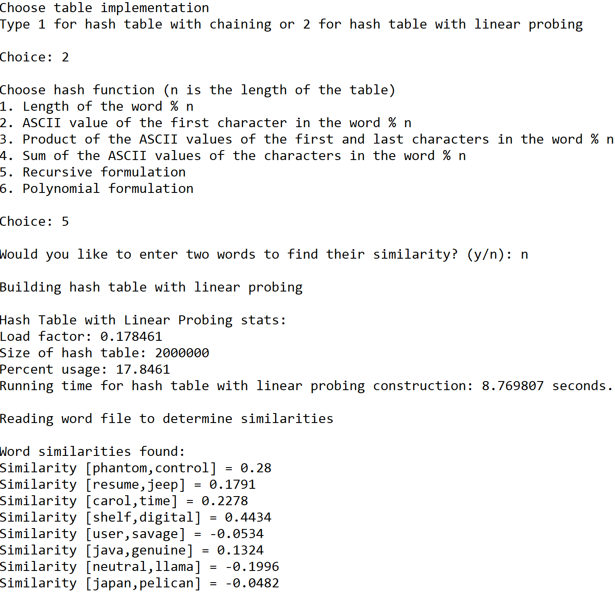

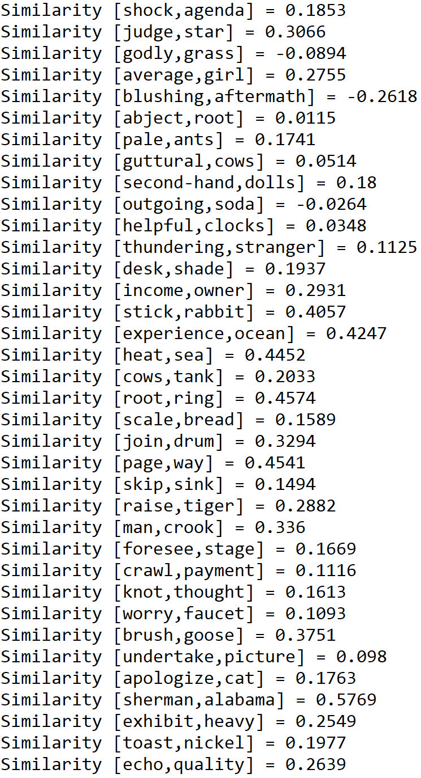

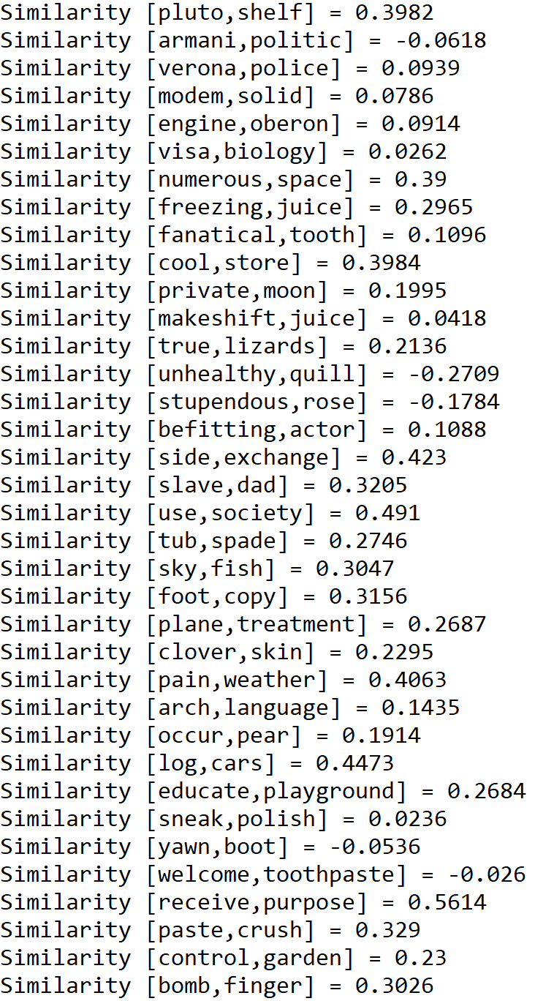

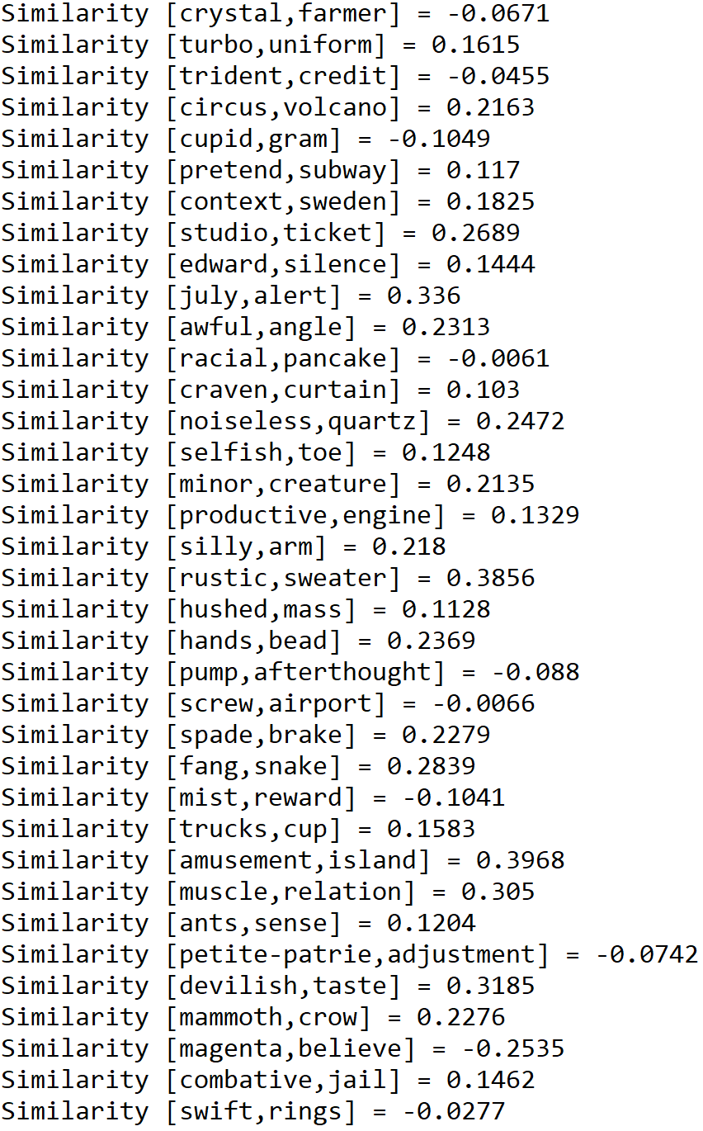

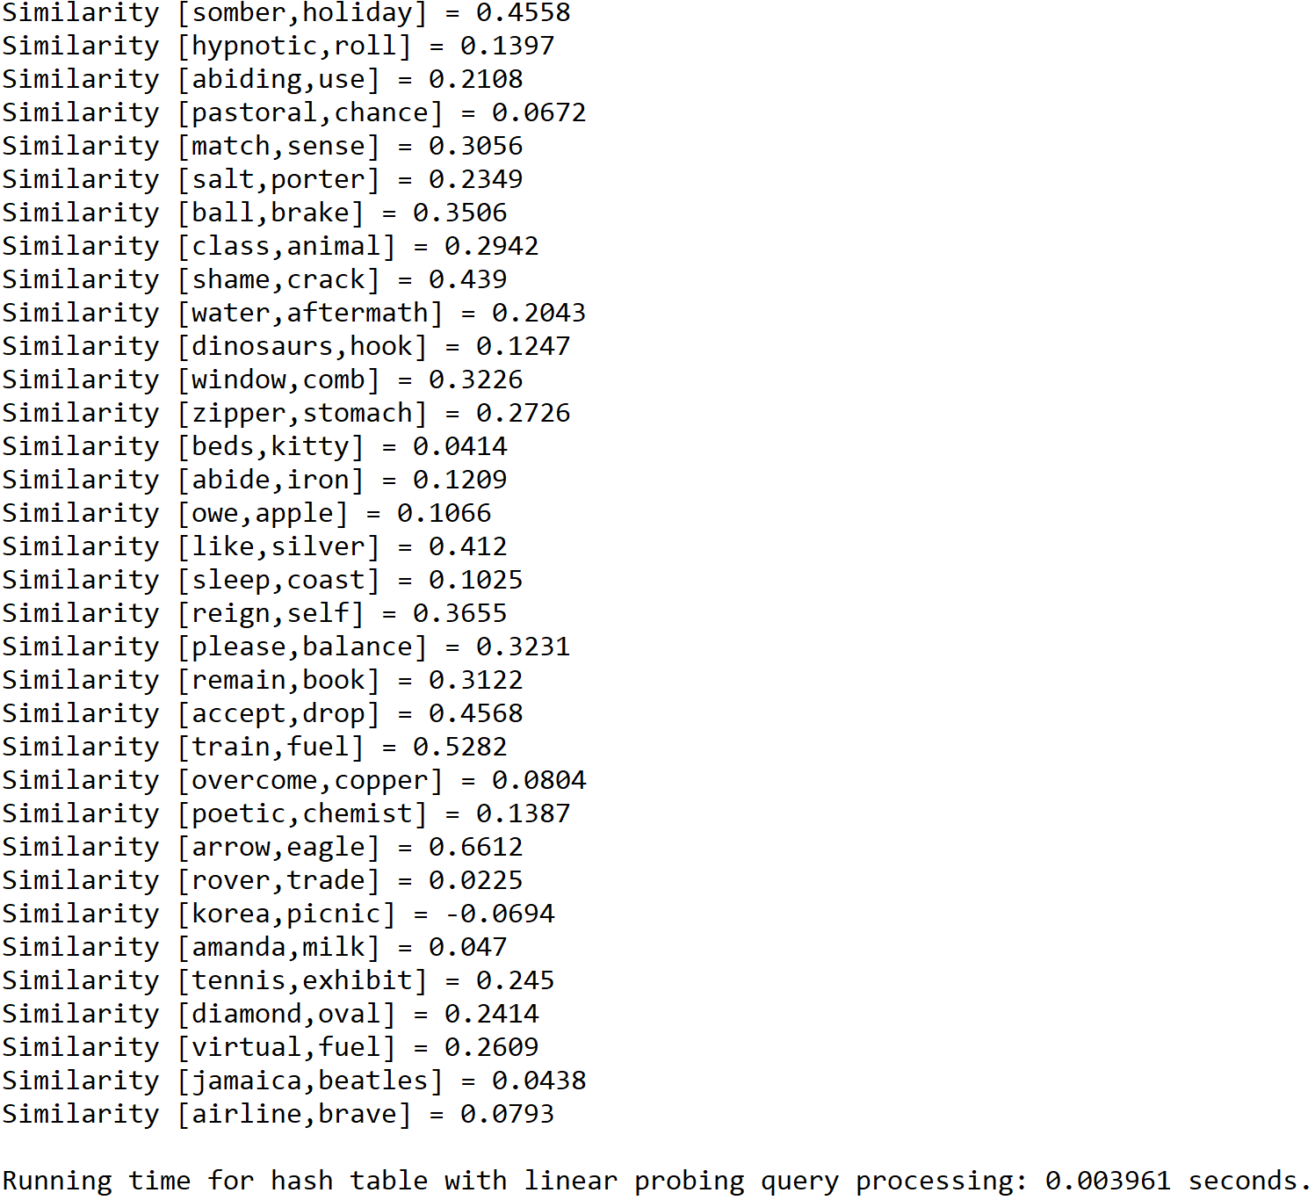

**Operation #6:**

For this operation, I will test text files of size 50, 100, and 150. The size of the hash table is determined by the total number of lines in the “glove.6B.50d” text file times 5.

Case 1: Size of text file = 50

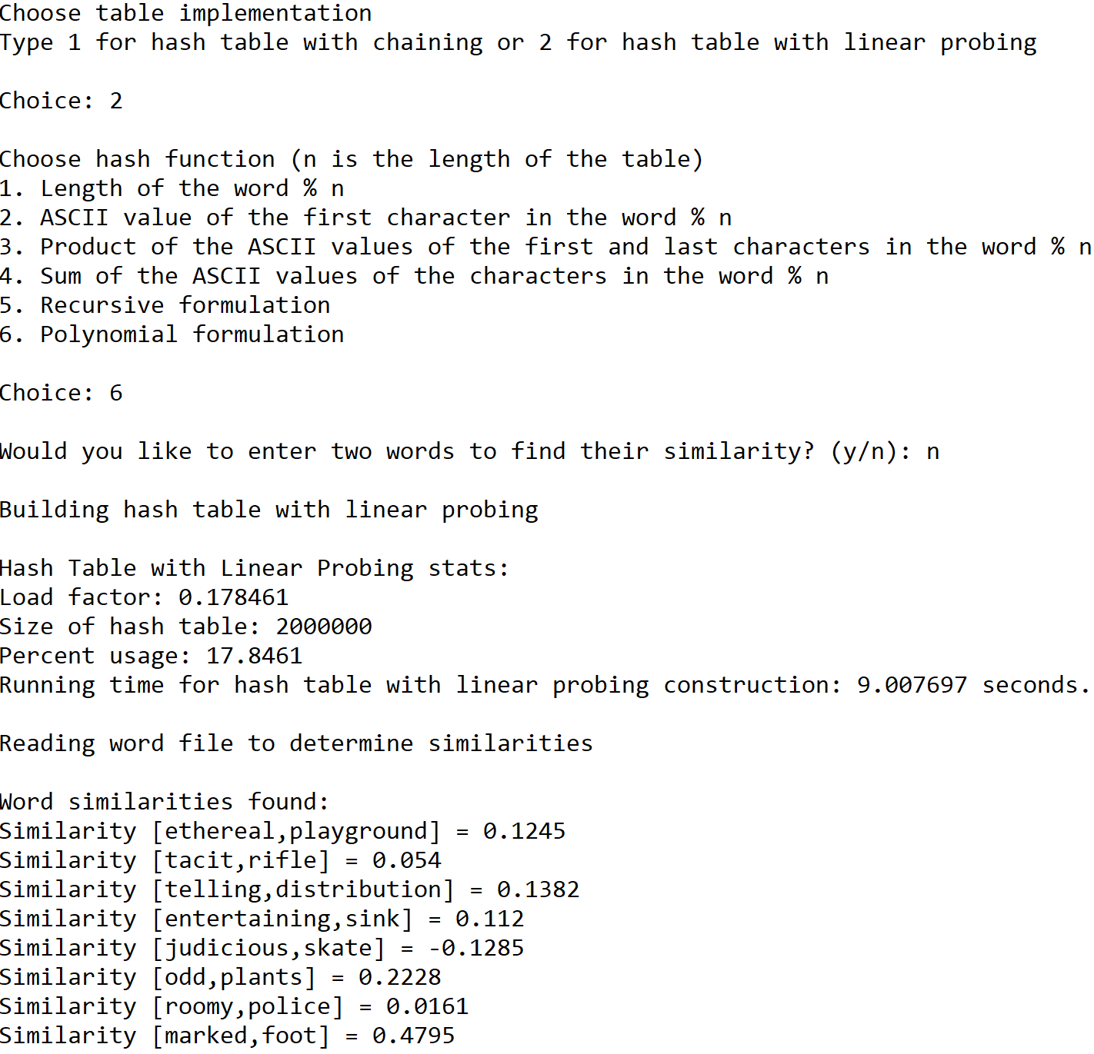



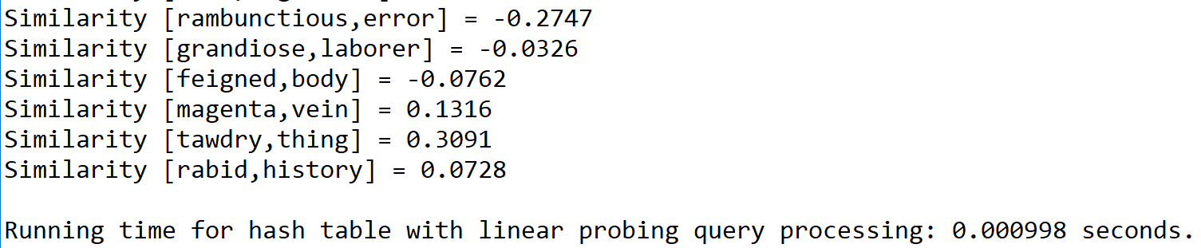

Case 2: Size of text file = 100

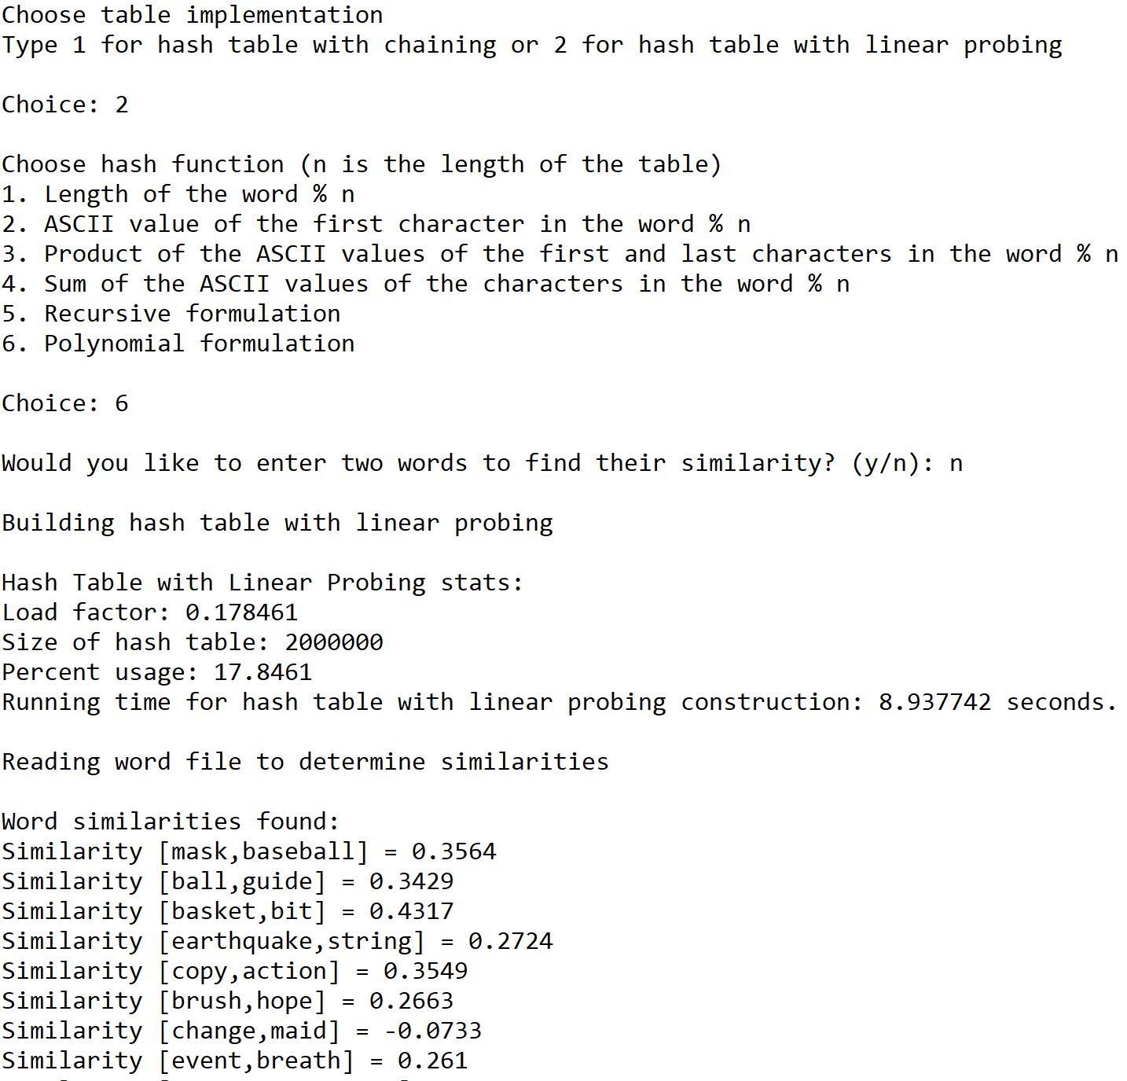





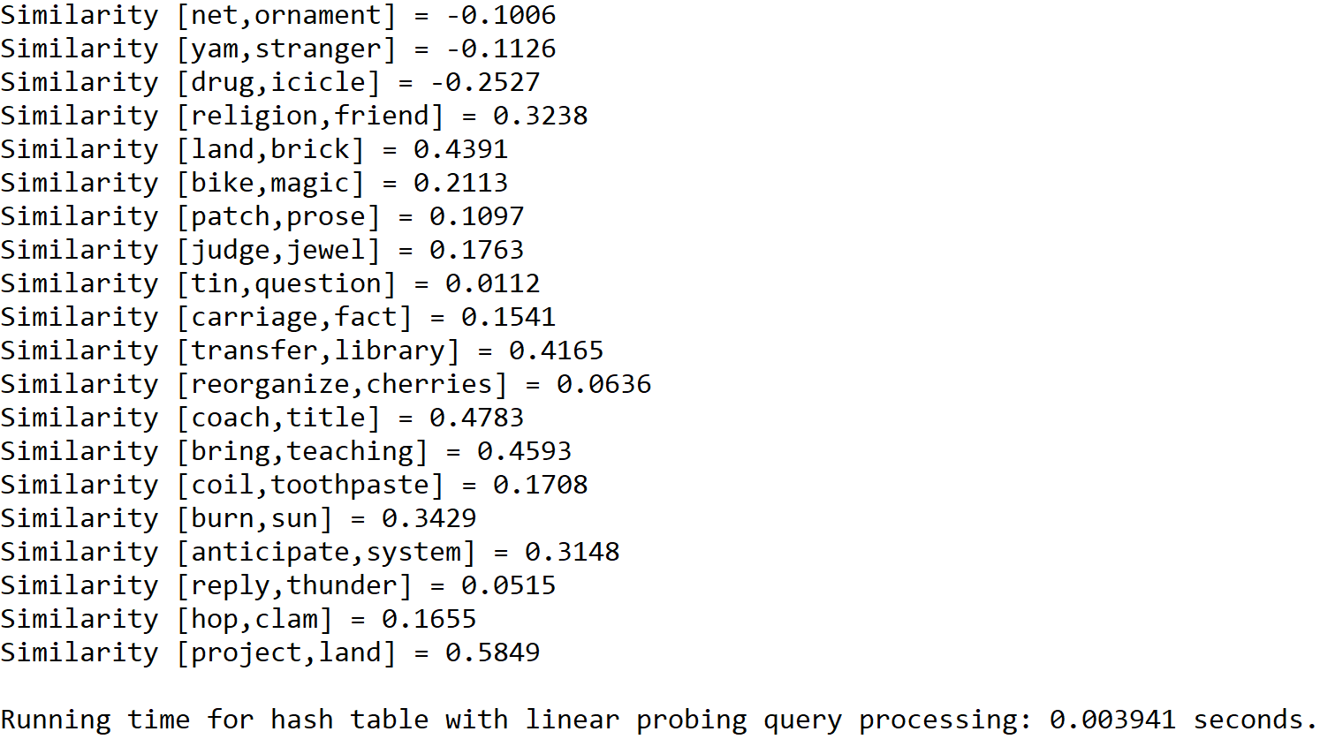

Case 3: Size of text file = 150

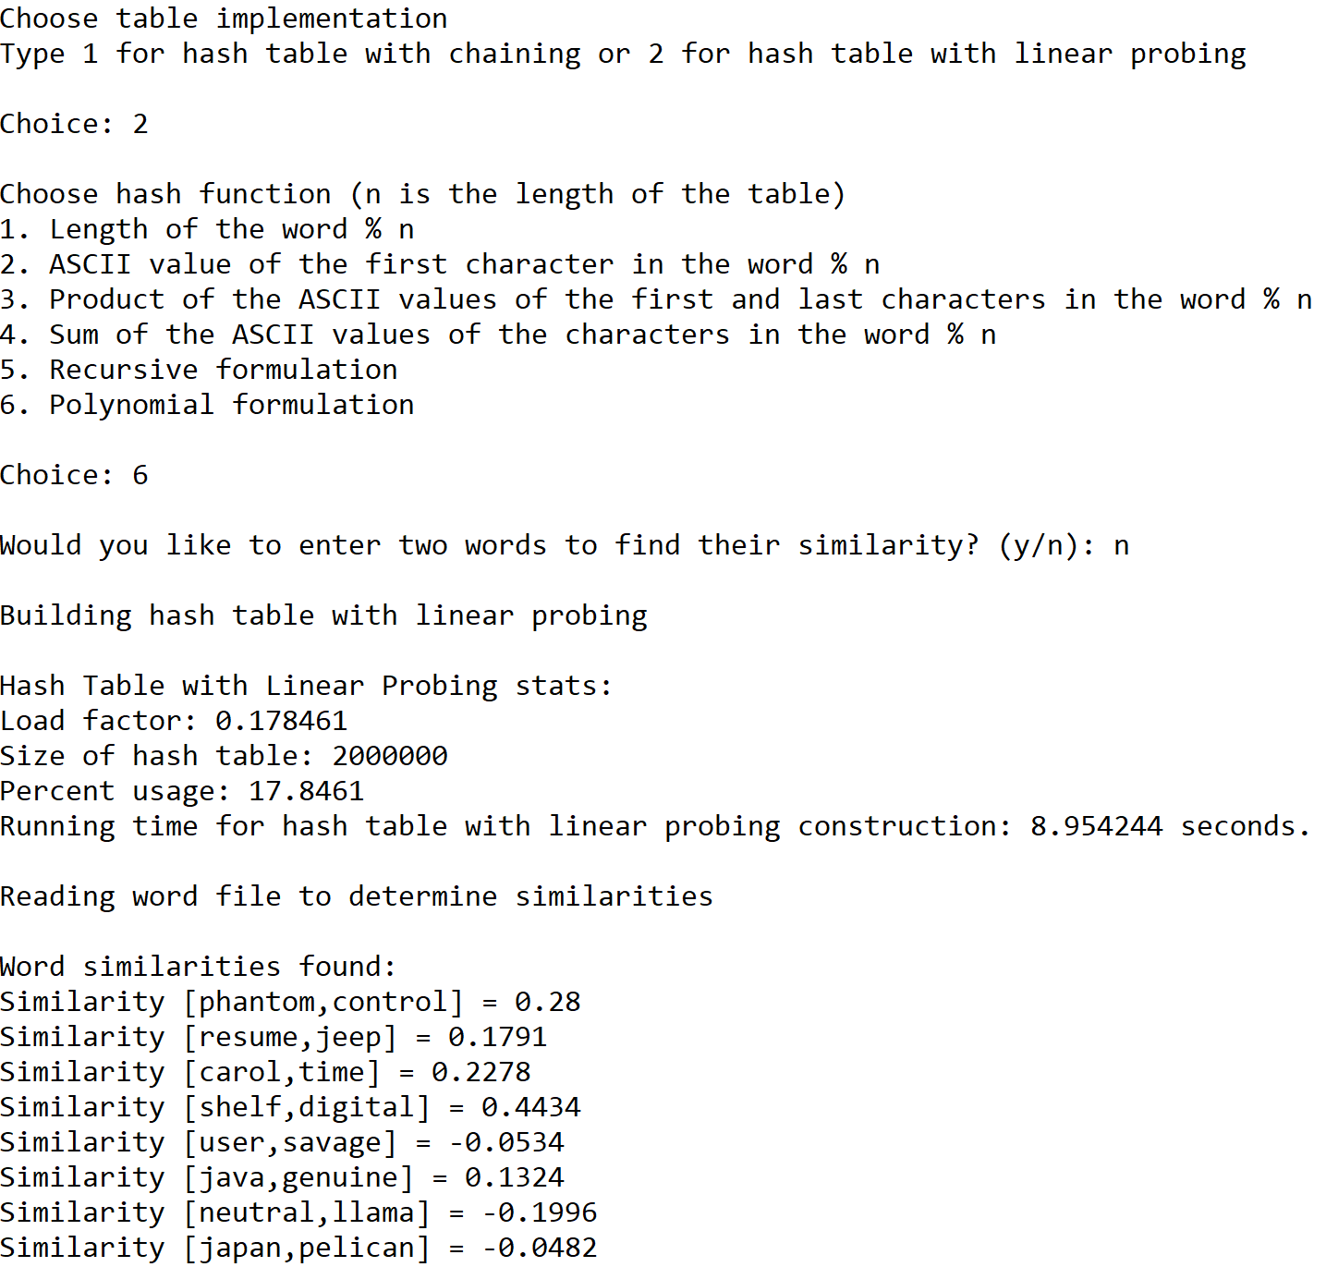







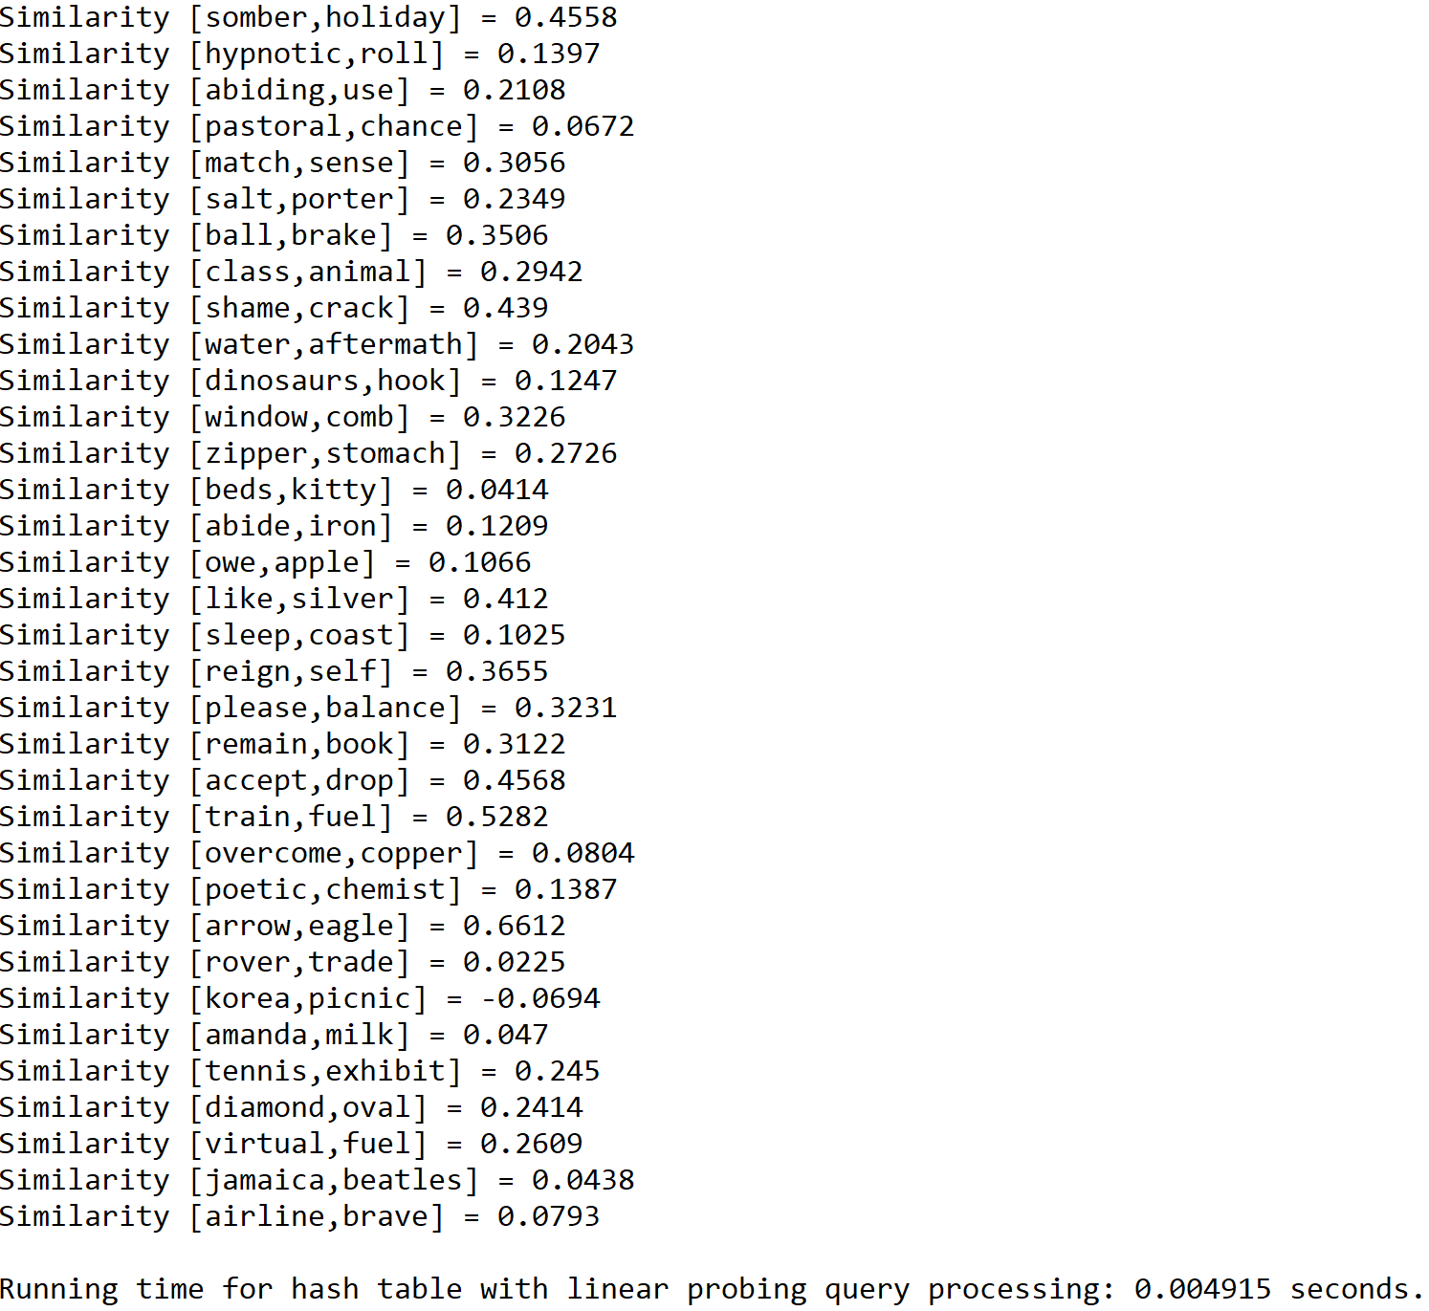

**Table of running times for construction implemented with trees and hash tables**

|  |  |  |  |  |
| --- | --- | --- | --- | --- |
|  | BST | B-Tree (max_items = 5) | Hash table (chaining) | Hash table (linear probing) |
| Running time (seconds) | 10.979989 | 13.083514 | 8.005216 | 8.656934 |

**Table of running times for query processing implemented with trees and hash tables**

|  |  |  |  |  |
| --- | --- | --- | --- | --- |
|  | BST | B-Tree (max_items = 5) | Hash table (chaining) | Hash table (linear probing) |
| Running time (seconds) | 0.001984 | 0.003006 | 0.001923 | 0.002136 |

**Tables of hash table performance for construction according to the implemented hash function**

**Table of average running times for construction implemented with a hash table that solves collisions by chaining and its corresponding hash functions**

|  |  |  |  |  |  |  |
| --- | --- | --- | --- | --- | --- | --- |
|  | Operation 1 | Operation 2 | Operation 3 | Operation 4 | Operation 5 | Operation 6 |
| Running time (seconds) | 7.014358 | 6.827216 | 6.876003 | 7.188387 | 8.411659 | 8.844089 |

**Table of load factors and percent usage for construction implemented with a hash table that solves collisions by chaining and its corresponding hash functions**

|  |  |  |  |  |  |  |
| --- | --- | --- | --- | --- | --- | --- |
|  | Operation 1 | Operation 2 | Operation 3 | Operation 4 | Operation 5 | Operation 6 |
| Load factor | 0.892305 | 0.892305 | 0.892305 | 0.892305 | 0.892305 | 0.892305 |
| Percent use | 0.01075 | 0.0675 | 0.43225 | 0.69675 | 47.67075 | 58.889 |

**Table of average running times for construction implemented with a hash table that solves collisions by linear probing and its corresponding hash functions**

|  |  |  |  |  |  |  |
| --- | --- | --- | --- | --- | --- | --- |
|  | Operation 1 | Operation 2 | Operation 3 | Operation 4 | Operation 5 | Operation 6 |
| Running time (seconds) | 66.596449 | 75.170445 | 76.234641 | 171.035474 | 8.73524 | 8.966561 |

**Table of load factors and percent usage for construction implemented with a hash table that solves collisions by linear probing and its corresponding hash functions**

|  |  |  |  |  |  |  |
| --- | --- | --- | --- | --- | --- | --- |
|  | Operation 1 | Operation 2 | Operation 3 | Operation 4 | Operation 5 | Operation 6 |
| Load factor | 0.18998 | 0.18998 | 0.18998 | 0.18998 | 0.178461 | 0.178461 |
| Percent use | 18.998 | 18.998 | 18.998 | 18.998 | 17.8461 | 17.8461 |

**Graphs of hash table performance for query processing according to the implemented hash function**

N = Size of the text file(50, 100, 150)

|  |  |  |  |  |  |  |
| --- | --- | --- | --- | --- | --- | --- |
| Size of the text file | Operation 1 | Operation 2 | Operation 3 | Operation 4 | Operation 5 | Operation 6 |
| 50 | 0.016725 | 0.000000 | 0.000000 | 0.001995 | 0.001923 | 0.001918 |
| 100 | 0.047873 | 0.024931 | 0.004987 | 0.005014 | 0.002964 | 0.002992 |
| 150 | 0.057846 | 0.039862 | 0.009967 | 0.005986 | 0.003924 | 0.005914 |

|  |  |  |  |  |  |  |
| --- | --- | --- | --- | --- | --- | --- |
| Size of the text file | Operation 1 | Operation 2 | Operation 3 | Operation 4 | Operation 5 | Operation 6 |
| 50 | 0.201461 | 0.222364 | 0.173540 | 0.399120 | 0.002136 | 0.000998 |
| 100 | 0.396013 | 0.451940 | 0.351100 | 0.775076 | 0.003990 | 0.003941 |
| 150 | 0.595587 | 0.671791 | 0.507643 | 2.034560 | 0.003961 | 0.004915 |

As the results show, the implementation of the hash table that solves collisions by chaining is the fastest of the four data structure implementations tested to store words and their embeddings and compare pairs of words by retrieving their corresponding embeddings. One of the reasons this implementation is the fastest out of the four is that it can find the proper place to store a word and its embedding in constant time by using the hash value of the word. Additionally, it needs to traverse through no more than a single bucket in the table to find the words that will be compared with one another through their embeddings. Overall, the hash table that solves collisions by chaining can accomplish these two tasks quickly thanks to the property of the hash value of the word.

In terms of efficiency, the six hash functions implemented into the two types of hash tables greatly differ from one another as seen in the different running times and percent use values among all six functions. For the hash table that solves collisions by chaining, the most efficient hash function is between the recursive formulation (Operation 5) and the polynomial formulation (Operation 6), and the least efficient hash function is the one that determines the hash value of a word through its length (Operation 1). While the running times among all six hash functions are relatively similar, the main factor that determines the efficiency of the hash function for this type of hash table is the difference between the load factor and the percent use, which measures the efficiency of the table in terms of space. Operations 5 and 6 may have yielded the longest average running times for constructing the hash table, but their percent use values are the highest among all six hash functions. On the other hand, Operation 1 yielded the lowest percent use value out of all six hash functions.

For the hash table that solves collisions by linear probing, the most efficient hash function is also between Operation 5 and Operation 6, and the least efficient hash function is the one that determines the hash value of a word through the sum of the ASCII values of its characters (Operation 4). While the load factors and percent use values among different groups of hash functions are similar, the main factor that determines the efficiency of the hash function for this type of hash table is the running times, which measure the efficiency of the table in terms of time. Operations 5 and 6 yielded the shortest running times for table construction and query processing. On the other hand, Operation 4 yielded the longest running times for both tasks.

The main reason the last two hash functions are considered the most efficient out of all six hash functions is the way in which each function assigns a hash value to a word. For the first four hash functions, they assign hash values to words according to properties that are commonly shared among different words. For example, most words share the same length or first character . Furthermore, the efficiency of Operation 4 greatly depends on the number of anagrams a single word can have. Because many words share these properties, these first four hash functions produce a high number of collisions in the hash table, which affects the performance of the type of hash table implemented. In the case of the hash table associated with chaining, these hash functions will cause the table to have many empty buckets since most words and embeddings will be stored in just a few buckets. In the case of the hash table associated with linear probing, these functions will cause the insert and find functions to take longer to complete their task since the large number of collisions causes many words that have the same hash value to be spread throughout the table. By contrast, the last two hash functions assign unique hash values to different words, which greatly reduces the number of collisions produced. As a result, these hash functions increase the efficiency of the hash table by ensuring that each element in the table has its own hash value.

**Conclusion**

This lab helped me understand hash tables better by allowing me to test different ways in which elements of different data types can be assigned to their proper place in the table through their hash value. For example, I learned that you can store not just numbers but also words in a hash table by examining the properties of the words themselves such as their length and the numerical representation of each of their characters. That way, it is possible to come up with different hash functions that can be used to store each word in its proper place in the table. Additionally, this lab helped me understand the concept of collisions in a hash table and the way in which they can affect the performance of this data structure. For example, I learned that collisions have a greater effect on hash tables associated with linear probing because they cause this implementation of the hash table to take longer to complete its tasks due to the fact that it needs to traverse through the table until it finds a position in which it can insert a new element that shares its hash value with other previously-inserted elements or stop searching for a particular element that may or may not be present in the table. In the case of hash tables associated with chaining, collisions affect the efficiency of the hash table by increasing the load factor while not increasing the percent use of the table since all elements are being assigned to a few buckets. If the percent use of the hash table is significantly lower than its load factor, then the hash table cannot be considered efficient in terms of space because all of those empty buckets are wasted. Overall, this lab allowed me to analyze the efficiency of hash tables in terms of time and space.

**Appendix**

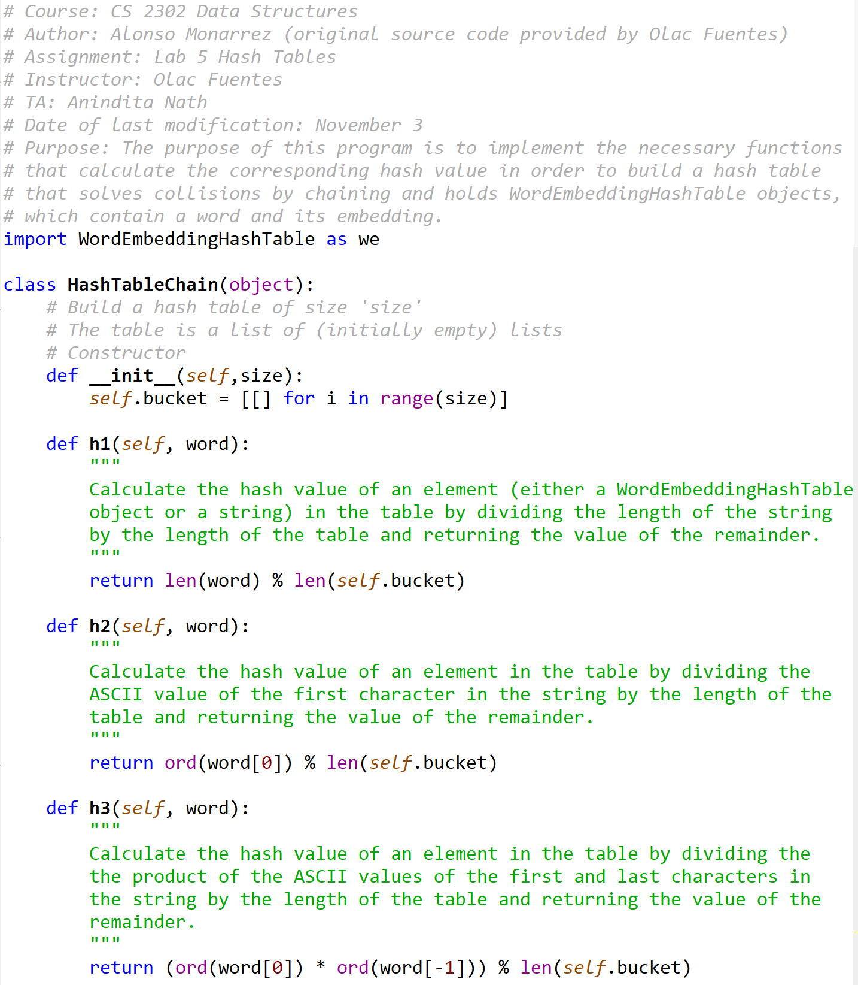HashTableChain.py



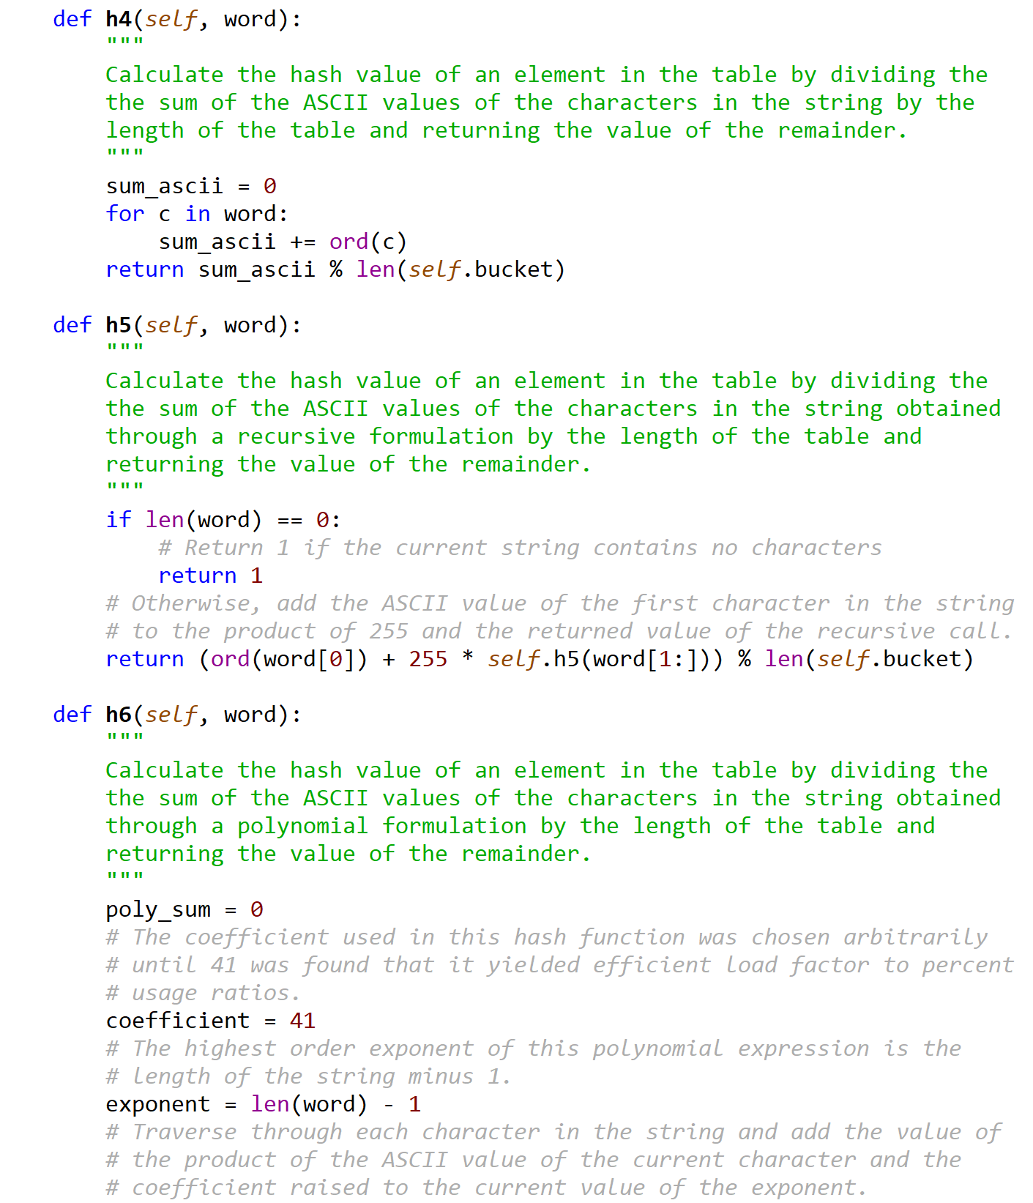

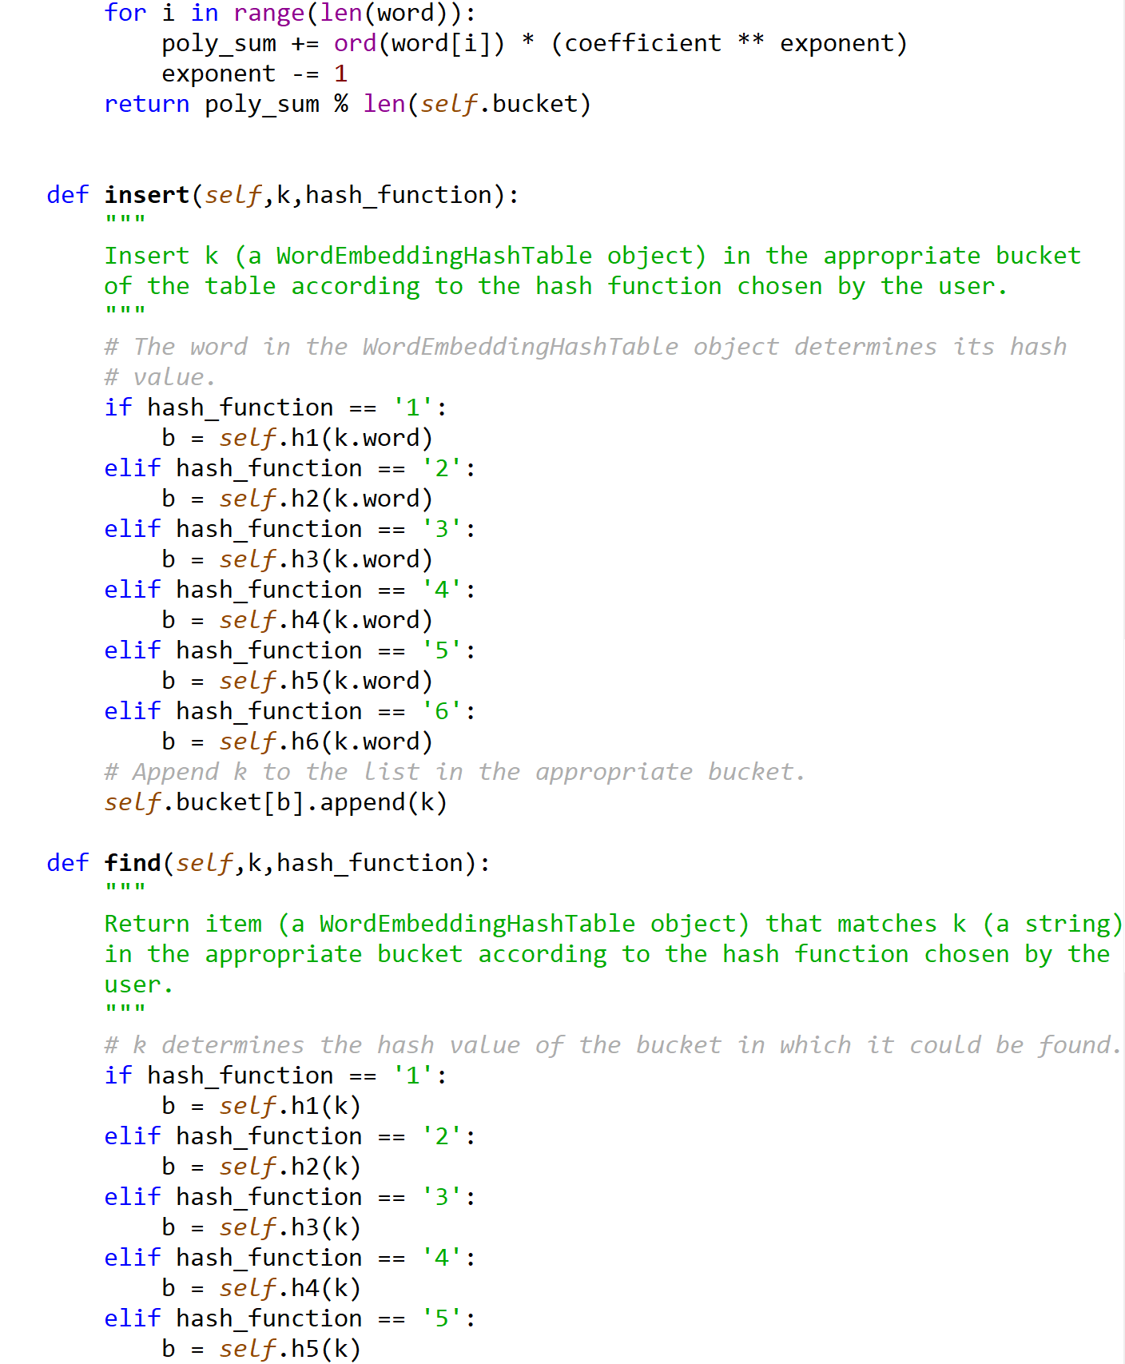

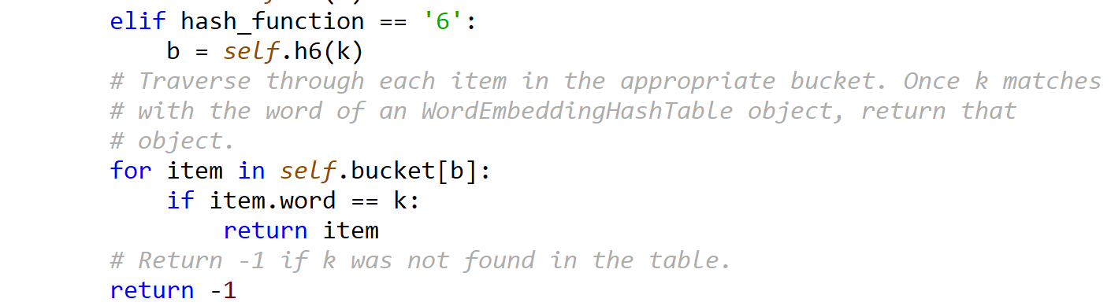

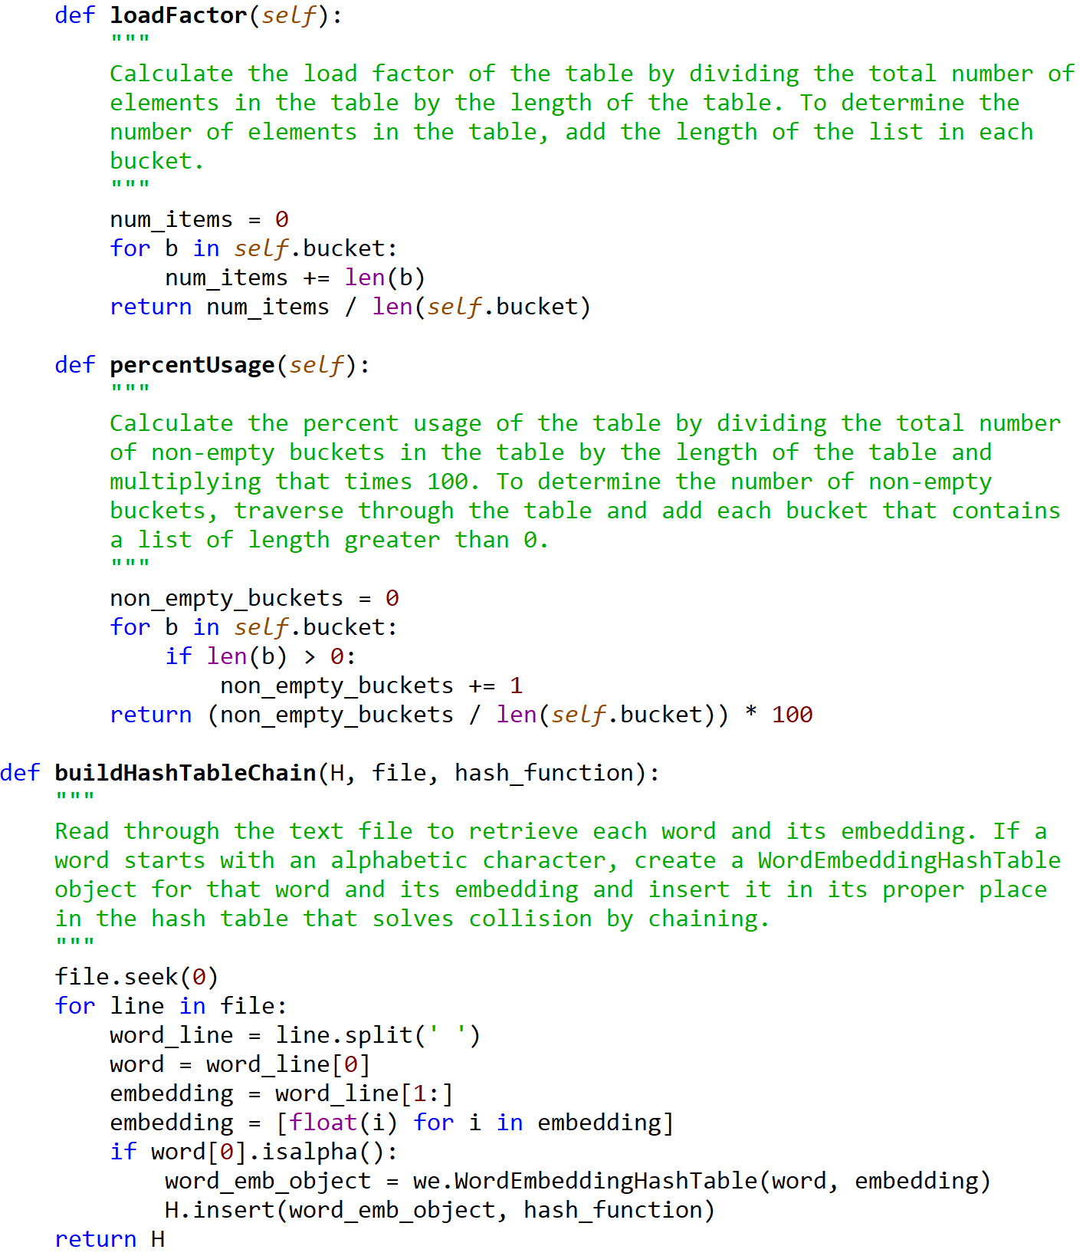

HashTableLP.py

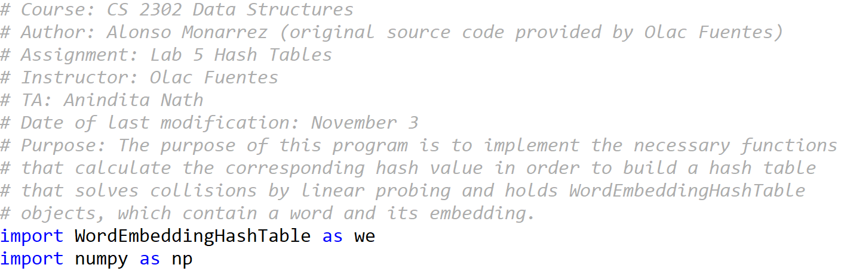

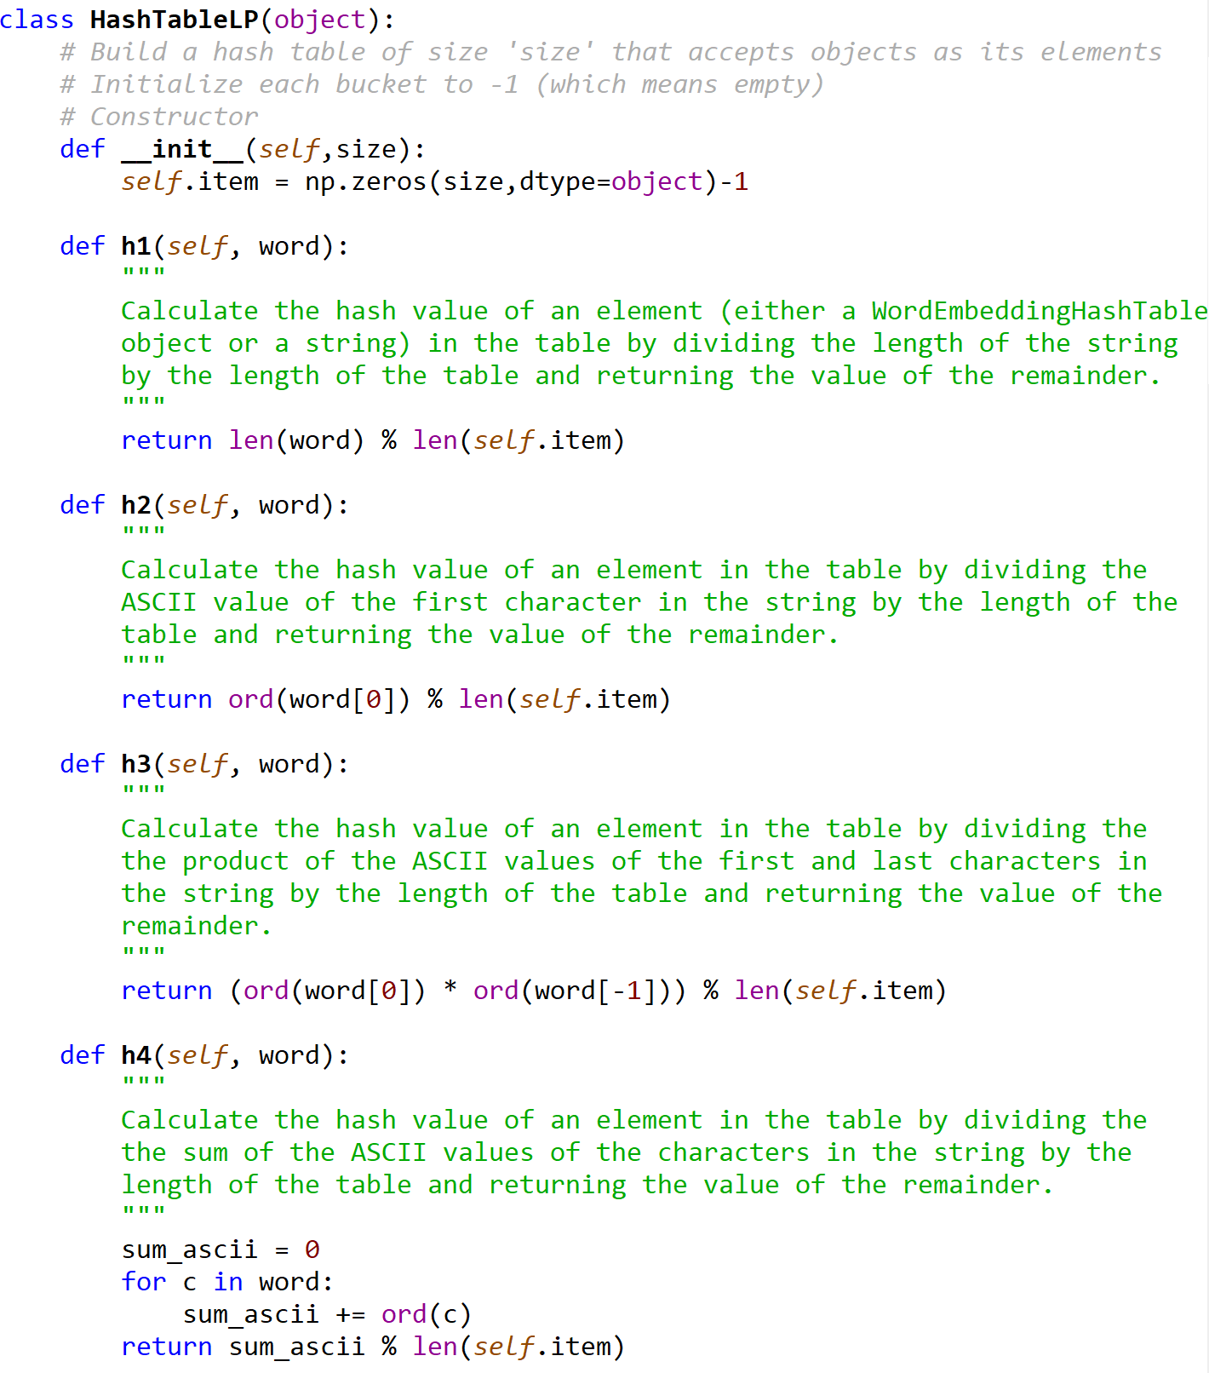

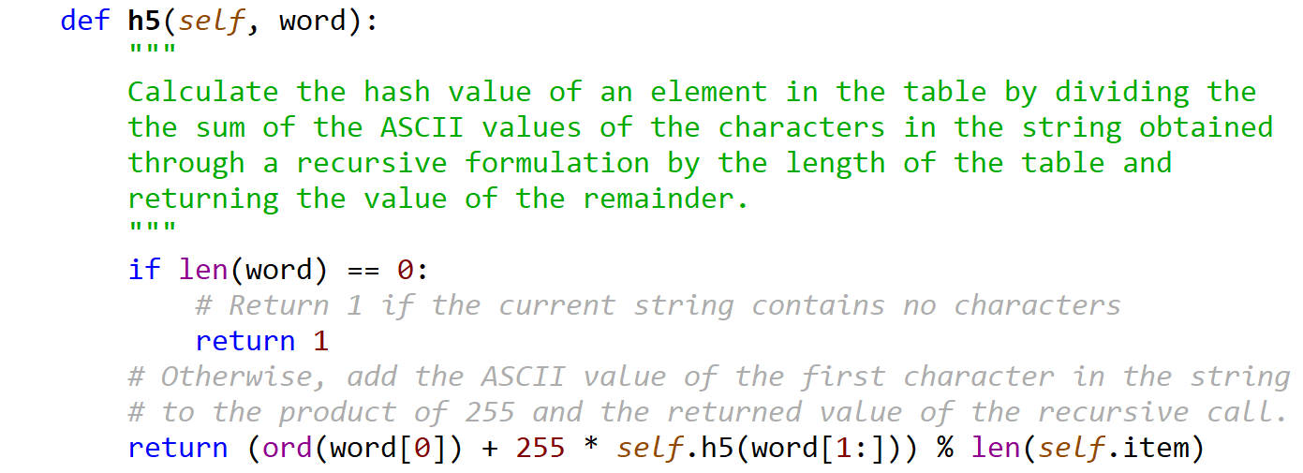

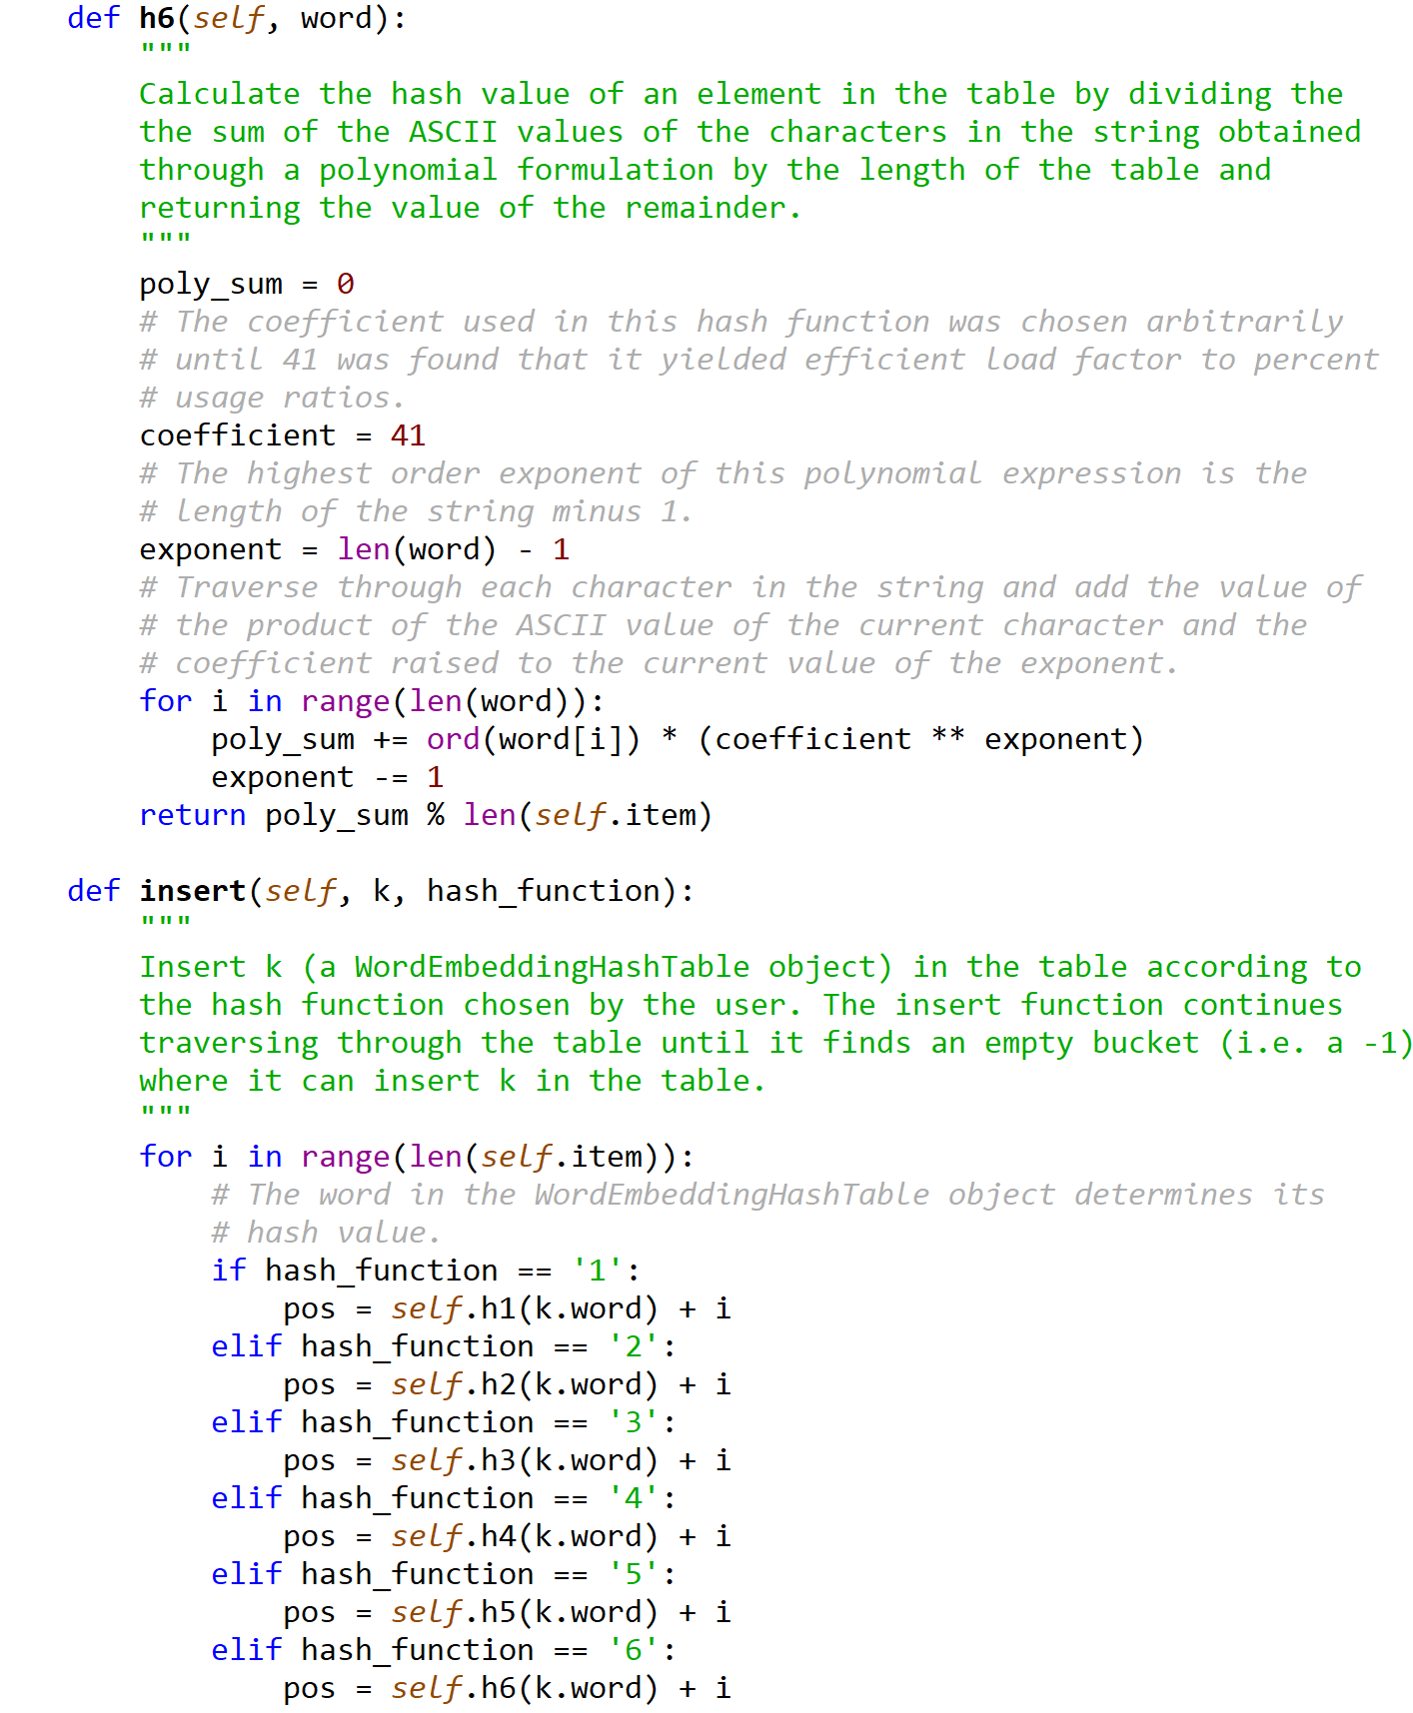

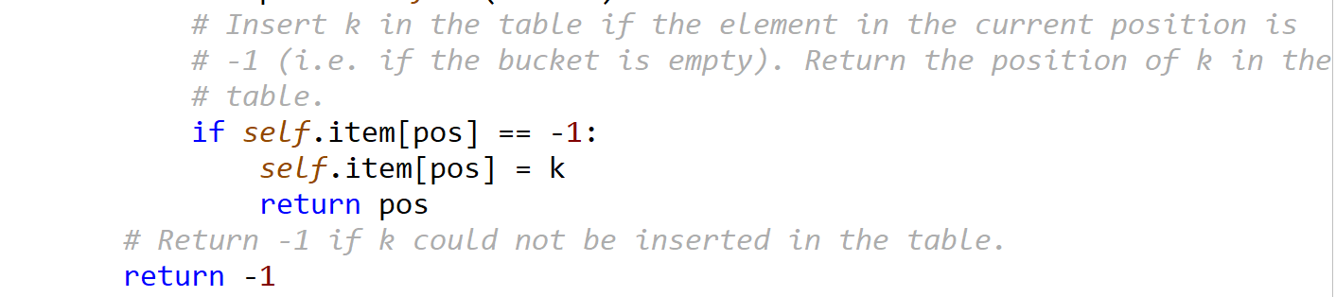

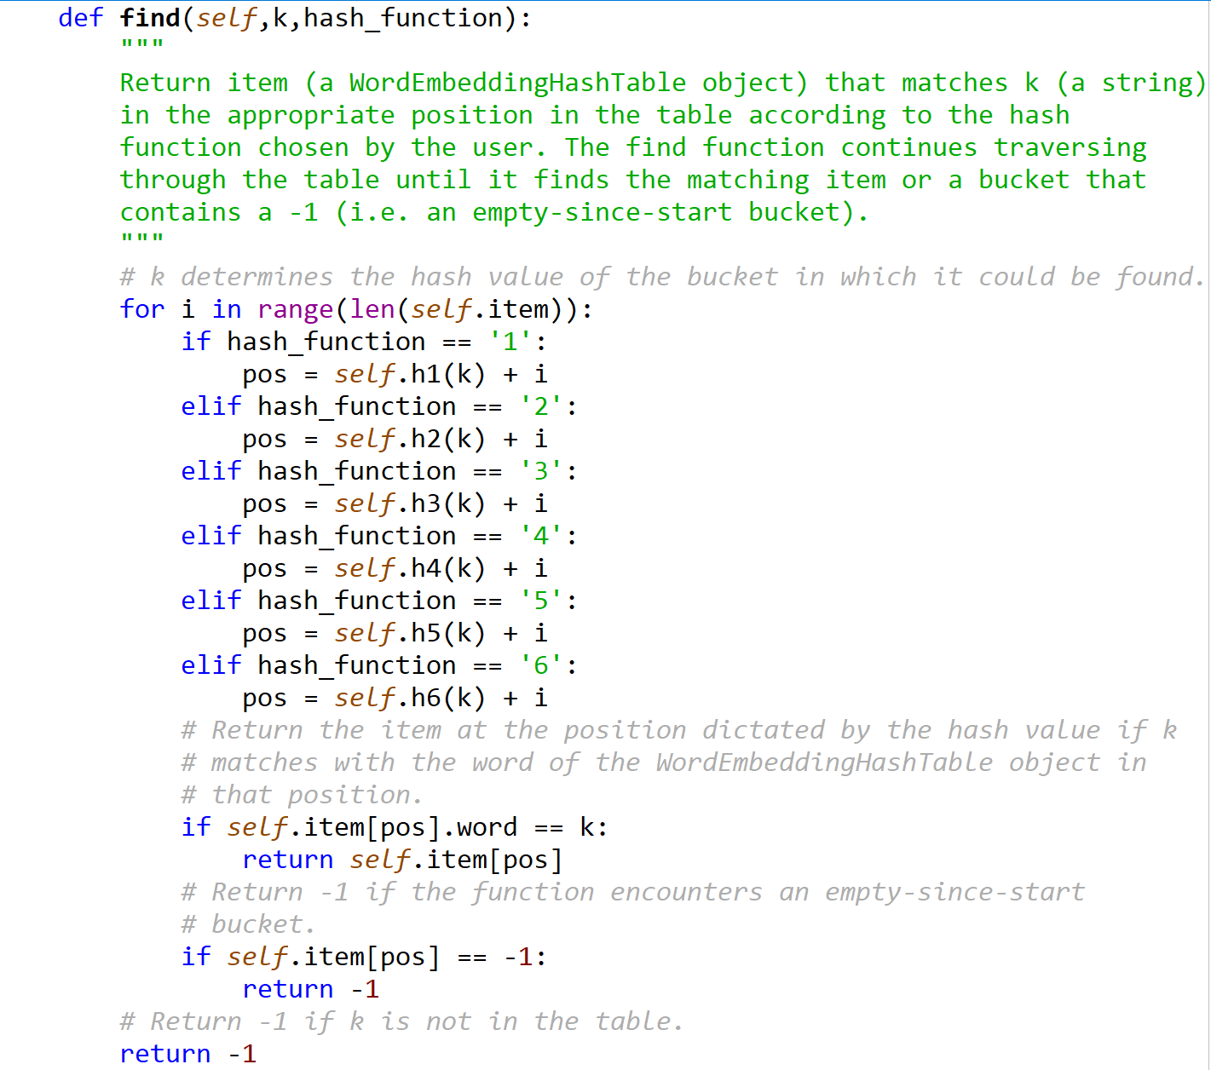

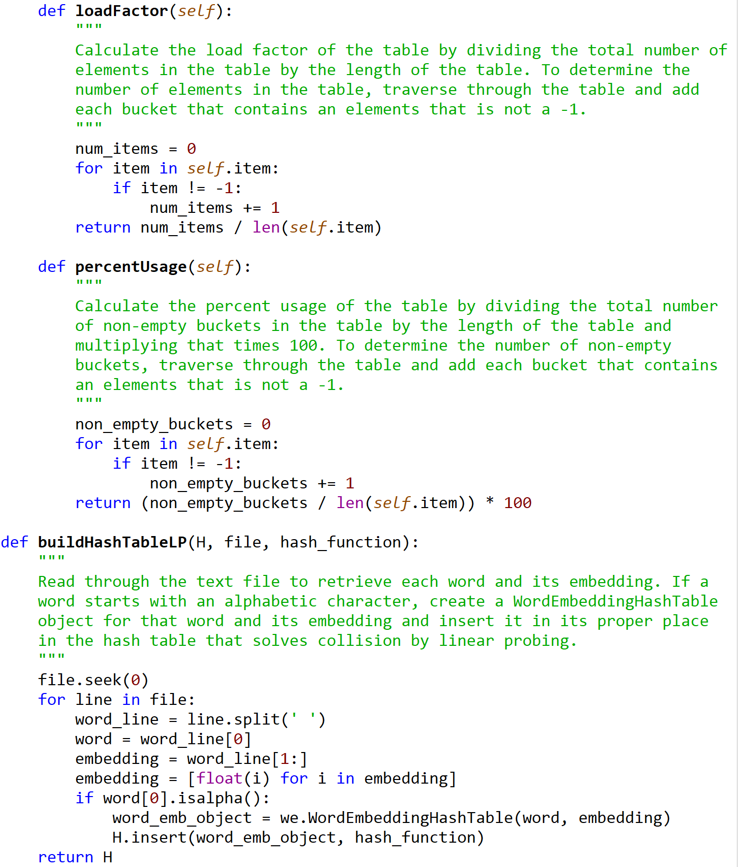



WordEmbeddingHashTable.py

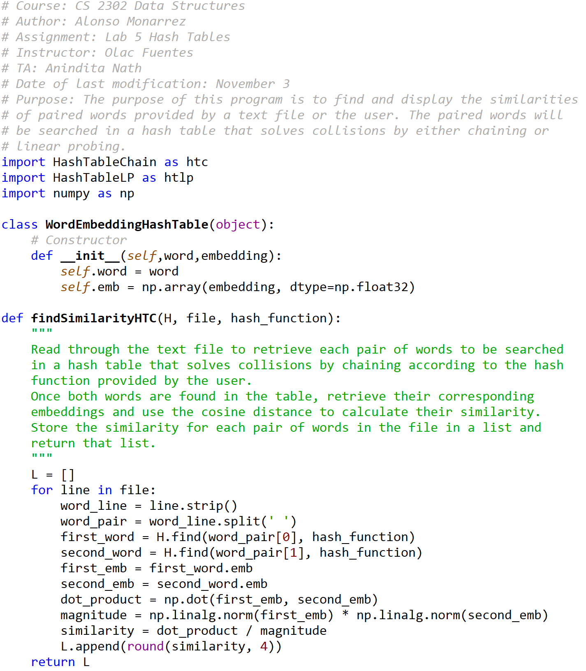

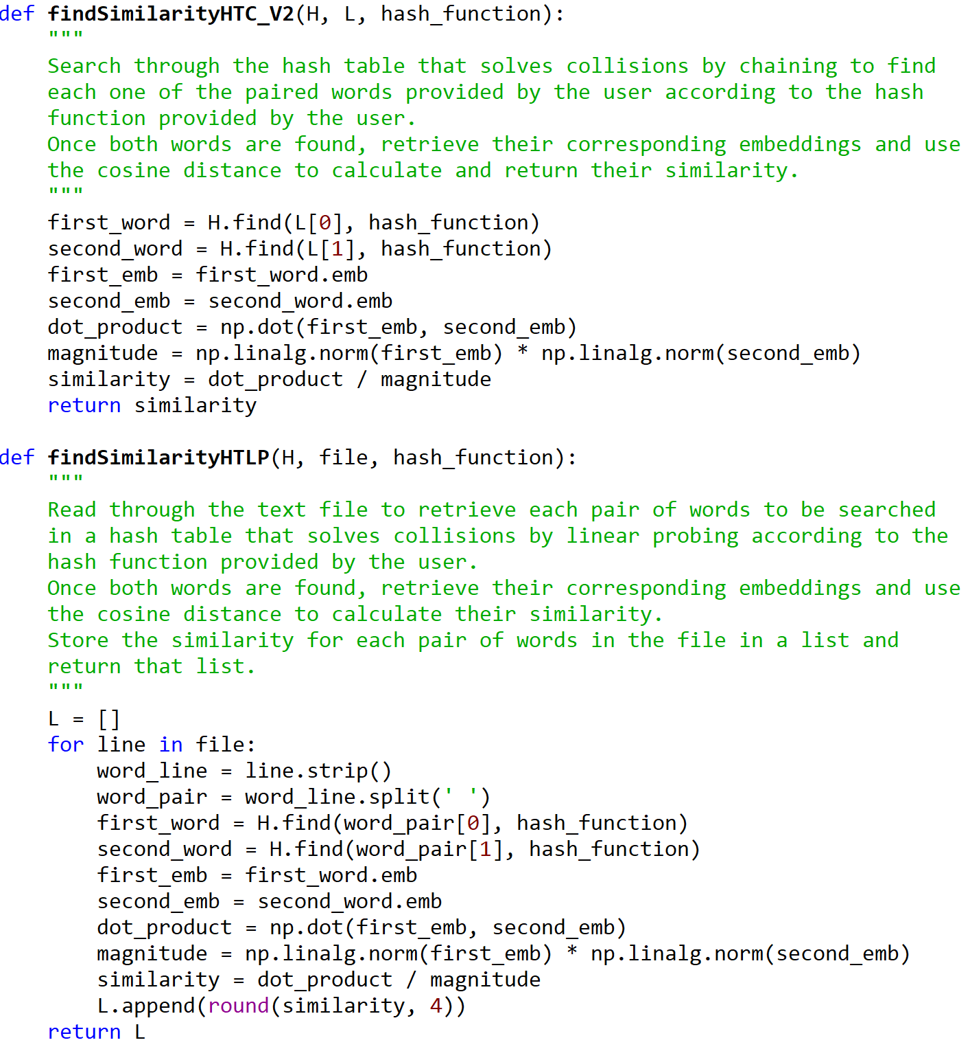

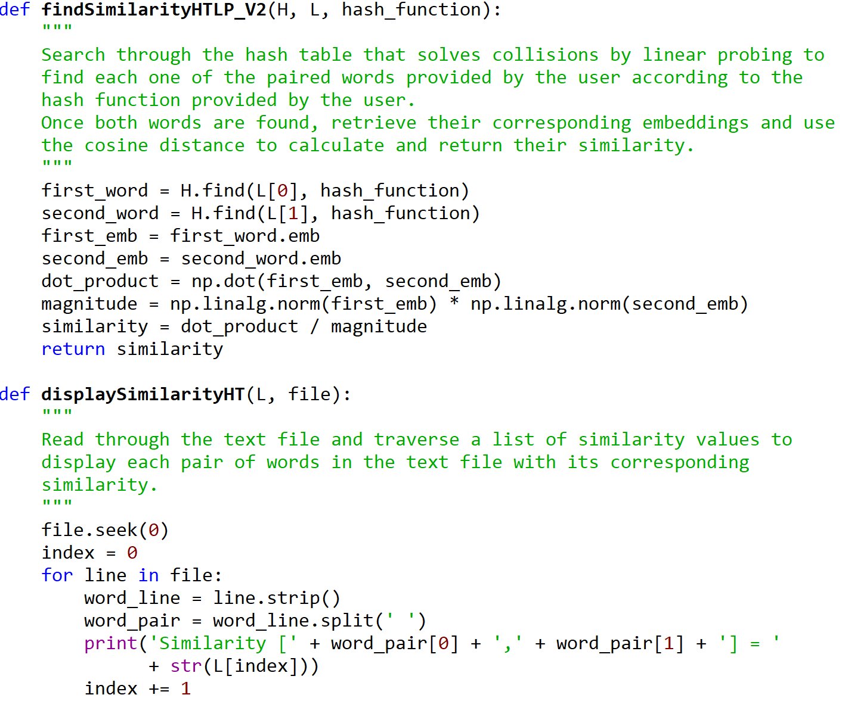

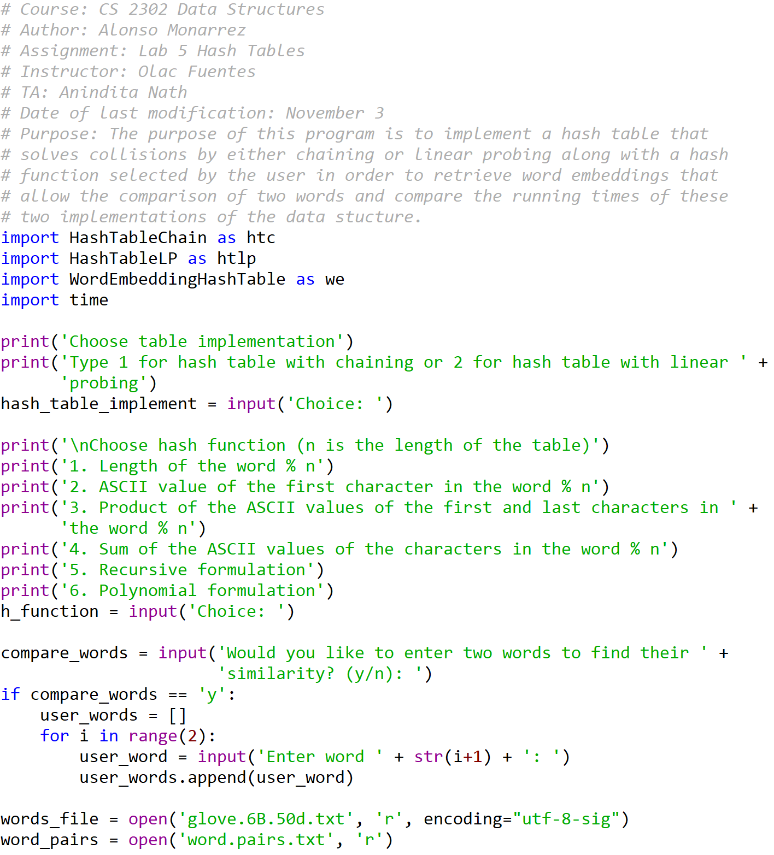

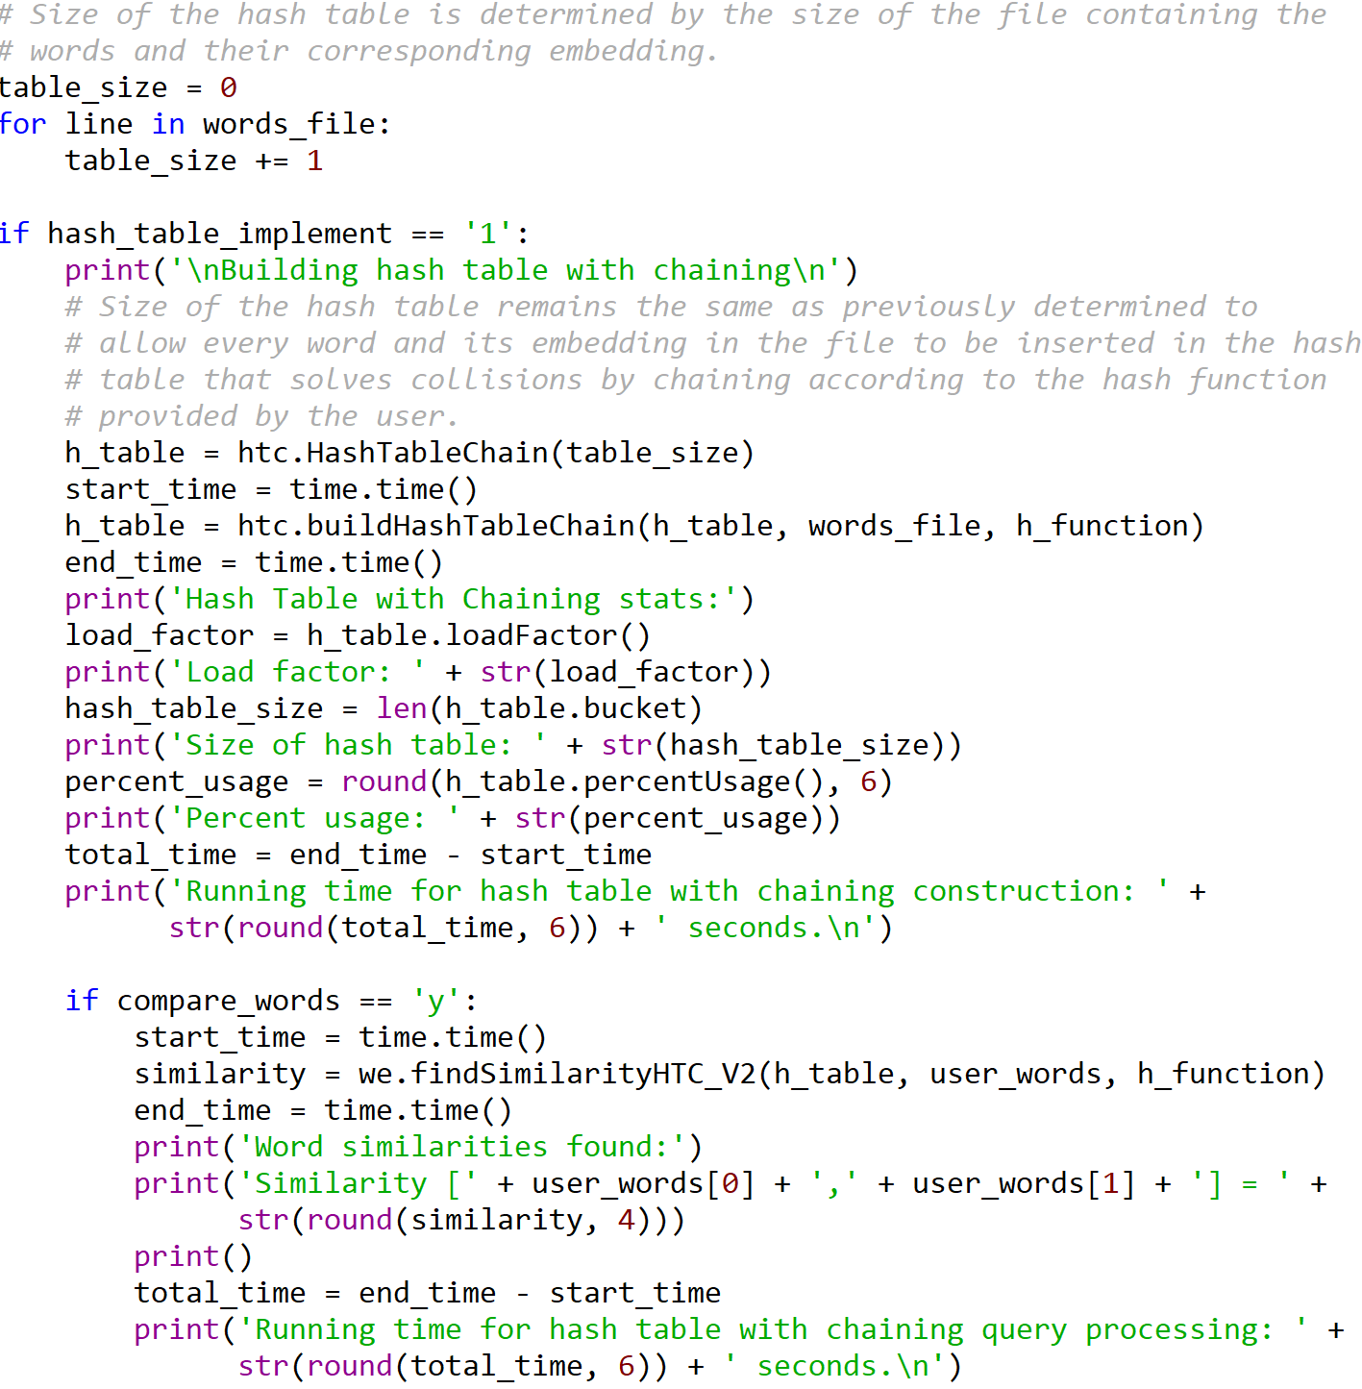



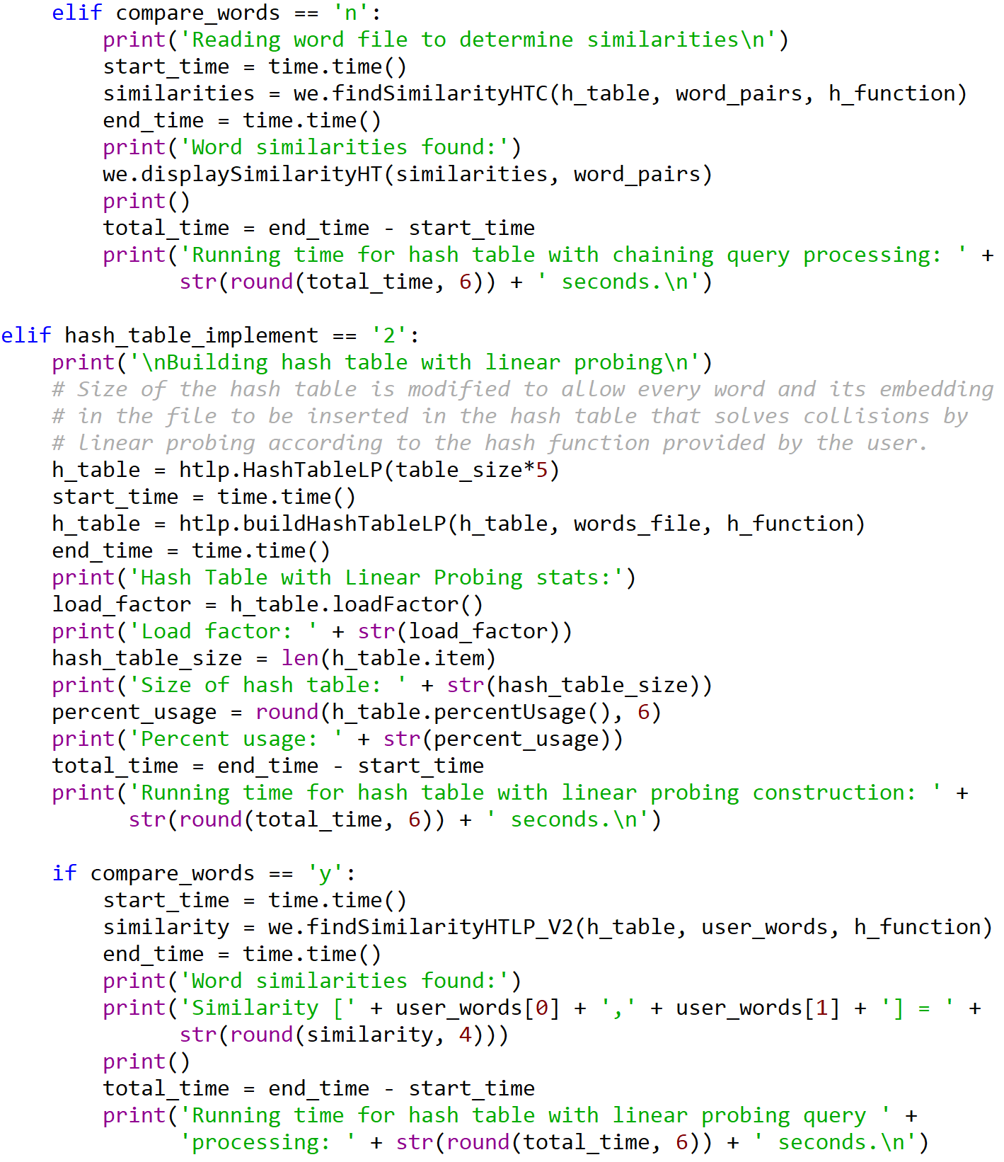

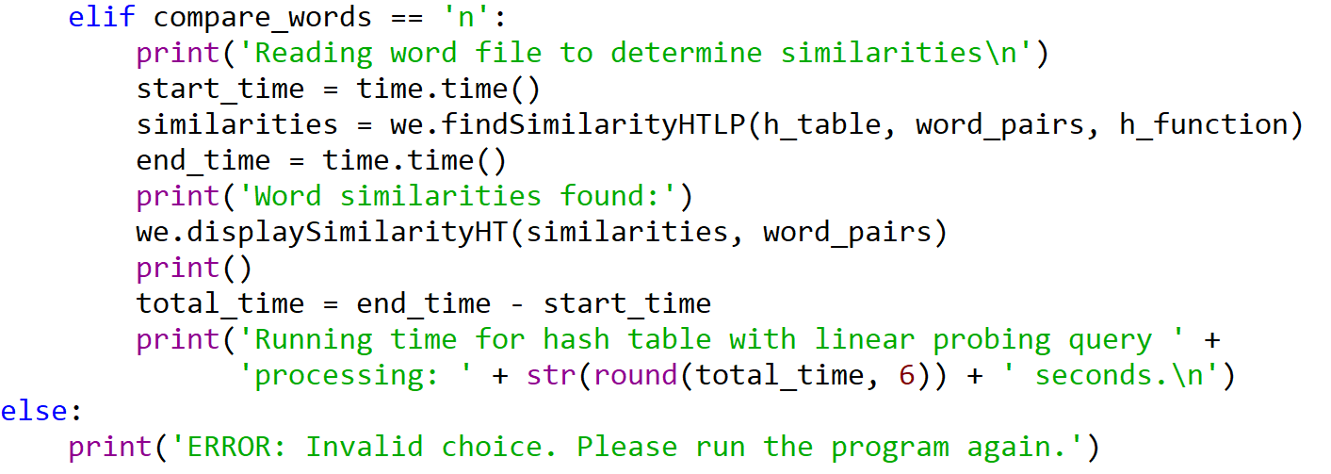

I certify that this project is entirely my own work. I wrote, debugged, and tested the code being presented, performed the experiments, and wrote the report. I also certify that I did not share my code or report or provided inappropriate assistance to any student in the class.